AR2000ex Rheometer Standard Operating Procedures
Revised: 5/6/2017

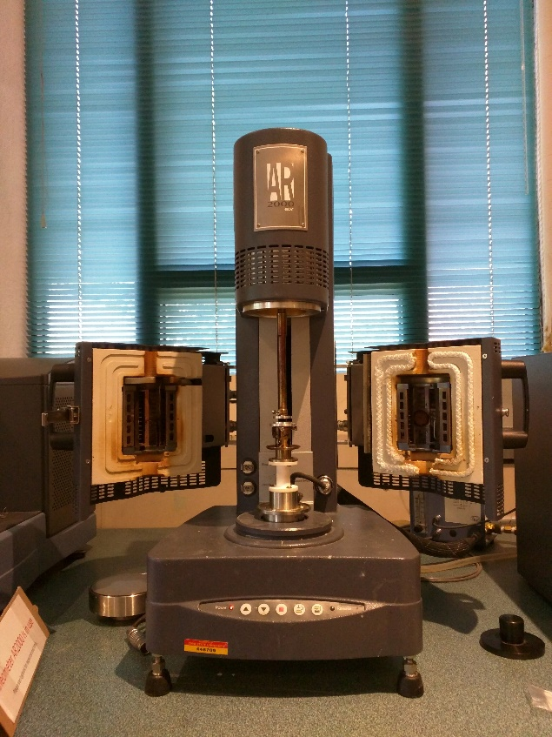

Startup Procedure
- Remove the black bearing lock by holding it place while turning the draw rod knob on the top of the instrument counterclockwise. Once the lock has been removed, the spindle should rotate freely.
- Turn on power to the rheometer by flipping the switch located behind the electronic control box.
- Please sign into lab notebook on the center table in the room. Then, log onto the rheometer computer using your ISU NetID. The Launchpad billing software will open.

  - Click the Login button that appears on the screen.
  - The first time you use the software you will get another window asking if you are using an ISU NetID or an external account. Leave it on the default of ISU NetID then click Continue.
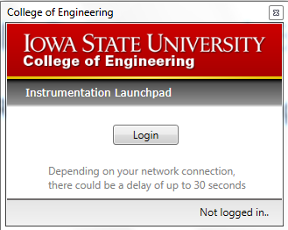
  - Enter your username and password.
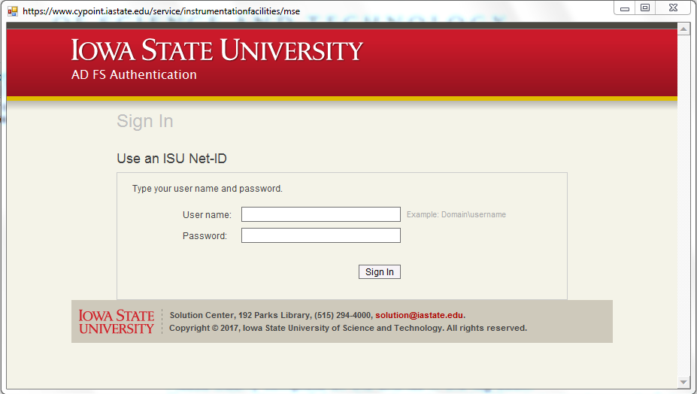

  - Enter your account number, supervising professor, sample description, experiment description, and click next. (NOTE: The account number will auto format so just enter the numbers and it will enter the dashes for you)

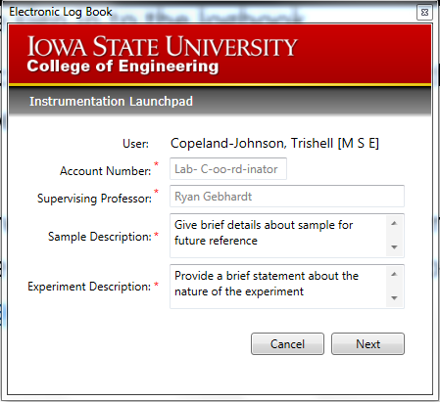

- Once this information is entered, the TA Instrument Explorer button will be displayed.

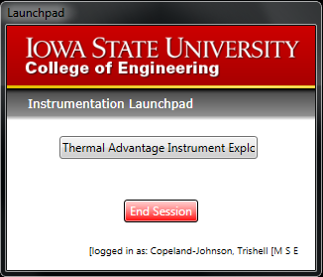

- Click to open the TA Instrument Explorer and select the AR2000ex icon, prompting the
AR Instrument Control software to open, featuring the Instrument Status tab. From the left of the Instrument Status tab, the Geometry, Procedure, Notes, and RealTimePlot tabs are also seen.
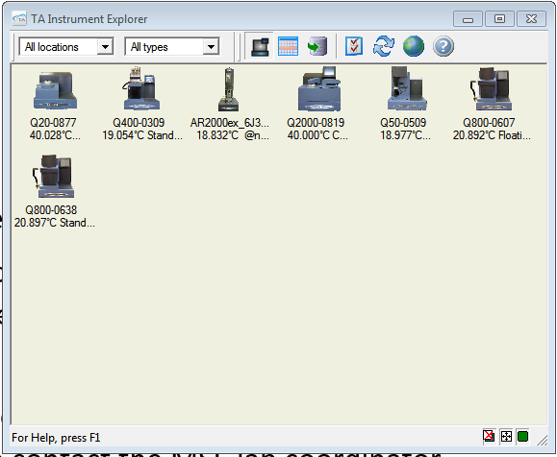

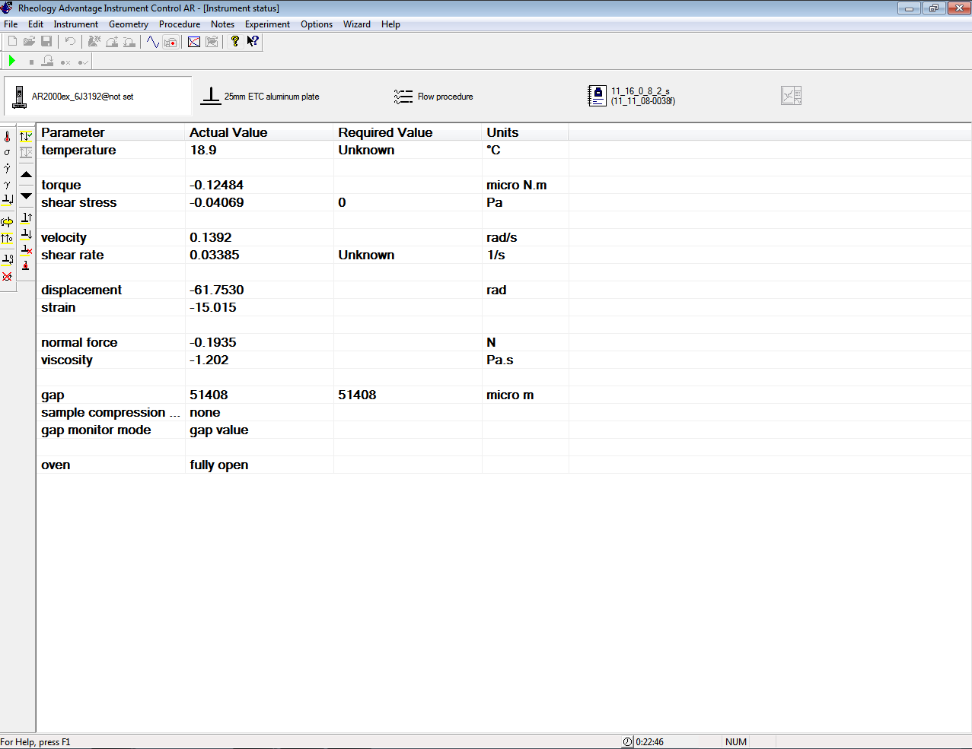
RealTimePlot
Notes
Procedure
Geometry
Instrument Status

- The AR2000ex is equipped with an environmental test chamber (ETC) that operates over a temperature range of -160 to 600°C at a maximum heating rate of 60°C/min and a Peltier plate system between -40 to 200 °C. The Peltier system can be used in lieu of a bottom plate geometry. The system is equipped using the Smart Swap rheometer feature, which automatically detects the attached accessory, anchored magnetically. Simply insert the bottom of the system into the lower part of the instrument. To remove the Peltier system, press the Release button on the instrument control panel, indicated by a corresponding flashing green light. Then, firmly pull the plate up from its base while the light is flashing.
- There are two options for cooling: air flow and active cooling. Air flow is usually feasible. Otherwise, active cooling may be utilized required to reach lower temperatures. Flow of either stream is controlled using the gauge located behind the rheometer.
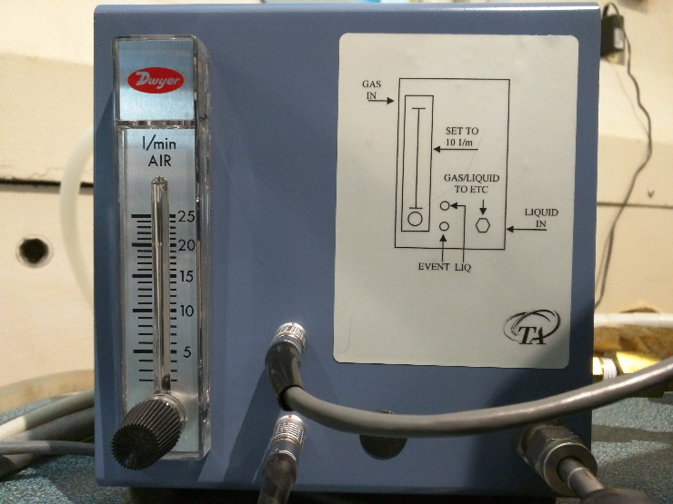
  - For air flow, close the furnace doors. If properly latched the interlock will release, prompting air flow that generates a hissing sound. Adjust the flow meter until the rate is10 L/min.
  - For active cooling, connect an LN₂ dewar to the corresponding cryogenic connection.
Procedure Setup
Setting up an experiment using AR Instrument Control software requires configuring the Instrument Status, Geometry, Procedure, and Notes tabs.
- Instrument Status tab: This screen displays the rheometer conditions before testing begins.
  - Using active cooling versus air flow: Click Options, Instrument, and then un-checking the box that is labeled No Active Cooling (Purge Gas Only). Click Apply and then Close. Selecting the box again will turn off the active cooling. This is considered the macroscopic or “global” liquid nitrogen control, and it will only affect pre and post-test conditions.
  - Normal Force: Normal Force can be crucial, depending on your test and material. Review relevant literature pertaining to evaluating the viscoelastic properties of your material to identify a relevant normal force.
- The Geometry tab displays the currently loaded geometry. Refer to the “Instrument Setup” section for more information.
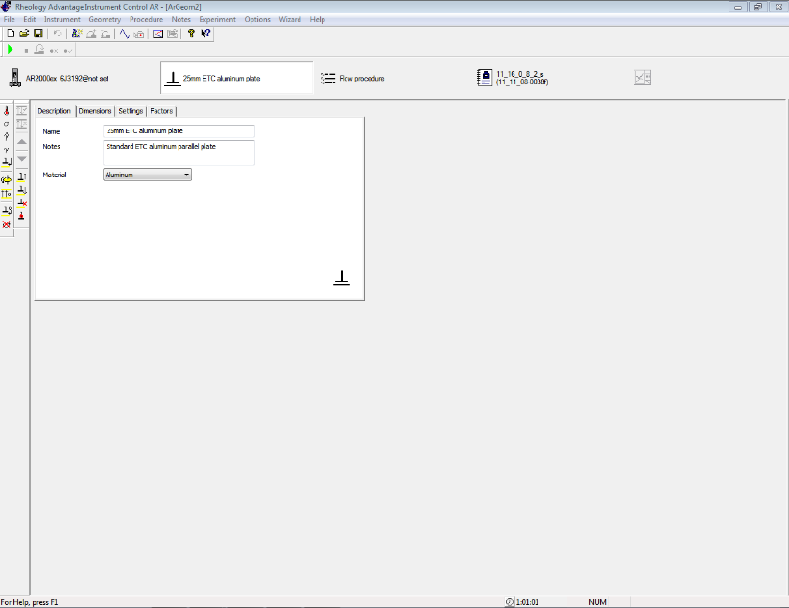
- Procedure tab:
  - NOTE: Procedure options are vast. Refer to Chapter 4 of the Rheology Advantage Instrument Control Getting Started Guide for initial guidance for crafting your procedure.
  - Open an existing procedure: Click Procedure followed by Open… and select a previously saved file.
  - To create a new procedure by clicking Procedure, New, and the Test Type of your choosing. Save the procedure by clicking File, Save As….
  - To add a new step to your procedure, right-click on an existing step (i.e. Conditioning Step) in the box labeled Steps on the left side of the screen. Holding your mouse over Add Step will display a menu of step choices.
  - NOTE: Existing steps can be copied and pasted into the sequence as well, just right-click to pull up the menu.
  - Steps to note
    - A step will only be run if the box next to it in the Steps box is checked. You can uncheck these boxes at any time during a test, so long as the step has not already begun.
    - Conditioning step: This is where the in-test or “microscopic” normal force and liquid nitrogen controls are located. Turn on/off the active cooling for the test by clicking the Advanced tab and checking or unchecking the Purge gas only (no active cooling) check box. NOTE: Liquid nitrogen and normal force controls set inside the conditioning step apply whether or not the step is included in the sequence. This is the only step to which this exception applies.
    - Post-experiment step: This step is handy if you won’t be at the controls when the test is completed. Set a temperature of your choosing by entering it in the box.
    - Step Termination: This tab is useful for programming the rheometer to skip to the next step when a certain parameter is met or exceeded.
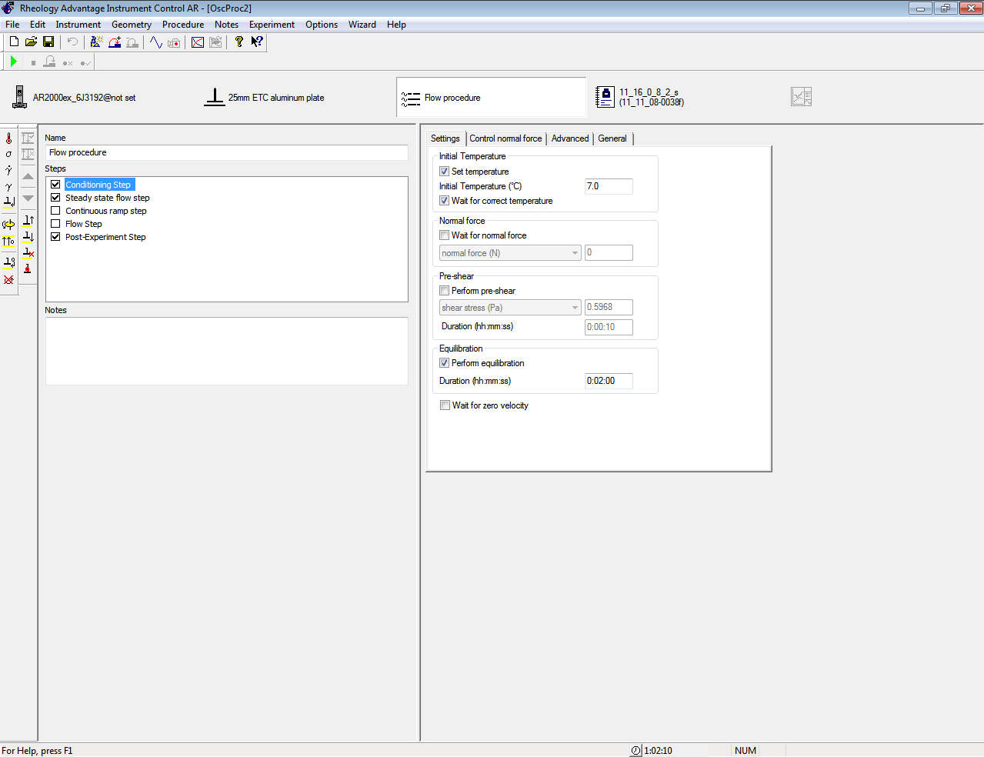
- In the Notes tab, enter desired sample and file names, checking to see that the directory is C:/Documents and Settings/All Users/Documents/TA/Rheology/Results. Also, include notes pertaining to your sample and experiment.
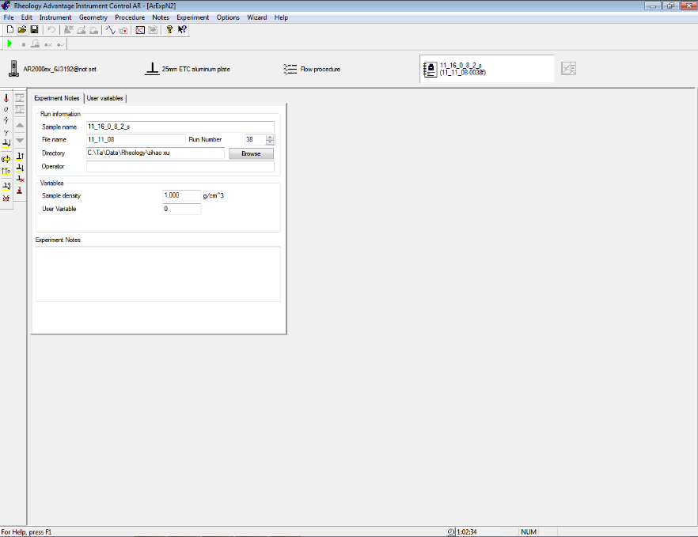
- The RealTimePlot tab is where data is displayed during the experiment. It is not available until the experiment starts.

Instrument Setup
Disposable 25 mm ETC aluminum parallel plates are readily for this system. The bottom geometry, displayed on the right below, features a drip channel for capturing fluids excreted from the sample during analysis.
NOTE: However, stainless steel, titanium, and acrylic parallel/cone geometries are also available. Please contact TA Instruments for purchasing different accessories.

- Before installing plates (used or new), clean them with a compatible solvent using Kimwipes.
- First, install the top plate to the upper geometry shaft and use an 3/32” Allen wrench to loosely secure the plates just enough to prevent them from slipping. If the shaft is already attached to the air bearing, remove the shaft using the following procedure to install a new geometry:
  - Hold shaft still with one hand and loosen the thumb screw at the top of the rheometer with the other.
  - Maintaining grip on the shaft, press and hold the Up Arrow on the control panel found on the rheometer until the shaft is free from the moving head. IMPORTANT: Always remove shaft before attaching or removing the top plate. Failure to do so my damage air bearing.
- As for the lower plate, fix it into the center hole on the rheometer’s platform and loosely tighten the two machine screws with a 3/32” Allen wrench.
  - Next, reattach the upper shaft with the plate.
  - Position the plates within 5 mm of each other.
  - After, activate Normal Force Control on the Instrument menu > Normal force control normal force with settings: Normal force: 5N, Tolerance: 1N, Limit Up/Down: 100µm, check the Set initial value checkbox,
  - Select the Window: On and Compression radio buttons.
  - Once the normal force has reaches ~5N, then tighten screws on the top geometry while holding the thumb screw and then the corresponding screws for the bottom geometry. This will to ensure that the plates are parallel. Again, DO NOT OVERTIGHTEN SCREWS.
  - Finally, raise the upper geometry.
- Select the corresponding geometry file in the Instrument Control software from the Geometry tab.
- The system must be properly calibrated to ensure accurate data collection.
  - Geometry Inertia: The geometry inertia should be calculated once during setup of a new geometry. The value of the inertia for each measuring system differs because they all have been uniquely engineered and have different masses. It is important to calibrate the inertia value for every geometry, particularly if high frequency oscillations are being used, or if low viscosity fluids are being measured. Click the Calibrate button that is found in the Geometry tab > Settings tab > Inertia: Calibrate window.
  - Rotational Mapping: Rotational mapping should be performed each time before using the instrument and every time the geometry is changed. Due to the micron-level tolerances needed to make an air bearing work, any bearing will have small variations in torque behavior around one complete revolution of the shaft. To perform a rotational mapping. Go to the Instrument menu > Rotational Mapping.
    - The recommended settings are “one” iteration and the “standard” type.
    - “Precision” type are designated for low-torque measurements (<10 µNm).
  - Oscillation Mapping: If conducting a continuous controlled strain experiment employing low torque, oscillation mapping is recommended. Go to the Instrument > Oscillatory Mapping and follow the on-screen instructions.
  - Zeroing the Gap: The gap between the top and bottom plates should be performed every time either is removed or replaced.
    - NOTE: If analysis will be performed at a temperature other than ambient, pre-heat the system to the desired temperature by changing the Required Value under the Instrument Status tab. If testing over a temperature range, select the initial temperature. Ensure that the top geometry is at desired temperature prior.
    - Press the Zero Gap icon on the control panel or go to Instrument > Gap > Zero Gap and follow the on-screen instructions.
  - Gap Compensation: If the experiment is to be conducted over a temperature range, the gap compensation should be active.
    - First, go to the Options menu> Instrument > Temperature to select the Temperature control Enabled check box.
    - Then, select the Geometry tab > Settings > Gap Temperature Compensation: Calibrate.
Sample Preparation and Loading
NOTE: Usually, samples should spread the entire surface area as their respective geometry. Consult with the AR2000ex manual for general guidelines on sample preparation.
For soft samples (e.g. gels, etc.)
- Unwrap a 1 mL syringe and discard the needle into the appropriate sharps bucket
- Draw up to 0.1 mL of sample and eject to fill the tip.
- Fill syringe with 0.25 mL of sample.
- Open furnace doors and raise plates a few centimeters until the center of the bottom geometry is easily accessible.
- Slow inject sample onto center of lower geometry.
- Lower head until gap is about 1000 microns.
- Then, decrease the gap to approximately 500 microns until the sample completely fills the plates. Hold the spindle knob and trim excess that oozes outside of the plates using a scraper.
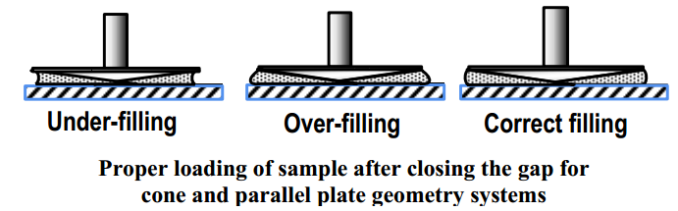
- Finally, close the oven doors and start the run.
For dispersion or polymer melts
When testing a dispersion or polymer melt when using the Peltier or Parallel Plate, go to Help > Video Clips: Loading and Trimming a Sample.
For a hard samples (e.g. hydrogels, hard polymers, etc.)
When testing pellets at ambient temperature, determine the idea geometry gap based on the volume and diameter of the material.
- Enter the sample diameter in the Geometry tab > Dimensions. Then, got to Geometry tab > Settings: Approximate sample volume.
- Adjust the gap value in Geometry tab > Dimensions until the approximate sample volume calculated by the software is as close to the actual volume as possible.
When testing a polymer pellets beyond ambient temperatures, use the 25mm stepped plates in conjunction with a melt ring to contain the pellets.
- Place the melt ring around the lower 25mm stepped plate to form a well into which the pellets are placed.
- Close the ETC.
- Set a melt temperature and allow sufficient time for the pellets to melt.
- Then lower the gap appropriately.
For Rectangular Torsion Samples
A ETC Torsion Kit is also available. For assistance with testing a solid torsion sample refer to the Instrument Help under Help > Content and Index > Index > Torsion > Guide to Sample Preparation.
- Make sure to calculate instrument compliance with a compliance sample. Go to the Geometry tab > Settings > Compliance: Calibrate.
- When closing the ETC, make sure to bend the upper moveable thermocouple approximately 1.5 to 2 mm away from the sample, ensuring it doesn’t come in contact with the geometry or sample.
Post-Test
- When run is over, if operating at an elevated temperature, set temperature value to 30 degrees Celsius and allow to cool.
- After instrument is cool, remove sample in the following way:
- Plate removal for low resistance (liquid) samples:
  - Raise head several centimeters and then holding the shaft above the top plate in place, loosen the screw at the top of the rheometer by hand.
  - Remove shaft as before.
  - To remove plate, loosen the two machine screws holding the plate to the shaft and pull plate off.
  - The lower plate can be removed by loosening the two machine screws with the Allen wrench and lifting off the stage.
- Plate removal for high resistance (gel/solid) samples:
  - Loosen machine screws on the lower plate first, loosen shaft, and then holding both the shaft and the lower plate down, and raise the head until the shaft is clear of the head.
  - Keeping a grip on both the lower plate and the shaft, remove both the lower plate and the shaft together from the stage, loosen the machine screws on the top plate, and pull the plates free of the shaft. Plates can be cleaned for future use.
- Then, reattach the bearing lock.
- After, close the AR Instrument Control Software and shut down the instrument.
- Finally, click End Session on the Launchpad software and complete the electronic notebook entry.

