Perkin-Elmer DSC 4000

Starting the DSC
- Log in to the ISU Billing software. Record your name and other information in the yellow logbook on the table.
- Turn on the DSC by flipping the large switch in the back. The green “Power” light at the front of the machine will turn on.
- Double click the “Pyris Manager Software” icon. A menu will appear at the top of the screen.
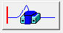
- Click the “DSC 4000” button to bring up the Pyris Software. If the software is connected, the button in the upper right corner should look like this.

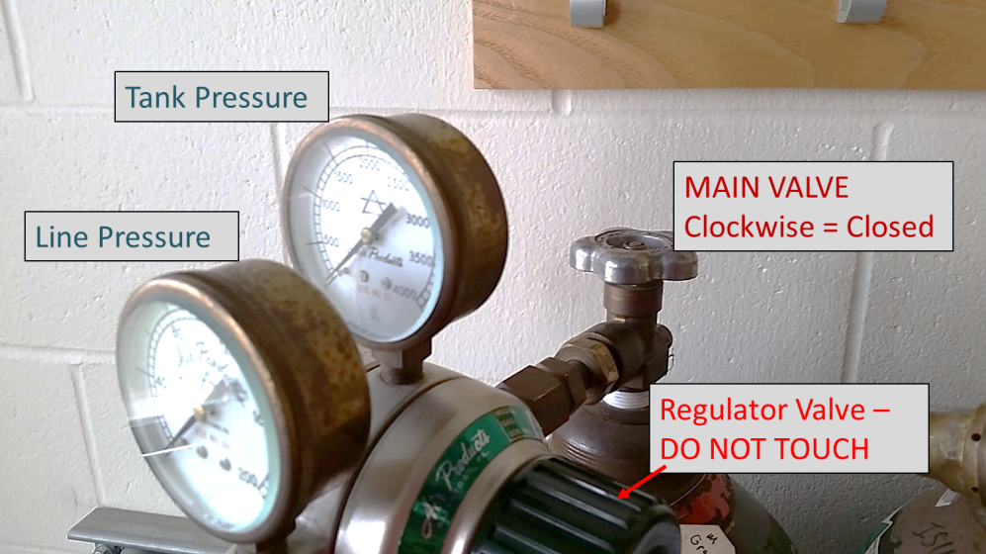
- Turn on the nitrogen gas by opening the main valve. WARNING: ONLY open the main valve. Do not touch the regulator valve.

- If necessary, turn on the intracooler (SEE APPENDIX). You must wait a minimum of 10 minutes for the intracooler to start up, and 1 hour for the intracooler to reach its coldest temperature.

Preparing a DSC Sample
NOTE: The pans currently available are meant for small amounts (5-15 mg) of solid sample.
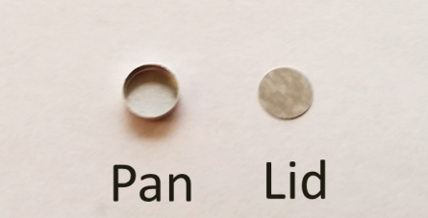
- You will need a sample pan and lid for each sample you plan to run, plus one extra pan/lid to be a reference. Aluminum pans and lids can be found in the plastic containers next to the balance. The lid should fit just inside the lip of the pan.

Reference Pan
- Using tweezers, place an aluminum lid in an empty sample pan. It should sink and lay flat against the bottom of the pan.
- Place the pan in the center of the sample crimper platform. Pull the lever arm over until it hits the rubber stopper. This will seal the pan shut.

Sample Pan
- Use the balance to measure an appropriate amount of sample. Generally, this will be 5-15 mg.
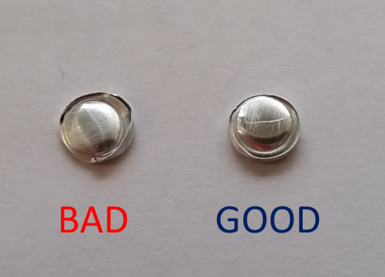
NOTE: Liquid samples require a special, hermetic sample pan.
- Place your sample in the sample pan, and place a lid on top. Do NOT overfill the sample pan.
- Place the pan in the center of the sample crimper platform. Pull the lever arm over until it hits the rubber stopper.
- Inspect the seal on the sample pan. If you see any holes, odd folds, or any sample that has overflowed, make a new sample pan.

Loading Samples into the DSC
- Using tweezers, remove the cover lid and the sample chamber lid. You will see two brass electrodes in the bottom of the sample pan.
Pan Suction Tool
- Use the pan suction tool to place the pans in the DSC:
  - Squeeze the balloon.
  - Lower the suction cup onto the pan
  - Release the balloon. The pan should now stick to the end of the suction cup
  - Squeeze the balloon again to release the pan.
The Reference pan goes on the right electrode, and the sample pan goes onto the left electrode.
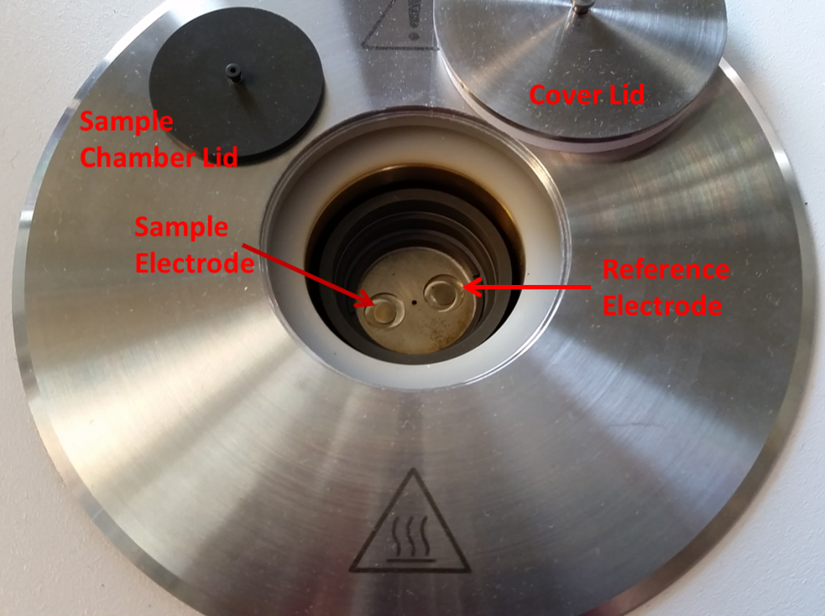

- Replace the sample chamber and cover lids.

Setting up a DSC Experiment
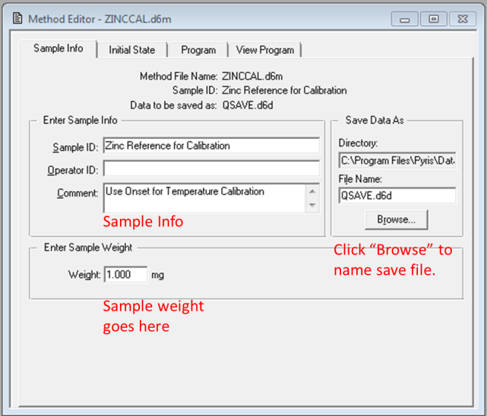
- In the Pyris Software, you should see two windows: “Instrument Viewer” and “Method Editor.”
  - Instrument Viewer – gives a live graph of the power/temperature data from the DSC
  - Method Editor – Where you set up runs for the DSC.
- Go to “Method Editor”
- Go to the “Sample Info” tab and put in all your sample information.
  - To select a file to save to, click “Browse,” go to the correct folder, and type in the desired file name.
  - The weight of your sample goes in the “Weight” window.

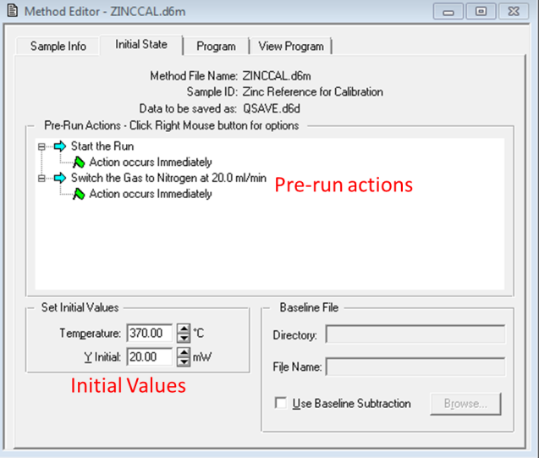

- Go to the “Initial State” tab. From here, you can set your purge gas (It is unlikely that you will need to edit that) and other starting parameters
  - Temperature: Set initial temperature
  - Y Initial: Set your initial power output. This will likely be 0.

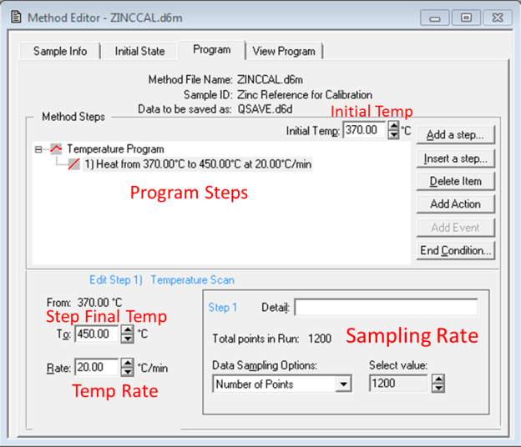
- Go to the “Program” tab to edit your run.
Options
- “Add a step” – adds a step to the end of your run
- “Insert a step” – inserts a step before the highlighted step
- “Delete item” – deletes the highlighted step
Types of steps
- “Temperature scan” – an increase or decrease in temperature at a specific temp/min
- “Isothermal” – holds the temperature at the selected value
- “Repeat Steps” – repeat steps within the program
Editing a step
- Highlight the step by clicking on it.
- In the bottom left corner, set the final temperature and a rate, if applicable.
- Go to the “View Program” tab and verify that your program is correct.

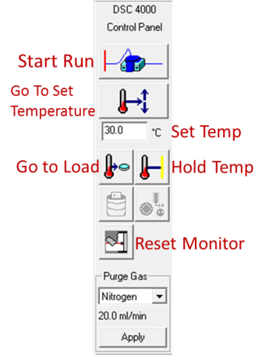
The column on the right-hand side of the screen has several instrument controls.
- Go to the “Set Temperature” window and type in your desired starting temperature. Then click on the “Go To Temperature” button above it.
- When the desired temperature is reached, allow the temperature to equilibrate. (1-3 minutes after reaching temp).
- Click “Run” to start your test.

After your test is finished
- Set the DSC temperature to 30°C. Click the “Go To Temperature” button.
- When temperature is reached, use tweezers to remove the lids on sample chamber.
- Remove the sample and reference pans using the pan suction tool. Be careful not to scratch the bottom of the sample chamber. If you choose to use tweezers, do so very carefully.
NOTE: If your sample is stuck, let your TA or lab coordinator know immediately. Do NOT attempt to dig it out of the chamber.
- Replace the lids on the sample chambers.
- If you are finished testing, turn off the intracooler by pressing the power button on the front of the cooler.
- Wait 2-3 minutes before closing the valve on the nitrogen tank. Take note of the remaining tank pressure, and let your TA or lab coordinator know if it is getting low.
- Clean your area. Throw away any old samples and pans.
- Log out of the ISU Billing Software. Double-check the logbook on the table to make sure all your information is correct.
- Turn off the DSC before leaving.

Data Analysis
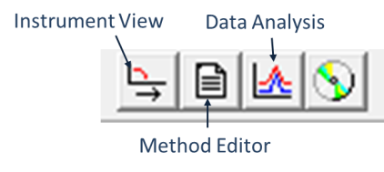
Your file will save automatically as a “Pyris Data Document” (.d6d). You will be able to find this file in the folder you specified in the Method Editor.
- Open the “Data Analysis” window by clicking the “Data Analysis” button. The program will prompt you with the file you want to open.
- To zoom in on certain features, click and drag in the plot window. This will create a pink box. Double-click on the box to zoom in.
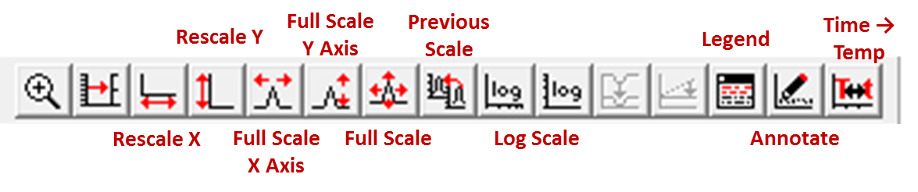
- To zoom out, there are buttons in the top toolbar, pictured below.

Melting/Crystallization Onset
Determine the onset temperature of melting, crystallization, or other thermal events.
- Zoom in on the peak of interest.
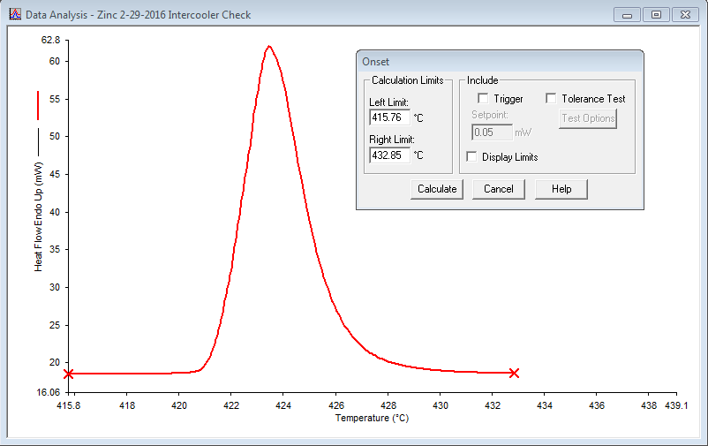
- While in the “Data Analysis” window, go to the top toolbar and click the “Calc” drop-down menu.

- Click on the “Onset” item. You will see a window like this. Two red “X”s will also appear at either end of the data.

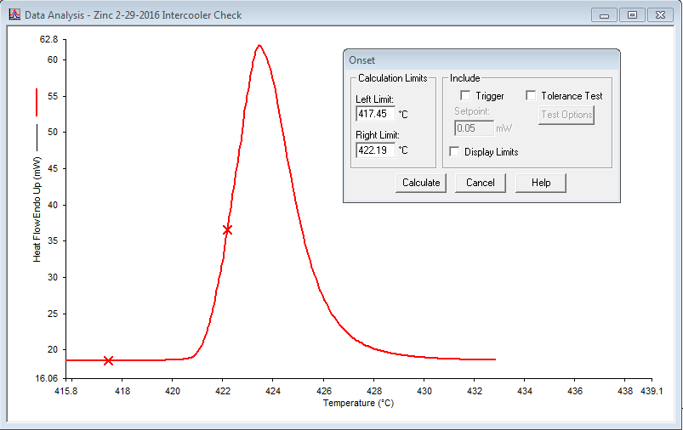

- Click and drag each “X” so that they frame the onset.

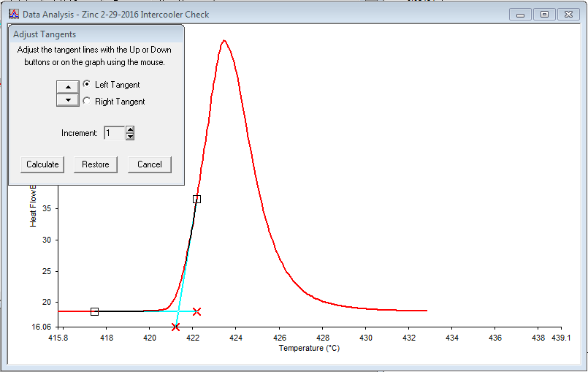
- Click the “Calculate” button. Two blue tangent lines will appear.

- Click and drag the red “X” at the end of each tangent line so that they 1) run parallel to the local data and 2) cross each other.

- Click the “Calculate” button. The onset data will appear on the graph. You can click and drag the text box if it is hard to see.
- If the feature is weak or the onset is gradual, it may be necessary to repeat this measurement. When repeating step 4, place the “X”s in slightly different positions and see if the onset temperature changes.

Glass Transition Temperature (T_{g})
- Zoom in on the area of interest.
- While in the “Data Analysis” window, go to the top toolbar and click the “Calc” drop-down menu.
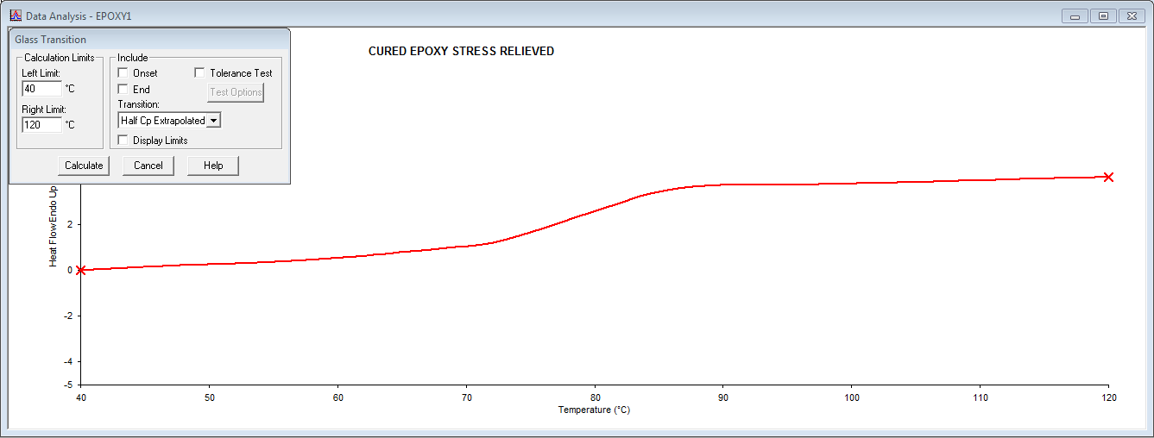
- Click on the “Tg” item. You will see a window like the one below. Two red “X”s will also appear at either end of the data.

- Click and drag each “X” so that they frame the transition.
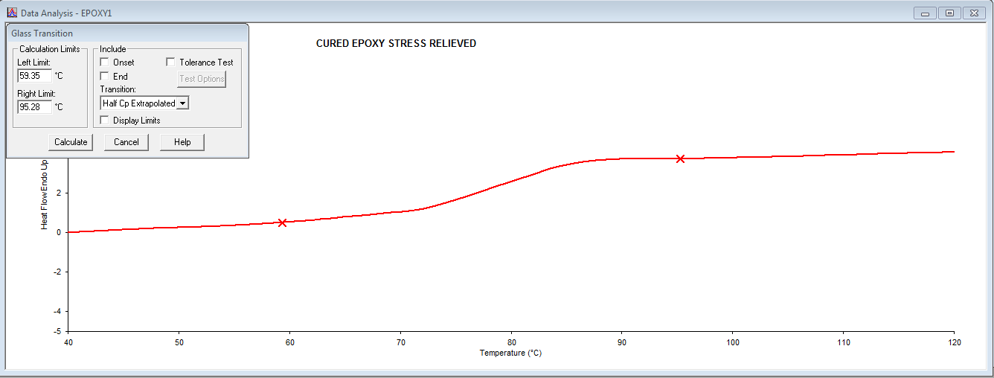

- Click the “Calculate” button. Two blue tangent lines will appear.
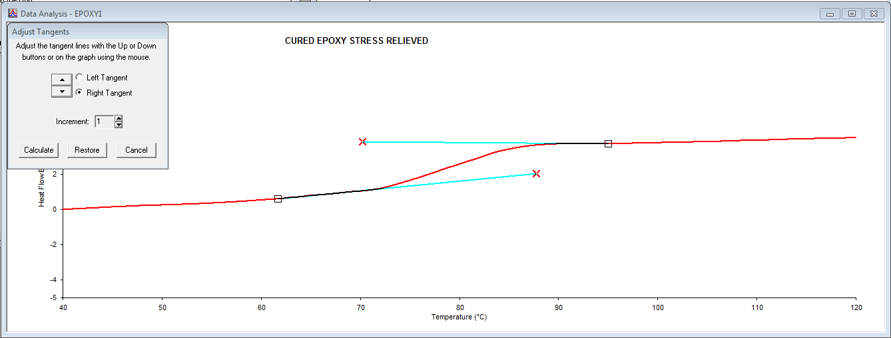
- Click and drag the red “X” at the end of each tangent line so that they run parallel to the local data. They should not cross.
- Click the “Calculate” button. The transition data will appear on the graph. You can click and drag the text box if it is hard to see.
- If the feature is weak or the transition is gradual, it may be necessary to repeat this measurement. When repeating step 4, place the “X”s in slightly different positions and see if the onset temperature changes.

Peak Area/Maximum
- Zoom in on the peak of interest.
- While in the “Data Analysis” window, go to the top toolbar and click the “Calc” drop-down menu.
- Click on the “Peak Area” item. You will see a window like this. Two red “X”s will also appear at either end of the data.
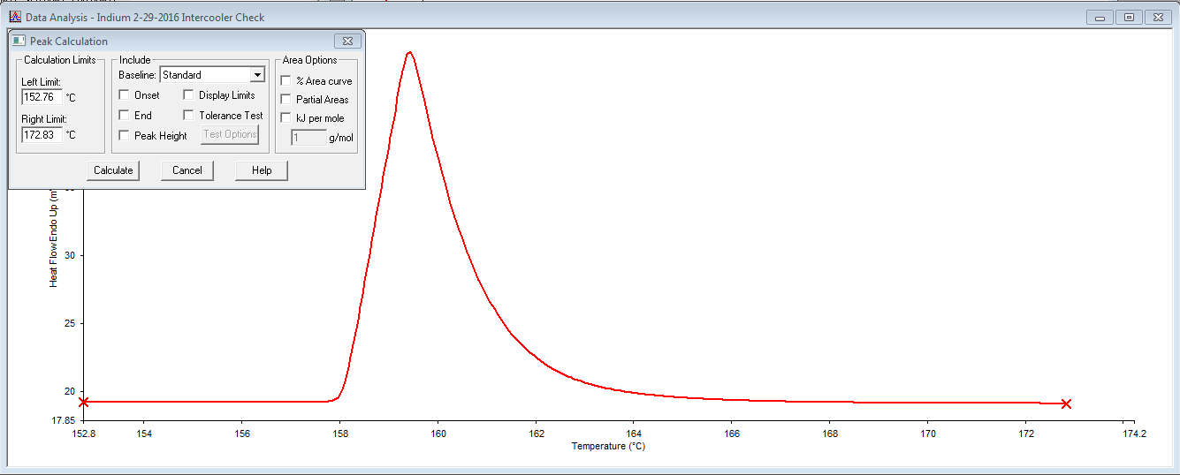
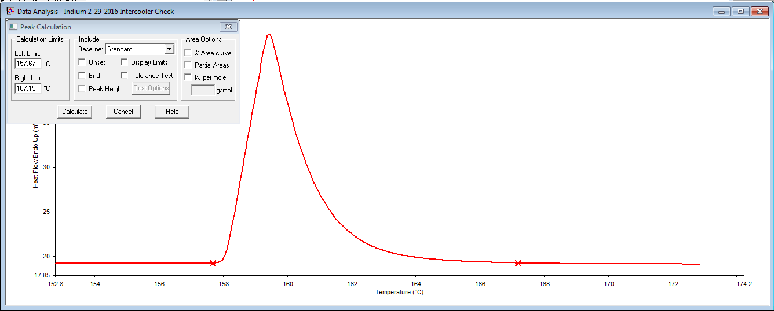
- Click and drag each “X” so that they frame the peak.
- Click the “Calculate” button. The results will appear on the window. You can click and drag the text box if it is hard to see.

Exporting Your Data
- Go to “File -> Export Data.” You can export your raw data as an ASCII file (text) or as a CSV file (Excel).
- Save your data to a flash drive.

Need help? Try the “Help” drop-down menu in the top bar.
Feel free to ask your TA or lab coordinator whenever you have a question.

APPENDIX

Perkin-Elmer Intracooler
The intracooler is an accessory that allows for cryogenic experiments and faster cooling rates.
NOTE: In order to reach its minimum temperature (-80°C), the intracooler must be turned on at least 1 hour prior to the experiment. The longer the intracooler is on prior to the experiment, the faster it will reach cryogenic temperatures.

WARNING: Do NOT turn on the intracooler if 1) the DSC 4000 is turned off OR 2) if the compressed nitrogen is not flowing to the DSC. Ice could build up in the sample chamber and has the chance to damage the electronics in the DSC.

Turning on the intracooler
- Check that the digital display is on. It should show 3 dots across the bottom of the display. If it is not on, check the power cables and the power switch on the back of the intracooler.
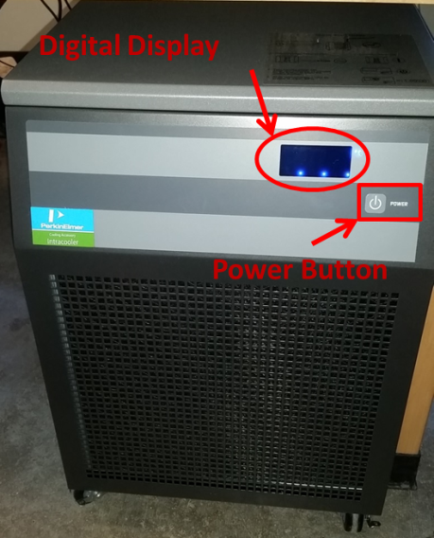
- Push the power button on the front of the intracooler. The display should flash “t04” before displaying the temperature.
- Wait 10 minutes. The machine will start to emit a low hum as the compressor starts. The temperature display will start to drop.
NOTE: On humid days, water/ice may form on the foam where the intracooler is connected to the DSC. This is ok.

Turning off the intracooler
- Press the power button on the front of the intracooler. The display should go blank, leaving only 3 dots across the bottom of the screen. You do not need to flip the power switch on the back.

