- Login to the computer using your NetID and password.
- Turn on the FTIR machine (the power button is in the front)
- Start IRSolution software. Start -> All Programs -> IRSolution
- A window may pop up asking to remove marked data. Click yes.
- Another window may pop up saying “Autoadjust required. Perform autoadjust now?” Click yes.
  - This may take several minutes
- On the top toolbar, click on Measurement -> EasyScan
  - A window will pop up with some options. Typically nothing needs to be adjusted, but you can select the range of wavenumbers scanned (in cm⁻¹).
  - Name the data file and add any comments. Then click ok.
- It will ask to execute BKG (background) measurement. Click yes.
- It will ask to execute BKG measurement again. Click no.
- Now it is time to place the sample in front of the beam. There is a triangular sample holder that can be used. Tape can also be used to hold the sample in front of the beam. (The beam is red; make sure it is going through the part you want to test).
- Once the sample is in place, close the chamber and click ok.
  - The spectrum will be acquired
- It will ask “Are you all right?” Click ok.
- Save the XPS file if desired. It contains the spectrum and lists peaks in a table.
- Now, you can export the data to a text file for use in Excel or other software if desired.
  - File -> Export. Save as (ASCII) which will make a .txt file.
- See the figure below to see what the screen should look like.
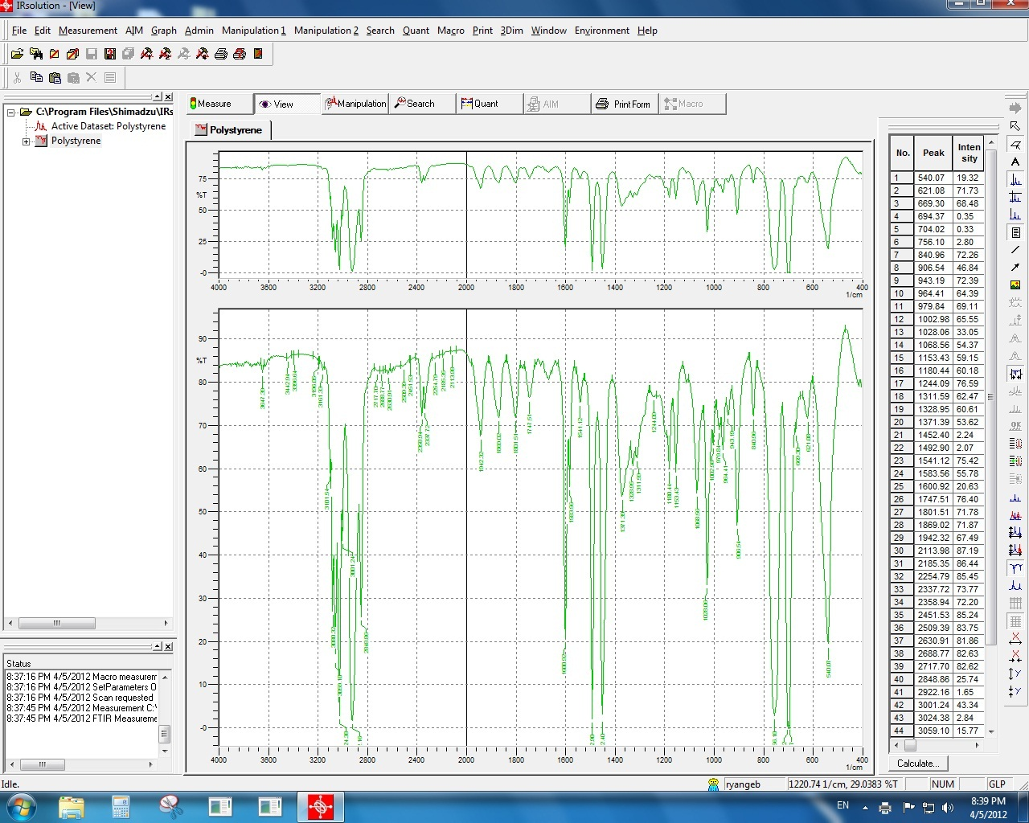
- A peak or spectrum search can now be performed by clicking on search.
  - It is recommended to try both as one may find a better match than the other.
- The Y-Axis can be changed to absorbance or % transmission by clicking Graph -> Y-axis mode -> Tra or Abs
- The blue – red = green button (circled in the image below) will put both the acquired spectrum and the matched spectrum on the same graph.
- The matched spectra will be given a score out of 1000 on how well it matches the acquired spectra (922 for this test).

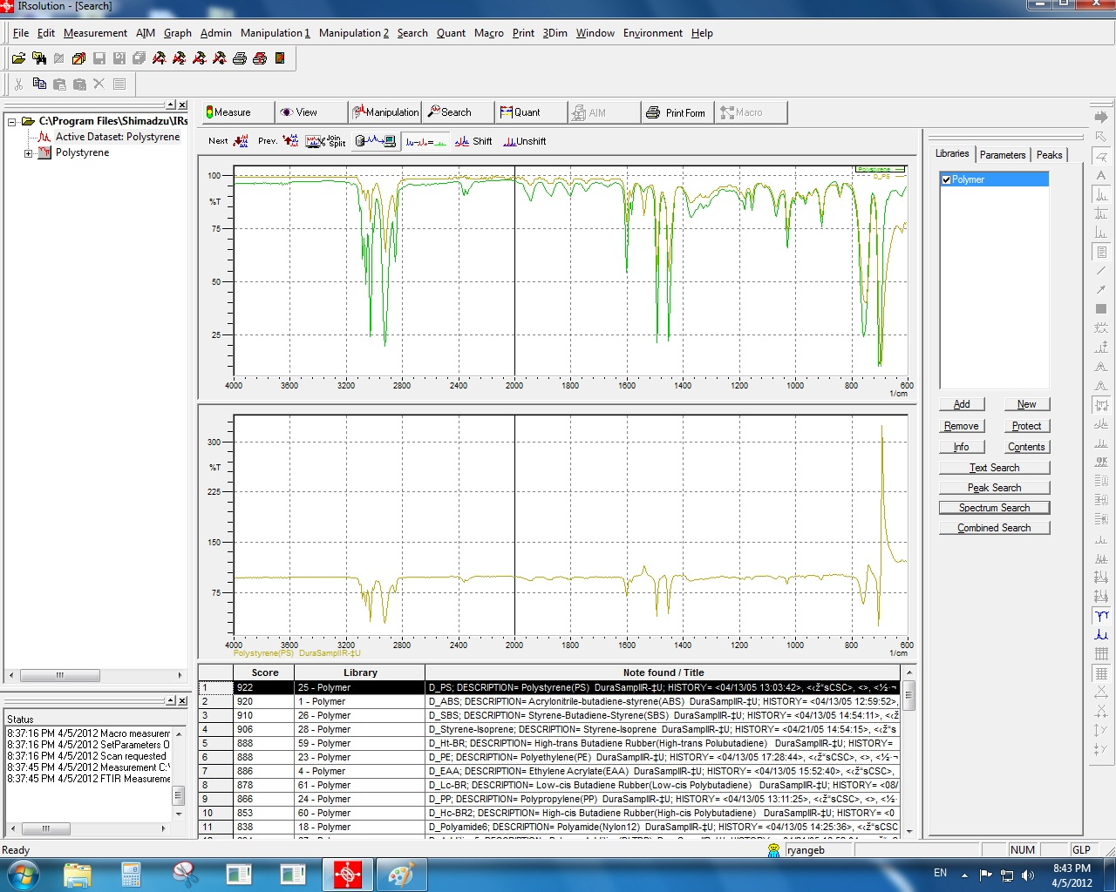

- When finished
  - Close the software
  - Remove the sample
  - Turn off the power
  - Log off

