Furnace Operating Procedure
10-16-14

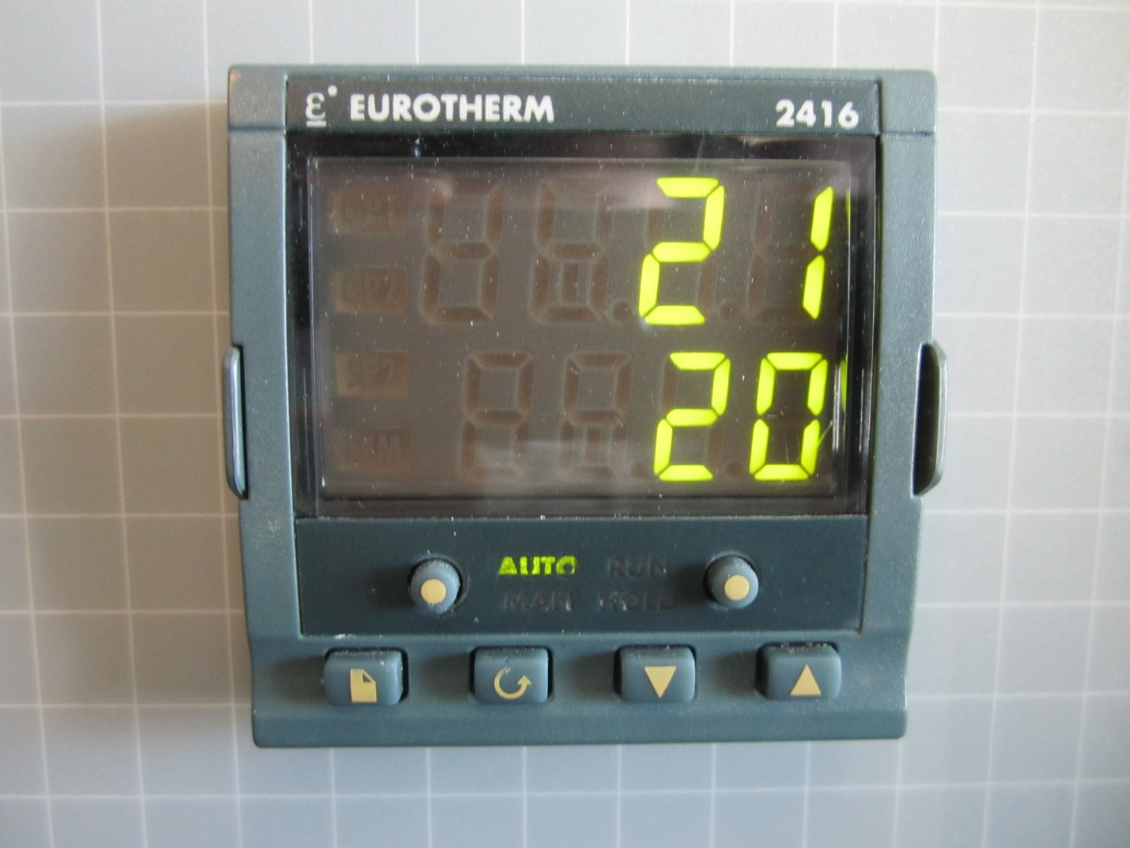

PAGE Button SCROLL Button DOWN ARROW Button RUN/HOLD Button UP ARROW Button

Procedure: (One cycle of ramping, dwelling)
- Set your sample inside the furnace. Be sure to know the melting point of your material. If your furnace run will exceed the melting point of your material, be sure to have the material in a crucible. Most likely, you will want to place your sample or crucible on a brick or slap of alumina.
- Turn on power to the furnace with the main switch.
- Preset of function units:
- Press the Page button until Prog list is displayed
- Press the SCROLL button until “rmp.U” is displayed. Rmp.U means “ramp units”. Set ramp units by selecting the unit of time over which the furnace will ramp. You can choose the units to be in seconds, minutes, or hours.
- Set “ramp” units by pressing UP ARROW and DOWN ARROW
- Press SCROLL button until “dwl.U” is displayed. Dwl.U means “dwell units”. Set dwell units by selecting the unit of time that the furnace will stay at the target temperature.
- Set “dwell” units by pressing UP ARROW and DOWN ARROW. You can choose the units to be in seconds, minutes, or hours.
- Set Ramp up step:
- Press SCROLL button until “seg.n-1” is displayed (use UP ARROW or DOWN ARROW to choose segment number)
- Press SCROLL button and set type to “rmp.r” (ramp at a rate) or “rmp.t” (ramp for a time) by pressing UP ARROW and DOWN ARROW. Ramp at a rate is most commonly used.
- Press the SCROLL button and set “tgt” (target) by pressing UP ARROW and DOWN ARROW to change temperature (this is the final temperature the furnace will reach at that ramp step)
- Press the SCROLL button and set “rate” to degrees/time unit that you want the furnace to heat at during the ramp. Each furnace should have a recommended ramp up and ramp down rate posted on the sign on the front of the furnace.
- Set Dwell step:
- Press SCROLL button until “seg.n-2” is displayed
- Press SCROLL button and for “type” choose “dwell”
- Press SCROLL button until you reach “dur” (duration) and set the dwell time by pressing UP ARROW and DOWN ARROW (The units on this were set earlier)
- Set the Ramp down step.
- It is recommended that you ramp the temperature down so that the furnace cools gently. Press SCROLL button until “seg.n-3” is displayed (use UP ARROW or DOWN ARROW to choose segment number)
- Press SCROLL button and set type to “rmp.r” (ramp at a rate) or “rmp.t” (ramp for a time) by pressing UP ARROW and DOWN ARROW. Ramp at a rate is most commonly used.
- Press the SCROLL button and set “tgt” (target) by pressing UP ARROW and DOWN ARROW to change temperature (this is the final temperature the furnace will reach at that ramp step). Set this target temperature to room temperature.
- Press the SCROLL button and set “rate” to degrees/time unit that you want the furnace to heat at during the ramp. Each furnace should have a recommended ramp up and ramp down rate posted on the sign on the front of the furnace.
- Set End step:
- Press the SCROLL button until “seg.n-4” is displayed
- Press the SCROLL button and set “type” to “End” by using UP ARROW or DOWN ARROW
- SCROLL to “End.t” If you want the run to end, be sure this is set to “stop”.
- Reset Display
- Press SCROLL button until “Prog list” is displayed again
- Press SCROLL to step through your furnace program. You will need to pause for one second at the beginning of each segment to step into that segment to see its settings.
- Press PAGE button until “Temperatures” are displayed
- Press “Run/Hold” button to start.

*Note:

- Beware to wear Safety glasses an appropriate heat protection during operation.
- Usage of “Run/Hold” button:
Press the Run/Hold for a short time to switch between run and hold; press the Run/Hold for a long time to stop operation.
- Usage of “Auto/Man” button:
This button switches the operation procedure between “Auto” Mode and “Manual” Mode. It is suggested to set Auto as default.
- Function and procedure of Run list:
“Run list” allows to switch between four operation procedures that were previously programmed. Change the run list by pressing PAGE button until “RUN LIST” is displayed---change the number by pressing UP ARROW and DOWN ARROW---Press PAGE button until “Temperatures” are displayed.

