Creating a Test Method in Bluehill 3 Software
Michelle Grawe; 12/14

Introduction

Both the Instron models 3367 and the 3369 use Bluehill 3 Software to conduct testing.

Step 1: Turning on the Instron and Bluehill 3 Software

The order in which the computer and load frame are started is important.
- Start the computer first, and log in using an appropriate IASTATE user ID.
- After the computer is started up, turn the power on to the load frame. The power switch is on the right side of the base near the back.
- Wait one minute, then log in to the billing software using your IASTATE user ID. Enter your account number and sample details, then click “OK”. This will launch the Instron Bluehill 3 software and take you to the Bluehill 3 homepage.

Step 2: Creating the Test Method
- Create a new test method by clicking on Method and then choosing “New Method” in the upper left hand corner. You will then see this screen:

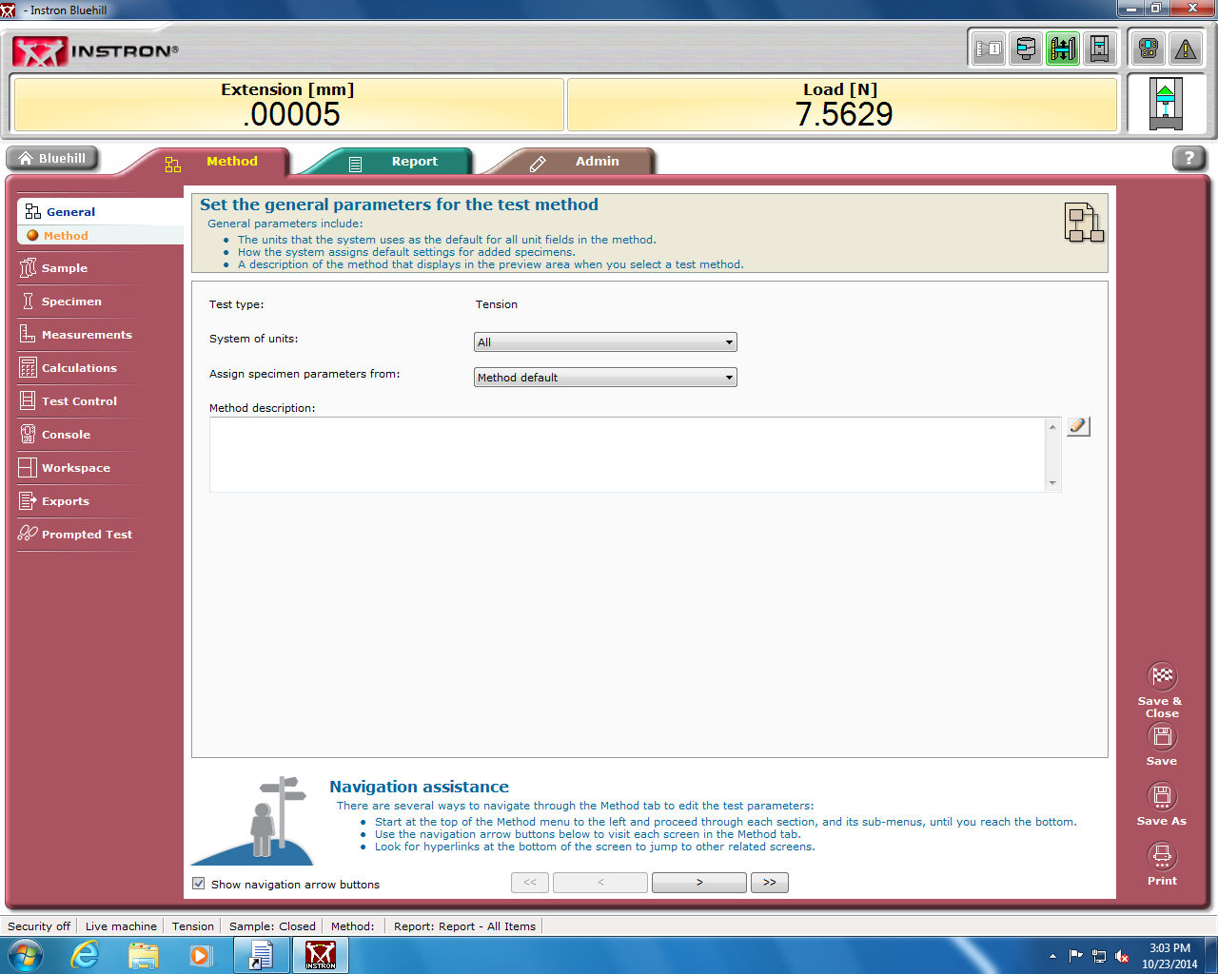

- Notice the different categories in the left hand column. Clicking on the name of each of these Sections “General, Sample, Specimen, Measurements, etc” will open up a different section to complete the method. Each section has its own sub sections to step through. It is recommended that you step through each section and subsection to be sure you don’t miss inputting important information for your method, although it is not necessary to fill out all subsections.

- For the Sample section, remember that “Sample” means a group of specimens. If you are testing 20 dog bones, then your Sample size is 20. Each piece being tested is a specimen. So your sample would contain 20 specimens. The Sample section pictured blow is intended for you to input specific qualitative data about your sample. This information can be used later in the Report that may be generated.

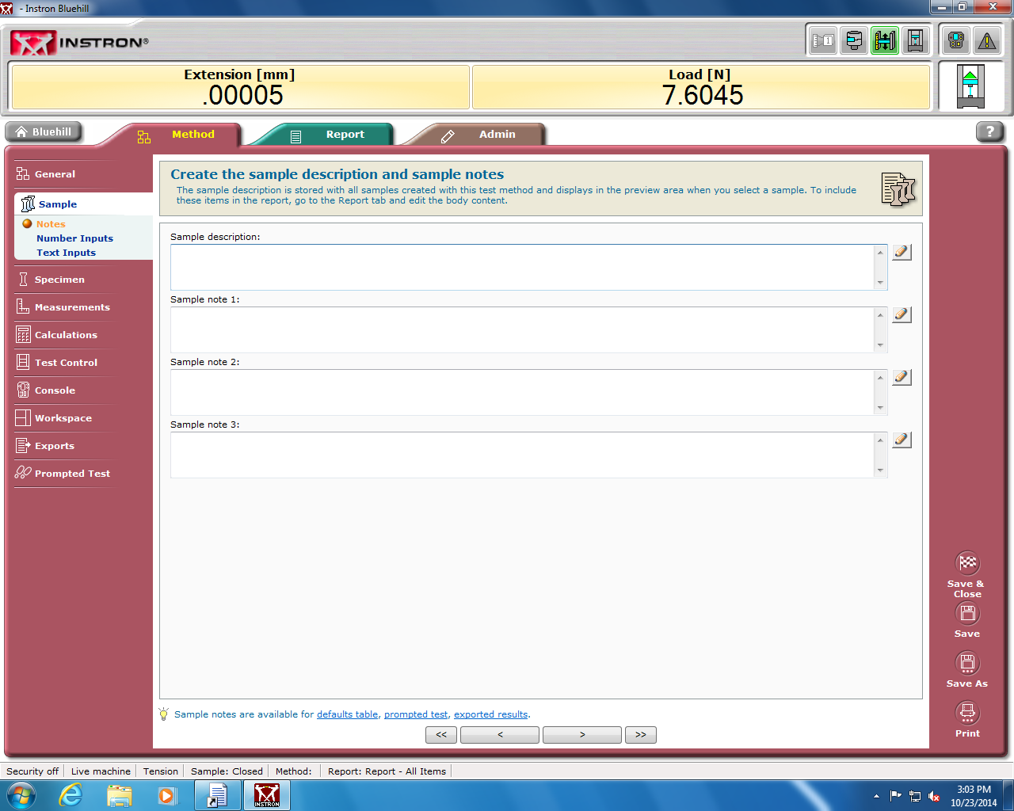

- In the Specimen section you can input data on the geometry of the specimen, label the specimen and use the Inputs subsections to choose extra input data about your specimen. The Number, Text, and Choice Inputs you define can be used later in the Prompted Test Section. Certain outputs may already use these inputs, or you can later specify in the Workspace and Exports sections how you want the geometry data to be used.

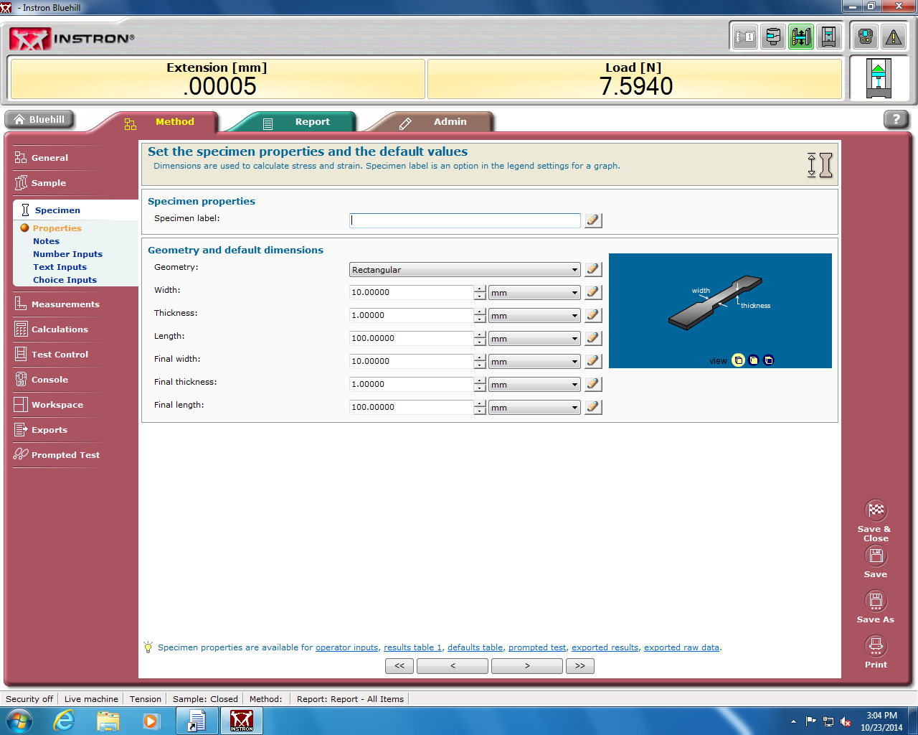
- In the Measurement section and in the Calculations section, you can specify which measurements you want the method to use and complete. Certain testing methods already have default measurements and calculations that are used, so use these sections to include more if needed.

- In the Test Control section,

The Tensile Specimen

Figure 2 shows a tensile specimen. The grip section (either threaded or flat dog bone) is where the load frame grabs the specimen and applies the load. The gauge length is the constant diameter section in the center of the specimen. This will always be the thinnest section of the specimen; therefore, deformation will occur here. The gauge length of the specimen has a cross-sectional area that the load will be applied across, generating a stress.

Cross
Section
Gauge
Length

Grip Section

Figure 2: Schematic of a standard tensile specimen

Step 1: Start the Computer and Machine

Step 2: Software Setup
- Once inside the test method of choice, enter a sample name. Your sample is the entire body of specimens that you will test. A specimen is one single item tested such as a dog bone or threaded specimen
- You can either let the data be saved in the default file or click on browse to specify an output file. For a class, check your lab manual for a folder specified by your instructor.
- Click on the Load Cell soft key 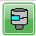. In the window that opens, click the “Calibrate” button to calibrate the load cell. When the cell is done calibrating, the screen will blink and options will again become available. Close the pop-up window. The load cell needs to be calibrated upon start up at the beginning of each day.
- The extensometer is a device for measuring strain more accurately in your specimen than crosshead displacement. The extensometer is a transducer with two knife edges attached that contact the specimen. If you will be using the extensometer, click on the extensometer soft key 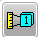. Hold the extensometer by pressing in the two button-sized round pins. This will fix the extensometer knife edges at exactly 25mm. Keep these pressed together and click on the calibrate button. Keep pressing the buttons together during calibration. When the screen blinks and options again become available, the extensometer is calibrated and the pop-up window can be closed. Now you are ready to load your specimen.
- From the test page, click on the Method tab. Under the Specimen menu, enter the specimen dimensions. Measure the gauge length and gauge diameter of your specimen. It is recommended to take three measurements of the gauge diameter up and down the gauge length and take an average. Click on save (lower left corner) and return to the Test tab.

Step 3: Loading the Specimen
Threaded Grips
- Insert the top specimen grip into the load cell and secure with the steel pin.
- Insert the specimen in the top specimen grip. Screw the specimen into the grip, but leave one thread outside the grip so that if the specimen breaks near the grips the specimen can still be removed.
- Insert the specimen in the lower grip (the lower grip should not yet be inserted into the load frame). Lift the bottom specimen grip up and rotate the large nut until the specimen has one thread outside the grip.
- Carefully move the crosshead down manually, ensuring that the bottom of the specimen grip fits within the available hole on the console until the steel pin can be inserted. Be careful not to lower the bottom specimen grip too far as this could jam the grip into the load frame, damaging these items.
- Slide the steel pin through the hole at the bottom of the grips, connecting the load frame to the specimen grip. Make sure to use the steel wire safety clip so that the pin is unable to violently eject from the load column.

Clamp grips
- Install both the top clamp grip and the bottom clamp grip into the load frame with the pins.
- Insert the specimen in the top grip. Hold the specimen vertical such that the bottom of the grip section is about 2mm outside the grip, and tighten the top clamp. Be wary when tightening to not bend your specimen.
- Lower the crosshead manually until your specimen is in a position where the top of the bottom grip section is about 2mm outside of the grip and tighten the bottom clamp. Again, be careful not to bend your specimen during tightening.
- Ensure that both clamps are tight.

Step 4: Equip the Extensometer (optional)
Equipping the extensometer is discussed following.
- Keeping the extensometer buttons pushed in, with two fingers, pull the two spring clips back and slide the extensometer over the gauge length of your specimen. WARNING! Do NOT drag the knife edges across your specimen, rather get the extensometer in place then release the spring clips. Try to keep the body of the extensometer either parallel or perpendicular to the crosshead.
- Release the two button-sized push pins.

Step 5: Starting the test
- Balance the load on the specimen by clicking on the load cell soft key . Click on balance, wait for the load to show zero (or close to zero), and click OK.
- Zero the extension. Click on the extension soft key . Click on balance, wait for the extension to show zero, and click OK.
- Balance the extensometer. Click on the extensometer soft key . Click on balance, and click OK.
- Start the test by clicking on the green “Play” button. The crosshead will move at the rate specified until the end conditions of the test are met or the test is stopped manually. If the end-of-test conditions are met, the screen will return to the beginning-of-test screen.
- Remove the extensometer from your specimen by pulling the spring clips back.
- If the specimen is broken, remove the pieces. If the specimen is stretched, look at the load reading. Jog the crosshead from the load frame until the load is close to zero. You should now be able to unload the specimen.
- Load the next specimen and begin the next test. The number of specimens in the sample should already be designated in the Method.

Step 6: Ending the Test
- When you are finished testing all specimens, click on the Finish button.
- A pop-up window will ask if you would like to continue testing using the same method, click “No”, and you will be returned to the Bluehill 3 homepage.
- Look for and retrieve your data from the appropriate data file specified at the beginning of the test.
- If no more tests are being completed, shut down the software by clicking “Exit”, and turn off the power to the Instron device. It is vitally important that you do not leave the Instron powered when it is not in use.

