- Wheel the table to the computer across from the Scintag XRD
- Turn on the computer and log in
  - Username: Administrator
  - Password: rigakuisu
- Load the sample before powering up the machine
- If measuring powder, use double-sided tape to attach a thin film of powder to the sample holder. To prevent peaks from the sample holder itself, use one of the ring-shaped sample holders instead of a disk (a disk was used in the picture below and background peaks were found). *Sample prep can probably be improved*
- 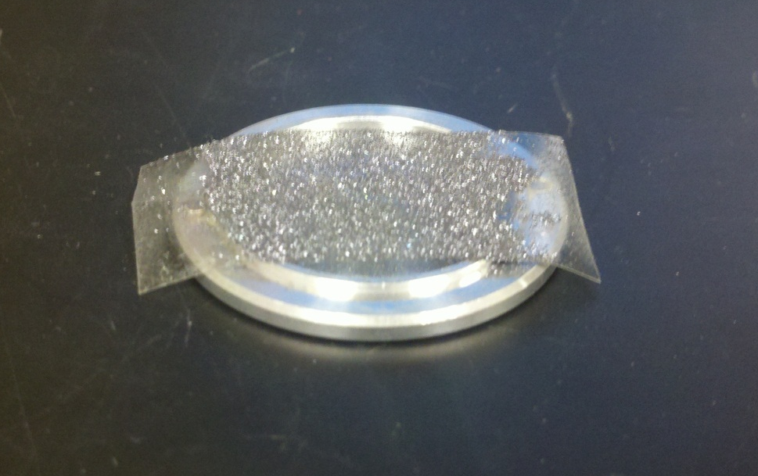
- Plug in the power strip attached to the table
- Turn on cooling system located on the bottom of the table
- Attach cable from the computer to the back of the XRD system
- Flip the switch on the back of the XRD up
- Press power button, which is also located on the back (Make sure the emergency button on front is not depressed)
- Open the Standard Measurement software
- Click measurement conditions and set parameters such as start and stop angle, and also scan speed (measured in degrees/min)
- Click close
- Set directory, file, and sample name
- Turn on the X-ray (button on front of machine)
- Wait ~1 minute and then click start measurement
- The scan will take some time depending on the angles scanned and scan speed
- The data is automatically saved into a .raw file
  - This needs to be opened in the Jade software, and can then be saved as a normal .txt file
    - Do not “delete” anything in the Jade software as it actually deletes the original file!!! It does not simply remove it from the program.
- Turn the X-ray off (button on front)
- Flip the power switch in the back
- Unplug from the computer
- Let the cooling system run for a couple minutes after turning the X-ray off
- Turn off the cooling system
- Unplug the power strip and wheel the system back to its normal location
- Shut down the computer
- The spectrum acquired from the silicon on tape with a disk sample holder: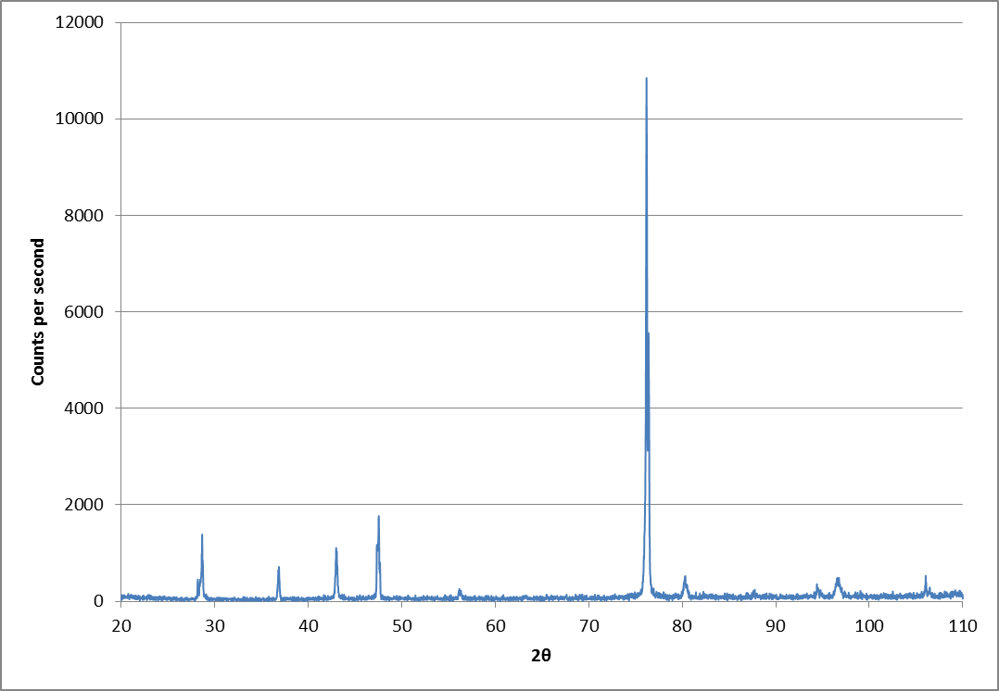The circled peaks are extra and not from Si. They are most likely from the sample holder. There is also a missing peak around 68 degrees which could be due to the thin layer of powder and possibly some preferred orientation of the powder.

