TA Instruments TMA Q400
Standard Operating Procedure
Updated: 4/4/2017

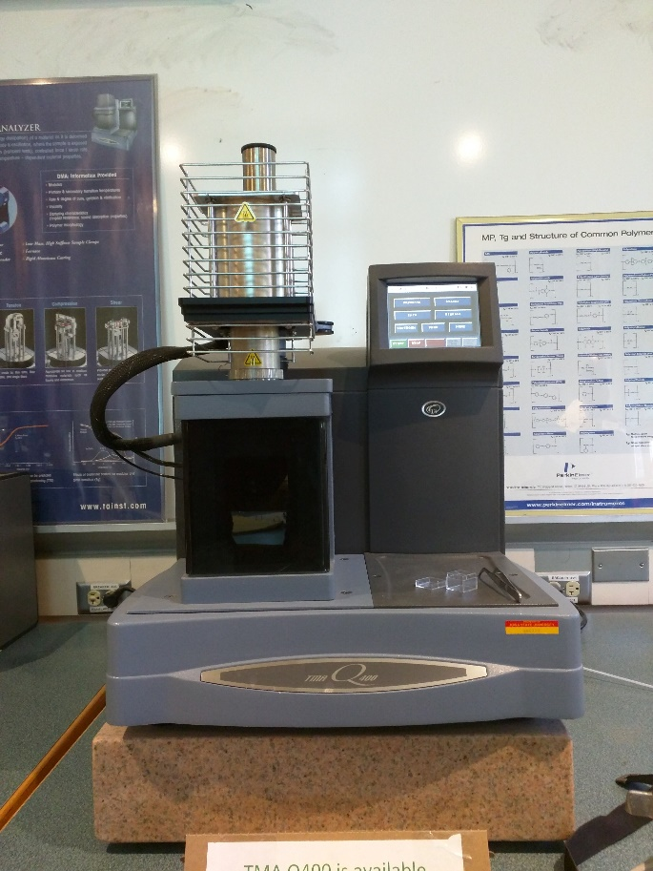

About Thermomechanical Analysis (TMA)
TMA is an analytical technique that measures thermal properties, such as the coefficient of thermal expansion (CTE) and glass transition temperature (T_{g}), of a polymer based on changes in its free volume due to changes in viscoelasticity, material aging, and exposure solvents.
Sample Preparation
- The TMA Q400 can analyze both hard (i.e. glassy polymers, metals, ceramics, etc.) and soft (i.e. powders, irregularly shaped samples, etc.) materials by attaching an expansion or macro expansion probe, respectively.
  - The expansion probe is attached by default.
  - Please contact the lab coordinator if your sample requires use of a macro expansion probe.
- The TMA Q400 can accommodate a sample with a maximum cross-sectional area of 25 mm² and a height from 2 to 10 mm.
  - Measure the height of your sample using a caliper.
  - Contact Lab Coordinator to verify if your sample will fit on the stage prior reserving time to use the instrument.
Instrument Start-Up
- The TMA Q400 operates using a purge gas, usually nitrogen or helium, which are shared with the DSC Q2000.
  - Check the gas level to ensure uninterrupted flow during analysis. The secondary regulator gauge should be at least 10 psi to reach the minimal operational flow rate of 50 ml/min.
  - To switch between gases, manually transfer the 1/8” diameter tubing attached to the quick-connect fitting on the gas regulator. Push on the small black ring to eject the tube.
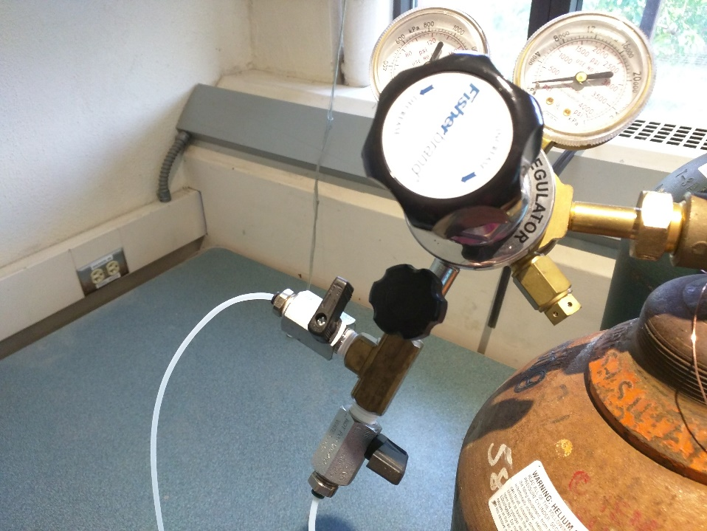
To DSC Q2000
To TMA Q400
  - Then, open the secondary regulator feed valve (parallel to tube fitting) leading to the TMA.
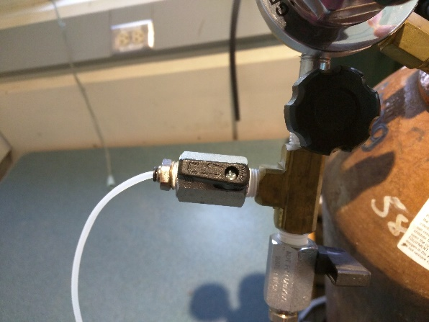
- Please sign into lab notebook on the center table in the room. Then, log onto the TMA computer using your ISU NetID. The Launchpad billing software will open.

  - Click the Login button that appears on the screen.
  - The first time you use the software you will get another window asking if you are using an ISU NetID or an external account. Leave it on the default of ISU NetID then click Continue.
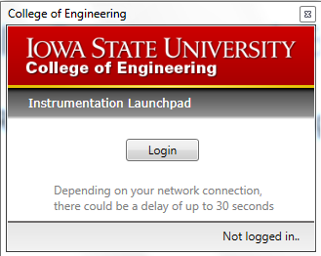
  - Enter your username and password.
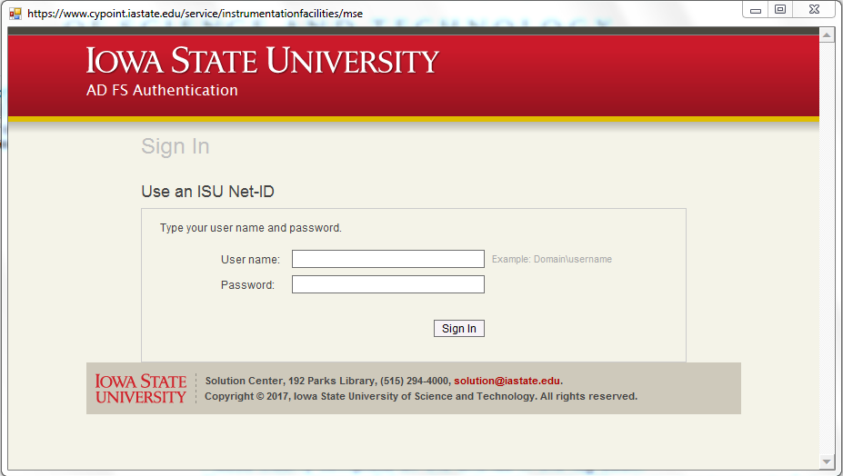

  - Enter your account number, supervising professor, sample description, experiment description, and click next. (NOTE: The account number will auto format so just enter the numbers and it will enter the dashes for you)

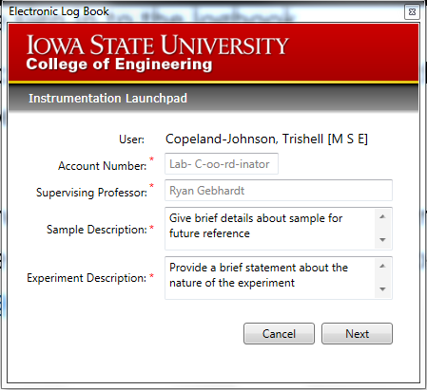

- Once this information is entered, the TA Instrument Explorer button will be displayed.

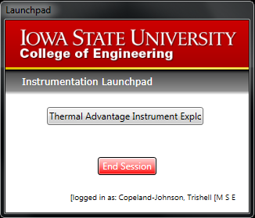

- Click to open the TA Instrument Explorer and select the Q400 icon. If the computer successfully connects with the instrument, an audible beep should be heard and a yellow plug symbol will appear at the top left hand corner of the instrument’s icon.
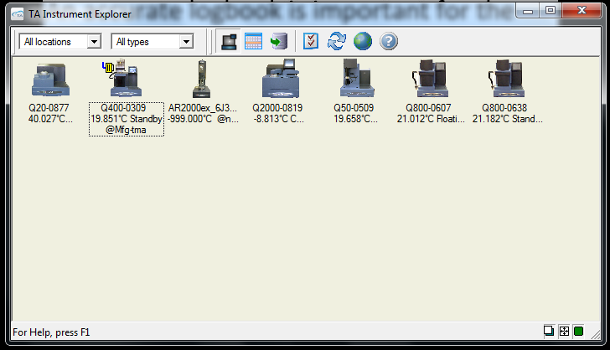

- Upon selecting the instrument, a Q Advantage window will appear. Q Advantage is the graphical user interface used to operate the TA Instrument suite.
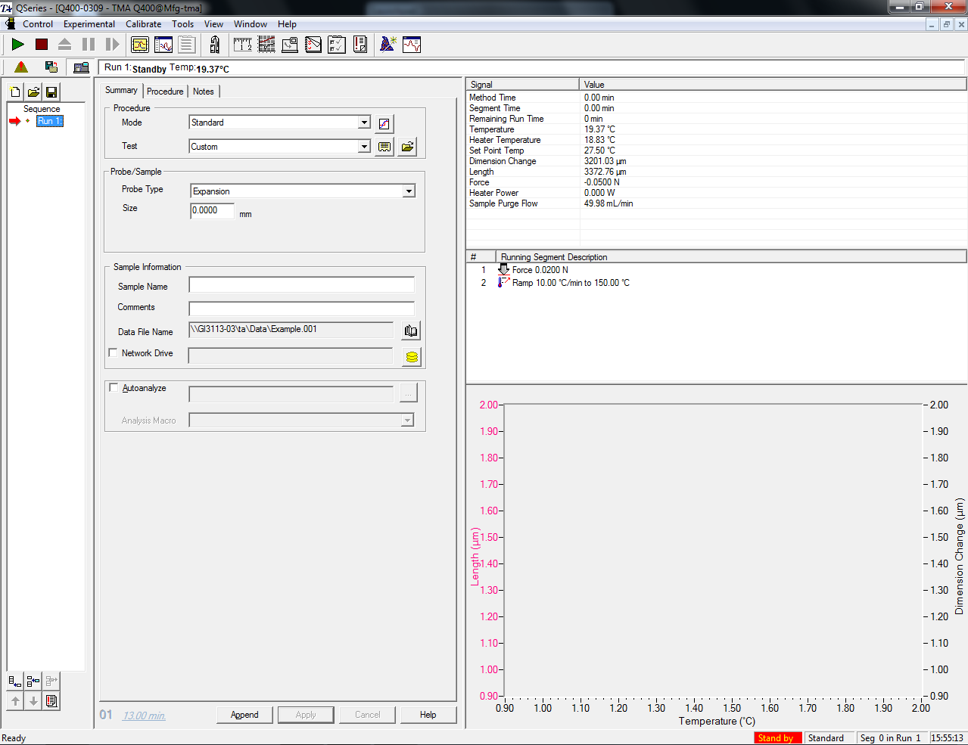

- Check the Signal Display Pane to ensure purge gas is properly flowing
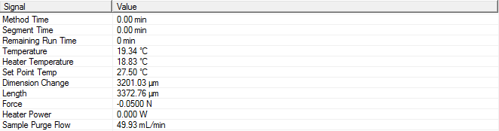

Experimental Design Setup

- Start with the Summary Tab in the Experiment View Pane
  - Under the Mode drop-down box, select Standard
  - General operation of the instrument requires developing a customized method on how to analyze the sample. Therefore, under the Test drop-down menu, select Custom.
  - Enter a descriptive sample name
  - Under Probe Type, select the expansion or macro expansion probe in accordance with that installed on the TMA.
  - Do not enter any values into the Sample Size field. The instrument will automatically measure the height of the sample.
  - Enter any additional comments, if applicable.
  - To setup the file path for where the data will be stored after the experiment is completed click the hard drive button adjacent to the Data File Name line.
  - Leave the Network Drive and Autoanalyze unchecked.
- Next, select the Procedure Tab
  - Again, under the Test drop-down menu, select Custom.
  - If there are any additional notes pertaining to the method, enter them in the Notes field.
  - Since the Test type is Custom, the Editor window can be displayed in the Method section by clicking the respective button.
    - Measuring CTE and thermal history
      - Ramp from 30°C to above the glass transition temperature (T_{g}) at 5°C/min.
      - Once the sample is cooled back to starting temperature, it can be heated subsequently to collect additional data that is independent of the sample’s thermal history.
        - Cooling at 5°C/min is possible above 100°C.
        - From 30 to 100°C the cooling rate must be below 3°C/min since the instrument is not equipped with a cooling accessory.
    - DO NOT go near or above the melting or decomposition temperature of the sample.
  - Finally, set the Pre-load Force to 0.02 N.

- Finally, go to the Notes Tab
  - Include your name and any additional notes in the Name and Extended Text fields, respectively.
  - Select the purge gas from the Sample drop-down menu and desired Flow Rate in mL/min the Mass Flow Control Settings section. (NOTE: Minimum flow rate for operation is 50 mL/min.)
- To save any changes made in each tab and finalize the run, click the Apply button at the bottom of each tab.
- To save current changes and add another run to your analysis, select the Append button at the bottom of each tab.

Sample Loading

- Before loading the sample, the probe needs to be zeroed to ensure accurate measurement of sample size. Go to the Control menu at the top of the screen and select Zero from the Length option.
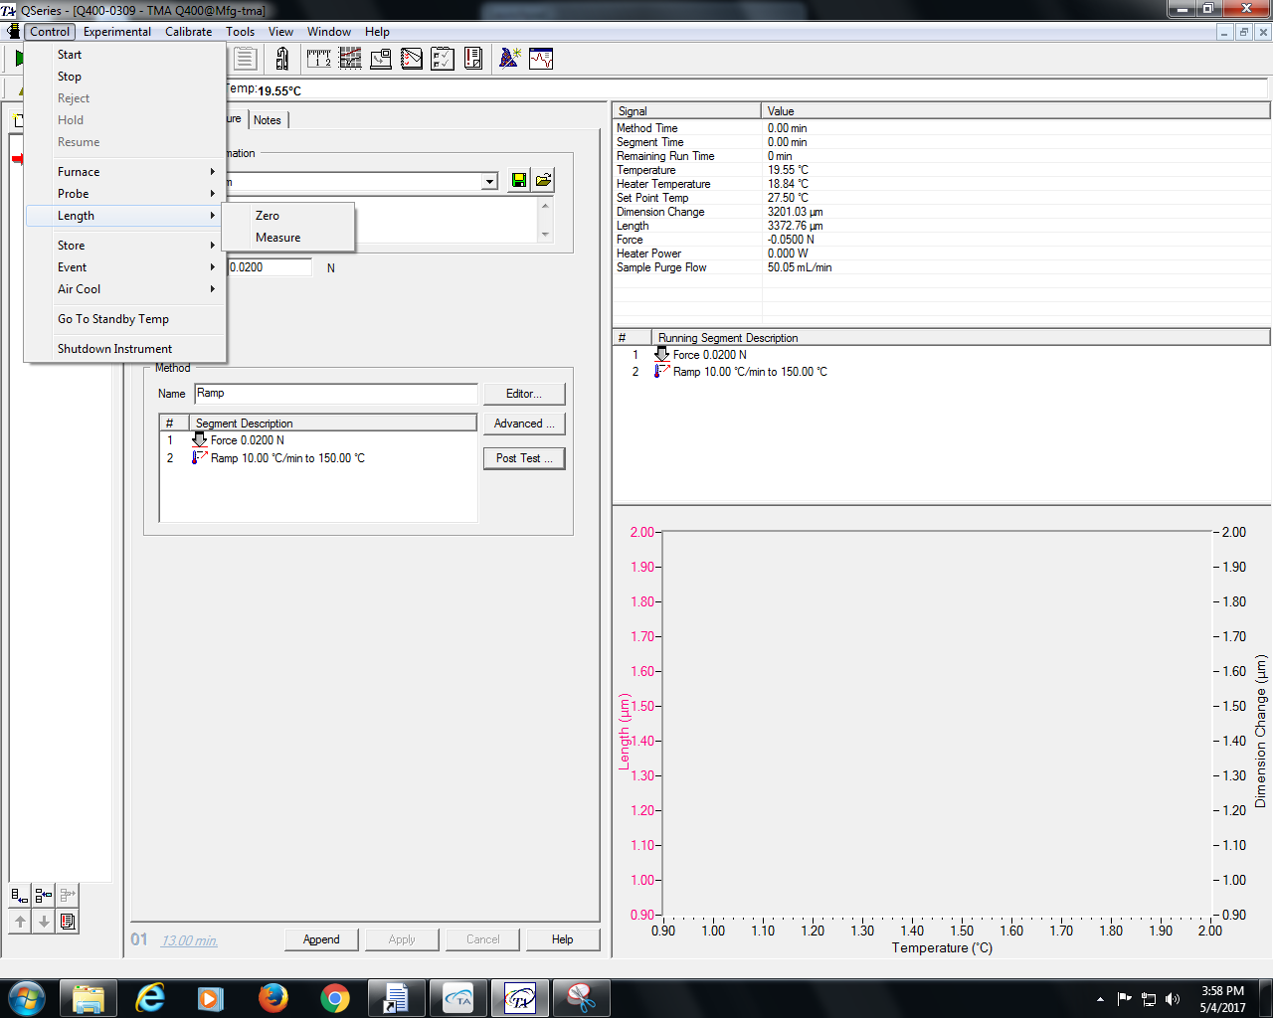

- The probe will lower automatically until it makes contact with the platform.
- After, go to the Probe option and select Up from the Control menu. The probe will rise to a pre-programmed height. NOTE: If the height is too small, go to the instrument panel and transition from the Display Menu to the Control Menu button. After, select Probe Up.
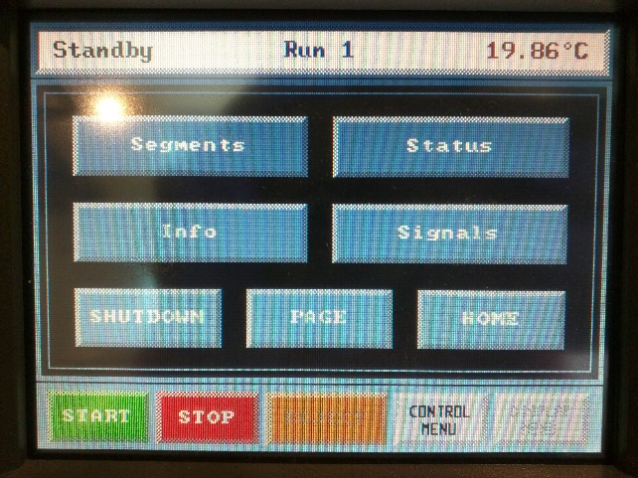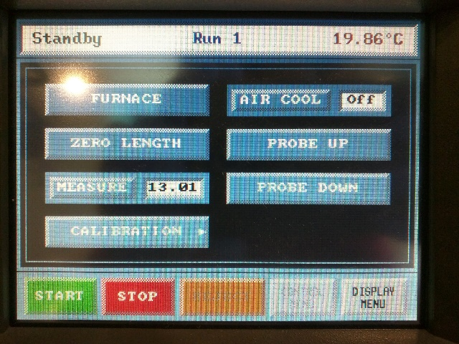
The probe will continuously move until the Stop button is selected. After reaching the desired height, load the sample.

- Use tweezers to place the sample onto the quartz stage, ensuring that it is centered below the probe but DOES NOT make contact with the thermocouple on the quartz stage.

- After, select Down from the Probe option in the Control menu in the QSeries software.

- Once the sample is loaded, verify that the set pre-load force is being applied. Then, press select Measure from the Probe option in the QSeries Control menu. The instrument will enter the sample height in the Sample Size field under the Summary Tab.
- After, from the QSeries Control menu, go to Furnace and then select Close.
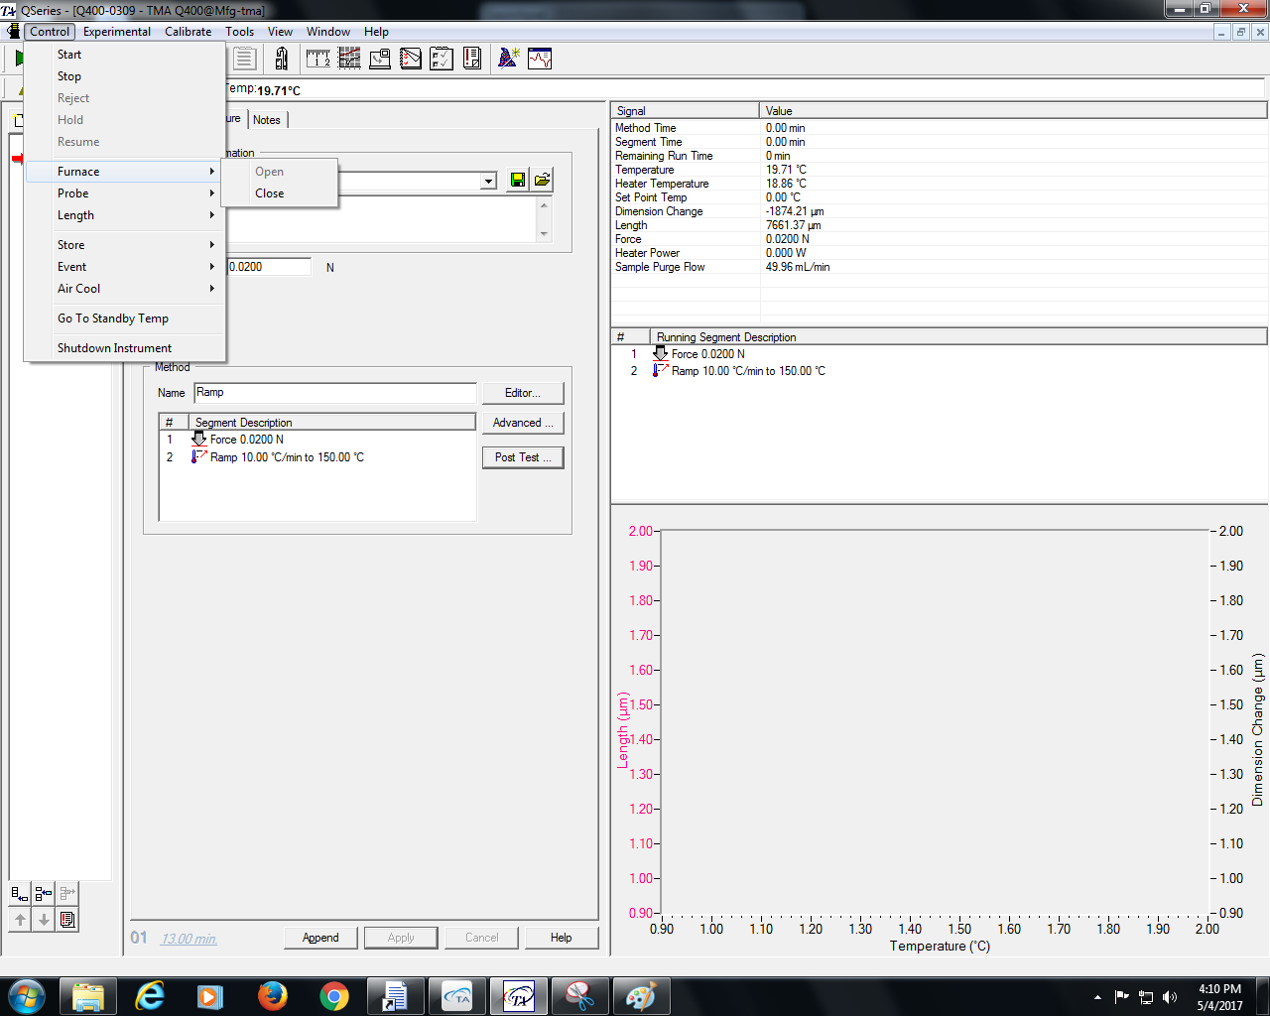
- Finally, start the experiment by pressing the Start the Run green button in the upper left corner of the screen.

Post-Test

- Once the run is complete, allow the furnace to cool before retrieving the sample. From the Control menu:
  - Select Control, then Furnace, and choose Open
  - Then, go to Control, then Probe, and finally Up
- Remove the sample using tweezers.
- Close the Q Advantage software and log off the computer
- Finally, close the TMA purge gas valve. DO NOT close the cylinder valve as this may interrupt operations being performed on the DSC Q2000 by other users.
- Close the QSeries software.
- Click End Session on the Launchpad software and log off the computer. Complete the Electronic Log Book.

