Perkin Elmer TGA 7 Calibration SOP
(Temperature Range: 30ºC-900ºC)
(Revised: 4/11/2017)

TGA 7 Calibration is performed with two reference standards, three 2” segments of 99.99% nickel and iron wire (Lot No. 072898ES and 061893, respectively), and a calibration magnet that are included in the instrument’s accessories kit. The following procedure is applicable when the standard furnace tube is equipped to the instrument. This procedure can be used with a high-temperature furnace tube but requires a compatible magnet.

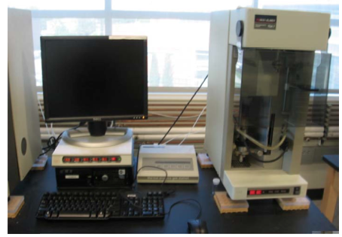

- Please sign into the logbook located on the table between the TGA and the DSC on the North wall of the lab. Write down the date, your name, the instrument used, what sample is to be run, and the temperature program (range and heating rate). Also indicate how many runs are performed and any problems that occur during use.

Please Note: If the system is shut off, the order in which the items are powered up is important. If they are not done in the proper order, the data system will not be able to communicate with the instrument. Please follow these steps in the exact order when powering up the system.

Using the TGA
- Open the valves on the Nitrogen gas and Air cylinders (lefty loosy) located on the North wall of the room.
  - The pressure should read 35 psi for the Nitrogen
  - For the Air it should be 40 psi

THE NEXT TWO STEPS ARE ONLY IF THE MACHINE IS OFF WHEN YOU START
- Before turning on the power to the TGA, check to make sure the “Master” switch on the computer panel and power switch on the instrument are turned on. Then, turn on the power to the TGA using the switch labeled “Computer”/“TGA 1” (or “Aux1”/“TGA 2”). Note that the furnace will automatically move out of its dock.
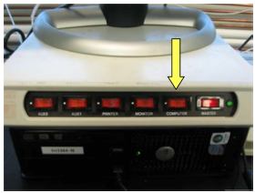

- Turn on the power to the Thermal Analysis Controller (TAC) labeled “TGA 1 TAC”/“Monitor” for TGA 1 or “Aux2”/“TGA 2 TAC” for TGA 2. Note that the furnace will stow back into the dock. Then, the “Control” and “Ready” lights should stay on for TGA 1 or 2.
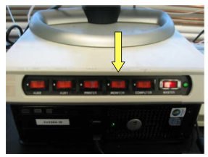

- The Launchpad billing software will have opened upon login. To use this software:
  - Click the Login button that appears
  - The first time you use the software you will get another window asking if you are using an ISU NetID or an external account. Leave it on the default setting of ISU NetID then click Continue.
  - Enter your username and password: it will verify
  - Enter your account number, supervising professor, sample description, experiment description, and hit next
    - Note that the account number will auto format so just enter the numbers and it will enter the dashes for you.
  - The software will then show you a “Pyris” button, click this to launch the software.
- With the Pyris Manager software open, you will see a menu bar at the top of the screen when you move the mouse all the way up. This will indicate that both TGA instruments are offline. Click the TGA instrument you will use in order to connect the instrument and the software.
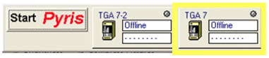
You should see temperature status information if everything is working.
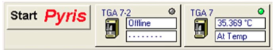

- The “Start/Stop” button should look like 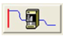, if it looks like 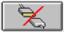, it means the software and instrument are not communicating. Click the button once to initiate communication.
- Go to the gas control station. Enter the following sequence; the buttons will change after each input: run—manual—N₂ or Air—start. The flow rate display will flash for a few moments while in editing mode but no further action is necessary after starting flow.
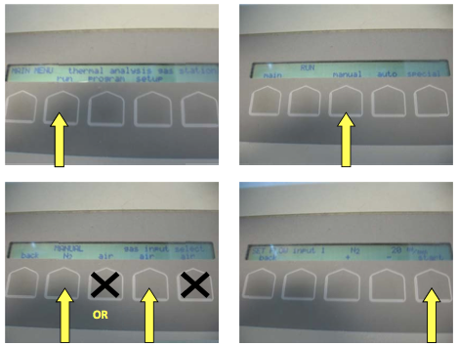

Temperature Calibration
Performing a temperature calibration
- From the Method Editor
  - Go to the File menu and select Open Method
  - Choose the method labeled “Nickcal.tgm”
  - Complete the Sample ID, Operator ID, Comment entries under the Sample Info tab.
  - Select a file path to save the data under File Name.
- Next, place a 1-2 mm long sample of nickel into a sample pan.
- Select the Raise Furnace button. Once the weight has stabilized, tare the pan by clicking the Zero Weight button.
- A magnet will be used to measure an apparent weight, spurred by the magnetism of the nickel. Position the magnet onto the sample loading platform, surrounding the furnace and adjust the height until the weight reads 3 to 6 mg.
- After the sample reading stabilizes again, click the Sample Weight button. The instrument will automatically enter a value into the Sample Weight field on the Sample info tab.
- Select Start Method to complete the calibration on nickel.
- Repeat steps 1-6 for Iron, using the method file titled “Ironcal.tgm”.

Analyzing temperature calibration data
A common calibration method for TGA is the comparison of the observed and actual Curie temperature (T_{c}). The T_{c} is the onset to which the material becomes susceptible to an induced magnetic field. For nickel and iron, the T_{c} at 354°C and 780°C, respectively, corresponds to where ferromagnetic to paramagnetic transition. Once the data for both calibration files has been obtained, the Curie Temperature is measured by identifying the onset of where the weight percentage (wt%) drops.

- Open the Data Analysis window from the Pyris menu at the top of the screen.
- Select the data file for iron or nickel. Make sure the x and y-axes display temperature and weight, respectively.
  - To change the x-axis display, select Rescale X option from the Display menu and choose Temperature from the Set Axis drop axis menu.
  - To change the y-axis display, select Weight from the Curves menu. To position, the values on the left-hand side, go to the Rescale Tools bar and select Swap Y Axis option.
- The T_{C} is determined from the plot’s step transition.
  - To measure the derivative of the onset, go to the Math menu and click the Derivative option. The first derivative curve will be displayed.
  - The left limit may be adjusted to improve the accuracy identifying the discontinuity in the curve.
  - Select the curve.
    - Go to the Calc menu and select the Onset option.
    - Two red markers will appear along with the Onset dialog box. Start from the right, selecting the respective marker and position it in the flattest region of the plot to the right of the step transition.
    - Then drag the cursor until it aligns with the minimum of the 1st derivative curve. When the left mouse button is released, the left marker will be displayed.
    - Then, click the Calculate button. The Adjust Tangents dialog box will appear along with two cyan lines, each marked with a red “x”. Drag the red “x” positioned on the step transition until it runs tangent and position the second “x” until its respective line runs tangent to the base of the trend, intersecting with the first line.
    - Click the Calculate button a second time. The T_{c} will be calculated and displayed as Onset X.
- Repeat Steps 1-3 for the other standard material.
- Once the T_{c} has been measured for each standard material, the information can be entered into the software.
  - Go to the View menu and select Calibrate
  - Select the Temperature tab and enter the measured values for each standard material
  - Then, select Save and Apply to update the calibration file.
  - Once done, Close the calibration window.
Weight Calibration
The balance on the instrument also requires calibration to ensure accurate measurement of sample weight during experiments.
- Prepare the instrument for calibration by loading a clean, empty sample pan.
- Then, measure the weight of the selected reference material using a mass balance and document the weight. The mass of the reference needs to correspond to the range to which samples are analyzed, between 5 and 15 mg.
- Then, go the View menu of the Pyris software, select Calibrate, and choose the Weight tab.
- Enter the weight of the reference material in the Reference Weight form.
- Then, click the Begin Calibration button. The furnace will raise automatically. The calibration will prompt the user to prepare the system for zeroing. After clicking OK, the Read Zero window will appear.
- When the weight stabilizes in the Read Zero field, click OK.
- Then, the software will prompt for the user to add the measured reference sample. After clicking OK, the Read Value window will appear. Once the weight stabilizes, click OK.
- The calibration is complete. Click the Save and Apply button to update the software.

Furnace Calibration
Furnace calibration must be performed after temperature calibration and the furnace needs to be in its active position during this time. In addition, the calibration should be performed over the temperature range that the system will be operated under. Note that the range should be greater than 100 °C for a successful calibration.
- Prepare an empty sample pan and load into the TGA.
- To verify if a furnace calibration is needed, please check that the thermocouple is operating properly by setting the temperature to 100 °C in the Go To Temp option on the control panel and validate that the observed temperature is matches the desired temperature.
- Also, check that the thermocouple can be at or below the desired minimum calibration temperature.
- If the thermocouple is within allowable tolerance to the desired temperature, then the calibration is not necessary. Otherwise, proceed with the remainder of this procedure.
- Return to the Calibrate window and navigate to the Furnace tab.
- Enter a minimum and maximum temperature in the respective inquiry fields
- Then, click the Begin Calibration button. Note that the allotted time for the calibration to complete will be displayed.
- Upon completion, click the Save and Apply button and Close the Calibration window.

