Perkin Elmer TGA 7
3-31-17

Operating Procedures
(Temperature Range: 30ºC-900ºC)

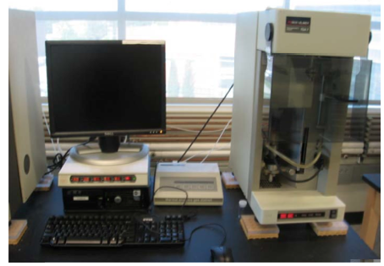

- Please sign into the logbook located on the table between the TGA and the DSC on the North wall of the lab. Write down the date, your name, the instrument used, what sample is to be run, and the temperature program (range and heating rate). Also indicate how many runs are performed and any problems that occur during use.

Please Note: If the system is shut off, the order in which the items are powered up is important. If they are not done in the proper order, the data system will not be able to communicate with the instrument. Please follow these steps in the exact order when powering up the system.

- Using the TGA
- Open the valves on the Nitrogen gas and Air cylinders (lefty loosy) located on the North wall of the room.
  - The pressure should read 35 psi for the Nitrogen
  - For the Air it should be 40 psi

THE NEXT TWO STEPS ARE ONLY IF THE MACHINE IS OFF WHEN YOU START
- Before turning on the power to the TGA, check to make sure the “Master” switch on the computer panel and power switch on the instrument are turned on. Then, turn on the power to the TGA using the switch labeled “Computer”/“TGA 1” (or “Aux1”/“TGA 2”). Note that the furnace will automatically move out of its dock.
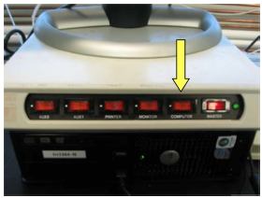

- Turn on the power to the Thermal Analysis Controller (TAC) labeled “TGA 1 TAC”/“Monitor” for TGA 1 or “Aux2”/“TGA 2 TAC” for TGA 2. Note that the furnace will stow back into the dock. Then, the “Control” and “Ready” lights should stay on for TGA 1 or 2.
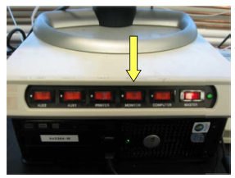

- The Launchpad billing software will have opened upon login. To use this software:
  - Click the Login button that appears
  - The first time you use the software you will get another window asking if you are using an ISU NetID or an external account. Leave it on the default setting of ISU NetID then click Continue.
  - Enter your username and password: it will verify
  - Enter your account number, supervising professor, sample description, experiment description, and hit next
    - Note that the account number will auto format so just enter the numbers and it will enter the dashes for you.
  - The software will then show you a “Pyris” button, click this to launch the software.
- With the Pyris Manager software open, you will see a menu bar at the top of the screen when you move the mouse all the way up. This will indicate that both TGA instruments are offline. Click the TGA instrument you will use in order to connect the instrument and the software.
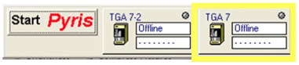
You should see temperature status information if everything is working.
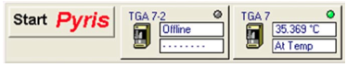

- Once the instrument is online, the main TGA window will open and the “Method Editor” window will appear.
  - On the “Sample Info” tab, enter the name of your sample, the operator’s name, and any comments about your sample. (NOTE: DO NOT enter anything into “Sample Info”, the instrument will automatically fill that entry.)
  - Place the cursor in the “File Name” box and click on “Browse” to find the folder in which you would like to save your data, and give the experiment that will be performed a file name. Click on save.
  - Next, on the “Initial State” tab, in the section labeled “Set Initial Values” enter the temperature you would like your experiment to start at.
  - Move to the “Program” tab of the “Method Editor” window and click on the “Add a Step” button to add temperature scans and isothermals, or to repeat steps. Below the program window, there will be options to edit the selected step by changing the temperature range and scan rate of thermal scans, or the temperature and duration of isotherms.
  - Make sure to save your method by going to “File Save Method as”, give your method an appropriate name and save it in the “Methods” folder.

- Starting an experiment.
- The “Start/Stop” button should look like 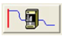, if it looks like 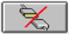, it means the software and instrument are not communicating. Click the button once to initiate communication.
- Go to the gas control station. Enter the following sequence; the buttons will change after each input: run—manual—N₂ or Air—start. The flow rate display will flash for a few moments while in editing mode but no further action is necessary after starting flow.
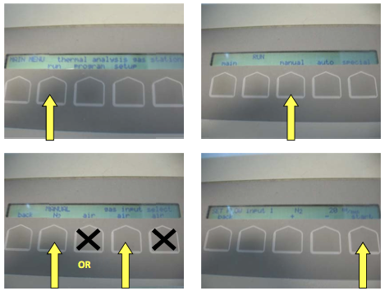

- Place an empty pan with the stirrup onto the hang-down wire by placing them on the movable platform. Bring the platform up to the height of the hook and carefully swing it over. Slide the stirrup over the hook, but do not touch the wire with your hands. Slowly lower the platform down and move it back to the safe position.
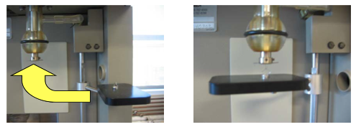
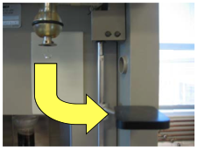

- Raise the furnace by clicking the “Raise Furnace” Button
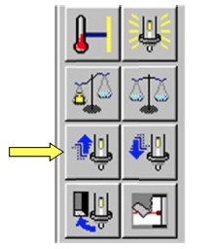
- When the pan and stirrup have stopped swinging and the weight reading stabilizes, press the “Zero Weight” button
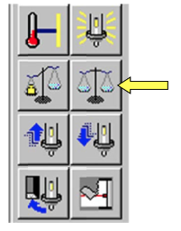
Afterwards, the sample weight should read zero or very close to it.

- Lower the furnace by clicking the “Lower Furnace” button.
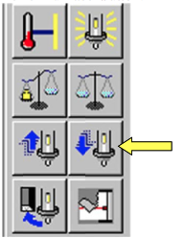
- Remove the stirrup and pan using the platform in the opposite way from how you put them on. Careful not to touch the hook.
- Remove the pan from the stirrup with tweezers. Weigh sample beforehand using nearby mass balance to verify the instrument’s measurement. Sample should be between 5 to 15 mg. Fill pan with sample and place it back into the stirrup. Move both back onto the hang-down wire using the platform to avoid dropping any sample into the furnace.
- Raise the furnace with the “Raise Furnace” button.
- Record the starting weight of the sample by clicking on the “Sample Weight” button after the pan and stirrup have stopped swinging and the weight has stabilized.
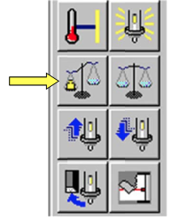
This will automatically enter the weight into the “Sample Info” tab of the “Method Editor” window, and set the % Weight to 100% on the status bar.

- Lower the safety shield in front of the furnace.
- In the menu on the right-hand side, enter your starting temperature and then click “Go to Temp”
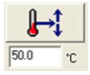
- When the TGA has steadied at the starting temperature, click on the “Start/Stop” button.
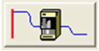
- After the run has started, you can monitor it by clicking on the ‘Instrument Viewer’ window. You can rescale the graph and change either axis to what suits you. Do this by going to the ‘Display’ menu and going to both ‘Rescale X’ and ‘Rescale Y’ to change the axes.
**If at any time during the run you need to stop, click the “Start/Stop” button again.

- After the experiment.
- The furnace will automatically lower when the run is finished but it will not move back into dock. Press the “Cool Furnace” button to stow the furnace.
- When the furnace temperature is back around room temp, remove the stirrup and pan from the hang-down wire with the platform.
- Clean the sample pan completely and leave in the stirrup on the platform. The pans are platinum, so if necessary, you can use acid to help remove residue from the pan.
- Turn off the gases at the gas control station by doing the following: stop—back—back.
- Then, shut off the “TGA 1”/“Computer” or “Aux 1”/“TGA 2” switch, followed by the “TGA 1 TAC”/“Monitor” or “Aux2”/“TGA 2 TAC” switch for TGA 1 and 2, respectively.
- Close the Pyris software by moving your mouse to the top of the screen. Click on “Start Pyris” and select “Close All.” A new window will launch where you can enter and issues you may have had while running your experiment. Then, select “End Session” on the Launchpad Software before logging off of the computer.
- Close valves on the Nitrogen and Air tanks.
- Clean up any miscellaneous items around the computer and instrument area.

- Data Analysis

- With the Pyris Software open, select “Data Analysis” under the “Start Pyris” menu on the top left.
- Open your file and the run data will come up. You can zoom in on an area by dragging a box around the area of interest and double-clicking inside the box. It will bring up an enlarged image.
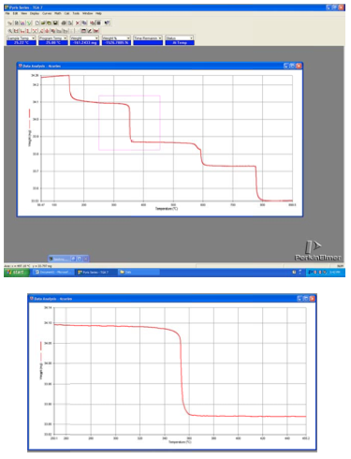

- To calculate both the onset temperature and the change in weight percent, click on “Calc” in the top menu bar and click on “Step”.
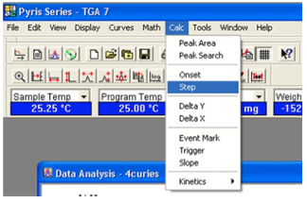

In the “Step Transition” dialog box, make sure “Onset” is checked and then hit “Calculate”.
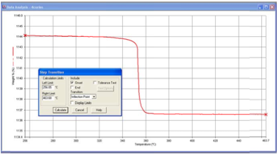

Two tangent lines will appear and you can adjust these to make them tangent with the line. Click on “Calculate”.
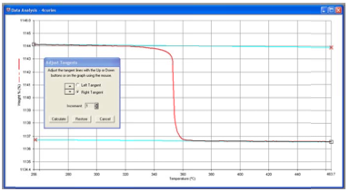

Your result will look like this:
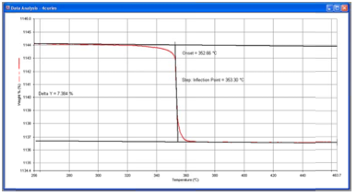

- If you only want to find the onset of a change in the curve, go to “Calc” in the top menu bar and click “Onset”.
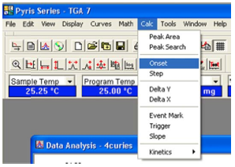

A dialog box will pop up and a small “x” will appear on the each end of your line.
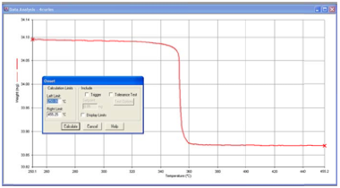

To find the onset, it is easiest to drag each “x” closer to the side you want to measure as seen in the next image. The following spots will measure the upper portion of the curve.
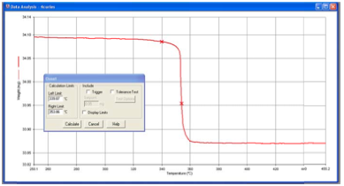

Press “Calculate” in the dialog box and you will be given the option to move the tangents of each “x”. Make sure that the light blue line is as close to tangent as possible and going toward the onset point.
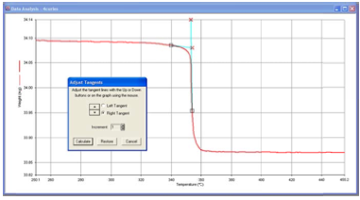

Press “Calculate” in the dialog box and your result will look like this:
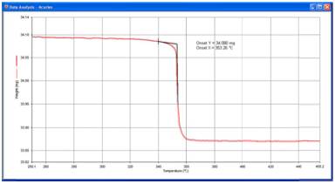

You can move the info box around by just clicking and dragging.

- To save the calculated results, click on “File” from the top menu bar and then “Save Data”.

