TG/DTA 320 User Manual
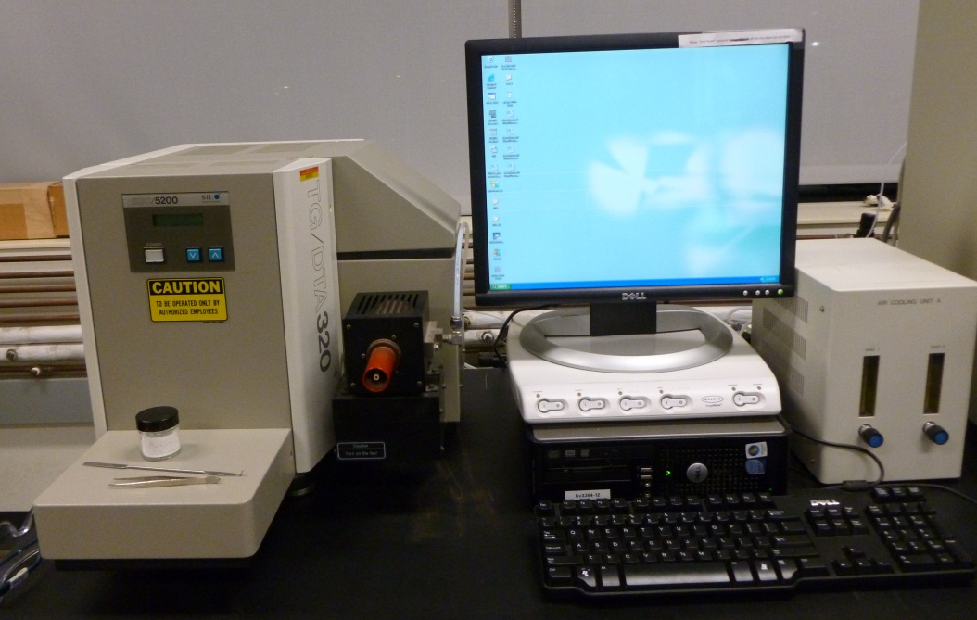
- Sign into the logbook. Write down the date, your name, what material used, the purge gas, the experiment range and number of runs. Please list any problems that occur.
- Turn on nitrogen/air gas in the tank.
- Log onto the computer:
  - login: pyris, password: perkinelmer
- Turn on the power switch on the front of the TG/DTA and wait a while.
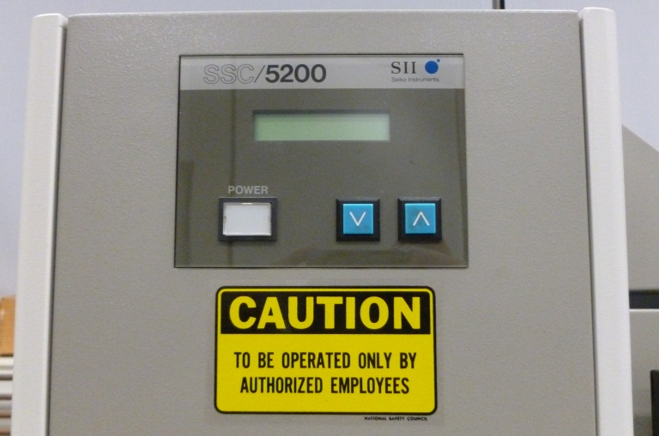

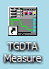
- Make sure the TG/DTA module is connected to a station.
  - Double click the TG/DTA measurement icon on the desktop to open program
  - Click on the File menu -> Open device -> com1
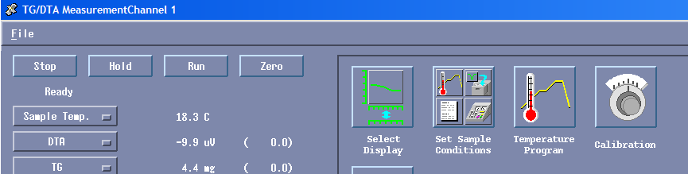

- Sample loading
  - Move furnace out (left button on the instrument)
  - Using tweezers remove right Al₂O₃ sample pan and add a small amount of Al₂O₃ powder by using spatula. It will prevent sample melt from sticking to the bottom of the sample pan.
  - Wait until cup reaches stability and then move furnace in (right button on instrument)
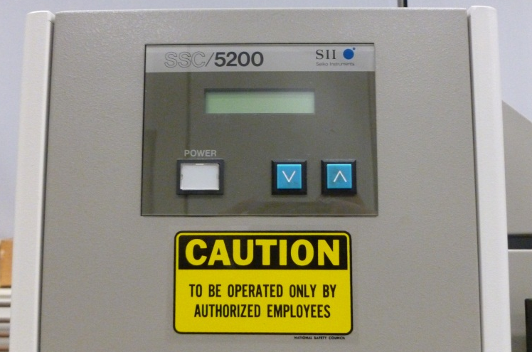
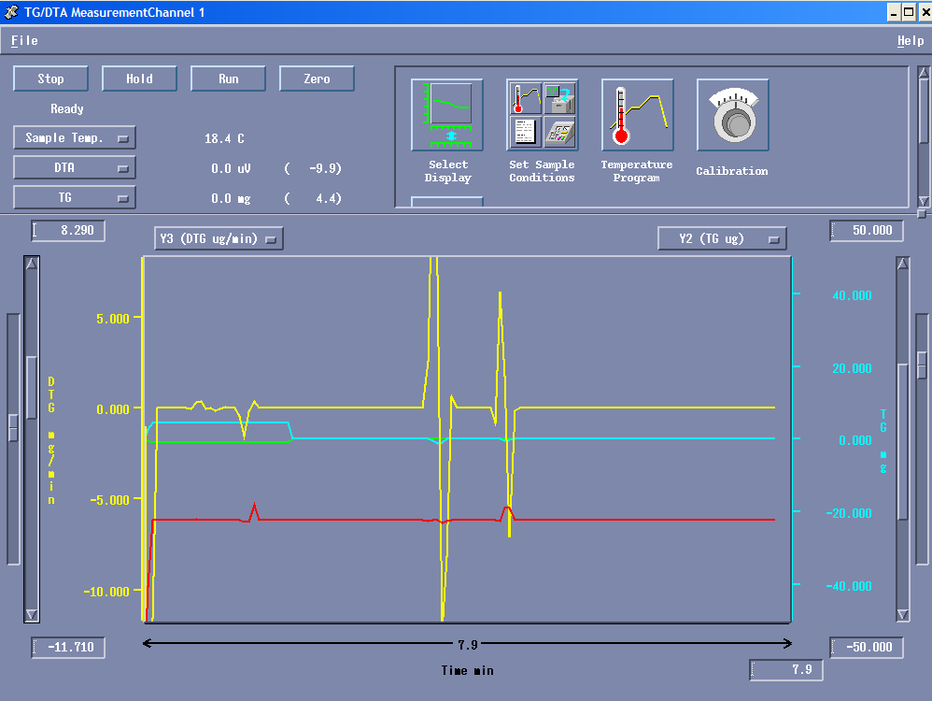
  - Wait for the TG signal to stabilize and then press ZERO button and the weight should read zero or very close to it.

  - Open furnace again and place the sample to the sample pan.
  - Reload the pan into furnace arm (note: make sure there is no sample on the bottom of the sample pan)
  - Wait until pan reaches stability and then move sample in.

- Click the SET SAMPLE CONDITIONS box
Temperature program
Set Sample Conditions
  - Insert your sample information (name, weight, any comments)
  - Record the starting weight by clicking on the “Auto Read” button. This will automatically enter the weight into the program.
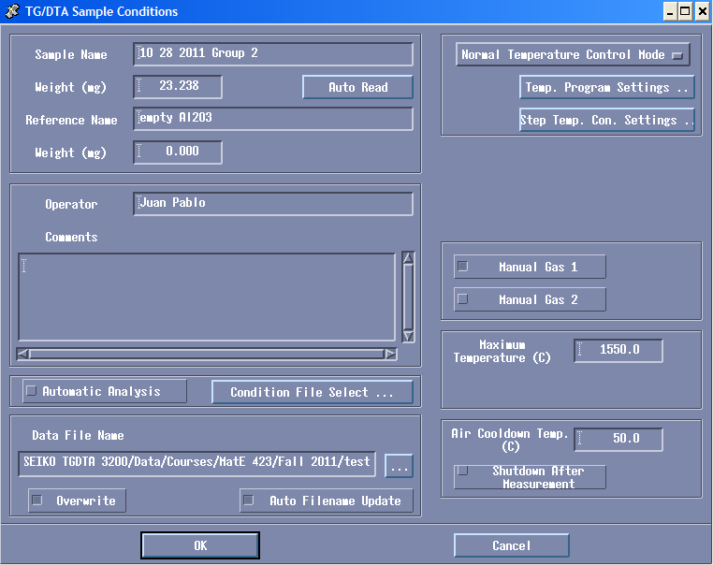
  - Setup where you want to save your data. The pathway for saving your data: C:/Seiko TGA 3200 Data/
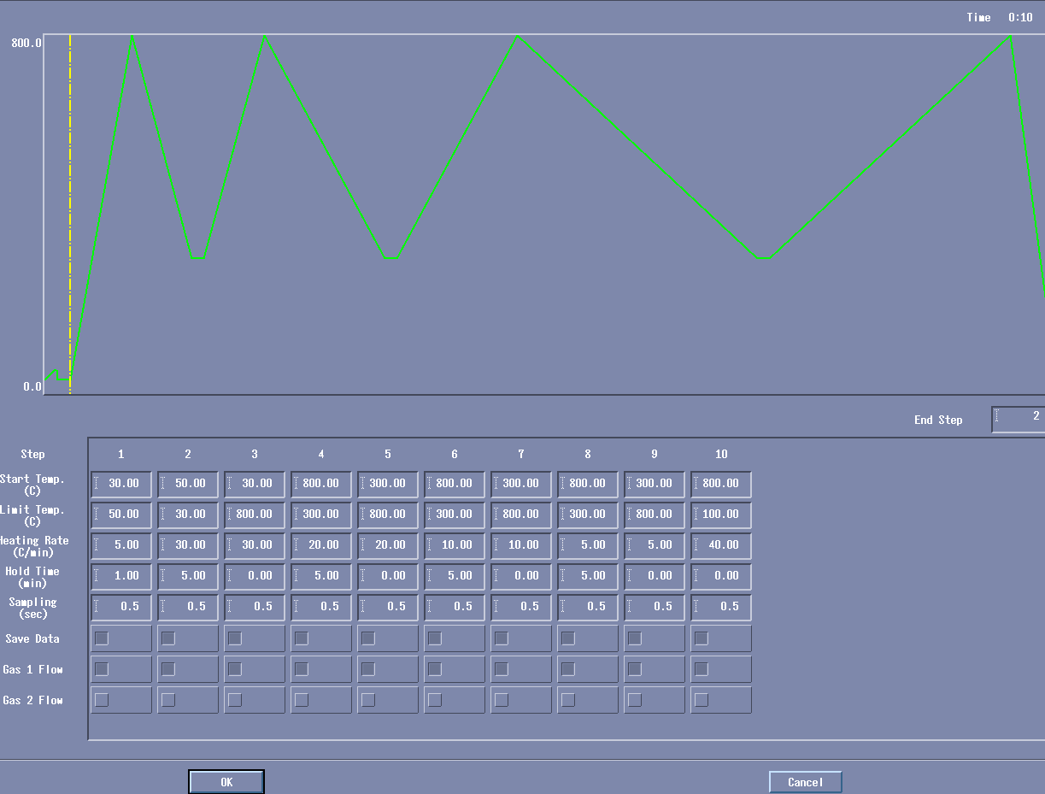
- Click on the TEMPERATURE PROGRAM box and add the necessary temperature steps.
- Enter appropriate temperatures for the steps and the heating rates, if necessary
- Sampling time at 0.5 sec is appropriate
- To start a measurement, press RUN button. (Note TG signal measurement is started form the initial weight of the sample. To start the measurement form 0 mg and to measure only sample weight changes, press ZERO button before pressing the RUN button)
- When the end point of the temperature program is completed, the measurement is automatically terminated.
  - Pull the furnace and remove the sample pan.
  - Clean the pan and place it back
  - Logout the instrument, insure that TG/DTA has returned to room temperature and the software is returned to its main screen

