Young’s Modulus Dial Instructions:
A
D
B

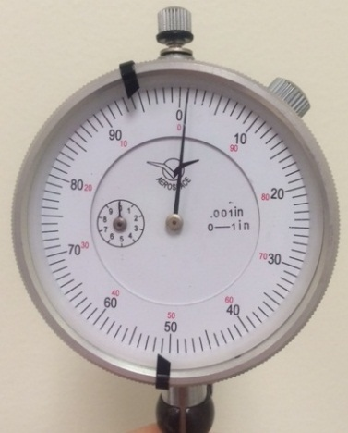
E
C

- Use knob A to zero the long hand, C, on the measurement dial and the short hand E on the counter dial.
- Note that each division on the measurement dial is 1/1000th of an inch, and once around with the long hand is one inch.
- The counter, dial E, tells you how many times the long hand has traveled around.
- Knob B also helps to zero the measurement hand by allowing you to move the face and the location of the zero mark.
- Be sure both the long measurement hand and the short counter hand are on zero before you start each run of your experiment.
- Tabs, D, can be moved around the dial to mark starting and/or stopping points.

