

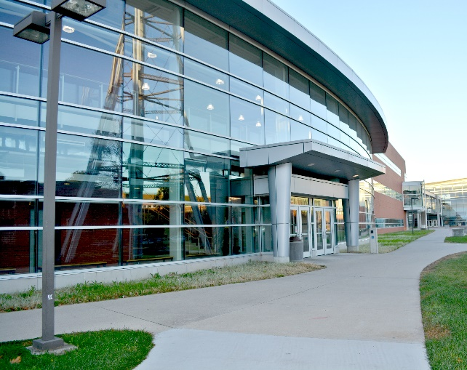

2018-2019 Undergraduate Handbook



1. INTRODUCTION

This guide has been prepared as a resource to help you progress toward your degree in the Department of Materials Science and Engineering (MSE) at Iowa State University. This handbook is far from all-inclusive, and it is intended to supplement other valuable sources of information such as the Iowa State University Catalog, AccessPlus, and information you will receive from your academic adviser or course instructors.

Iowa State University Catalog - <http://catalog.iastate.edu/>

AccessPlus - <https://accessplus.iastate.edu>

MSE Department - <http://www.mse.iastate.edu>

We hope you will read the MSE Undergraduate Handbook now and also refer to it frequently throughout the coming semesters. You can also access the MSE Undergraduate Handbook online on the MSE homepage ([www.mse.iastate.edu](http://www.mse.iastate.edu)). Under the “Current Students” drop-down menu, select the “Academic Advising” page, where you will find a number of academic advising resources.

We are here to help in whatever ways we can – please don’t hesitate to ask!

The MSE Department was formed in 1975 by the merging of the two previously existing departments of Ceramic Engineering and Metallurgy. MSE is one of eight degree-granting departments in the College of Engineering.

II. THE DEPARTMENT OF MATERIALS SCIENCE & ENGINEERING

The departmental office is located in 2240 Hoover Hall. At this location, you can find the Department Chair, academic advisers, and members of the MSE staff (APPENDIX F). Many departmental faculty are located in 2220 Hoover Hall (APPENDIX E). An undergraduate departmental bulletin board with important student information is located outside 3337 Hoover (“Mat E Student Room”).

**II.A. The MSE Faculty**

One of the most important elements in any department is its faculty and we have good reason to be extremely proud of ours. Our faculty are nationally- and internationally-known experts in their fields. They are very student focused and excel in engaging students in course material and research opportunities. You can find a directory of names, academic backgrounds, and research interests of the faculty in APPENDICES D & E.

**II.B. The Advising System**

Developing a good working relationship with your academic adviser will be critical to your success as a student. The goal of the departmental advising system is to assist you in the formation of an academic program that meets your career objectives and curriculum requirements. Your adviser interprets the rules and requirements of the university as well as the college and department so you are able to make informed decisions.

APPENDIX A provides a list of MSE’s academic advisers. When you join the department, you will be assigned an official adviser, and you should utilize this person as your primary point of contact for any advising needs and questions. However, if you are experiencing an urgent advising issue and your adviser is unavailable, feel free to contact the alternate adviser or the MSE front office staff. Contact information for all MSE staff is included in APPENDIX F.

Communication is key to the advising relationship. For this reason, please keep your current address and phone number (cell preferred) updated on your AccessPlus profile. Check your ISU email frequently, as your adviser, MSE faculty and staff send many important messages. Email is considered an official form of communication by Iowa State University, so expect that it will be used to relay updates and notices from the university, college, and department.

If your adviser cannot resolve a problem, either academic or personal, or if you are unable to get in touch with the advisers for an urgent issue, the MSE Department Chair or Associate Department Chairs will be happy to assist you. You are encouraged to visit with both the Chair and Associate Chair at any time, even when there are no problems.

**II.C. Teaching Facilities and Safety Policy**

An attractive feature of our department is that the small class sizes make instruction more interactive, and our curriculum includes a large number of laboratory courses that provide hands-on education to students. All teaching laboratories for the department are located in Hoover Hall.

Specific instructions regarding procedures and techniques will be given to students enrolled in each laboratory course. Information will be provided concerning the specific safety precautions that must be followed by every student. Students are required to pursue their laboratory coursework in a safe, scientific, and professional manner.

Safety of all students, faculty, staff, and visitors is a top priority. The responsibility for your personal safety can never rest solely with the instructor or staff. It is your co-responsibility to become familiar with the safety guidelines. The major hazards encountered in the laboratory setting include high temperatures, dangerous chemicals, and ionizing radiation. Ask your instructor for information regarding safety provisions and emergency procedures. The use and location of tongs, protective gloves, explosion-proof storage units for flammable chemicals, chemical sinks, fume hoods, eyewash fountains, body showers, and monitors for ionizing radiation should be discussed at the beginning of the semester. If the instructor does not include this information in your introduction to the course, then you should ask either the instructor, MSE Lab Coordinator, or MSE’s Associate Chair for Undergraduate Education. Use your common sense – if you do not have enough information, please do not attempt any hazardous procedures.

**II.D. MSE Student Room Facilities**

The MSE department maintains excellent computer and study facilities for use by MSE undergraduate students. The student room is located in 3337 Hoover, and contains computers (PC) with software needed for MSE homework and laboratory assignments, laser (B&W and color) printers and scanner. These computers are networked to the college file server as well as to the Internet.

The student room also has space available for group work, and students often meet there to work on homework and labs. The rooms are accessible 24 hours/day with a coded University ID card. (See the front desk staff in 2240 Hoover to gain access.) Your University ID card will also give you access to Hoover Hall after hours. Building hours are currently Monday through Saturday 6 a.m. to midnight, and Sunday 7 a.m. to midnight. The department’s systems support specialist maintains the computer lab. If you have questions, problems, or concerns, please email [msetech@iastate.edu](mailto:msetech@iastate.edu).

**II.E. Undergraduate Research Opportunities**

There are a significant number of opportunities for undergraduate students in MSE to secure part-time employment as research or teaching assistants. Faculty members in the department hire students as early as their first year in the program depending on the needs of the research group or course. You will hear about some positions through the MSE undergraduate email listserv or from faculty directly. However, at any time you can express your interest in these types of positions to your academic adviser. Your adviser can help you connect with opportunities that fit your interests and qualifications. Most positions are paid on an hourly basis, but occasionally you may be offered course credit (Mat E 490R or Mat E 490C). Both Mat E 490R and Mat E 490C require a proposal form completed by the student and faculty mentor, which then routes through the MSE Curriculum Committee for approval or denial. If a 490 proposal is approved, the academic advisor or MSE Curriculum Committee Chair will provide the reference number to the student so that they can register for the appropriate course. The approved proposal will specify how Mat E 490 credits may (or may not) be used toward degree requirements. See your academic adviser for the appropriate form to request approval to take a Mat E 490 course.

**II.F. Co-op/Internships**

Gaining experience outside the classroom is highly encouraged by the department and College of Engineering as a way to make yourself more knowledgeable, versatile, and marketable for post-graduation career endeavors. There are a couple types of experiences available:

* **Co-op** – semester + summer (6 months)
* **Summer Internship** – minimum of 10 weeks

Finding these positions is student-driven, but there are many resources available to help you in your search:

* **CyHire** – database which provides information about professional development and available positions (https://cyhire.iastate.edu/)
* **College of Engineering Career Fairs** – hundreds of employers visit campus each fall and spring semester for a one-day event that offers access to recruiters
* **MSE Advisers and Faculty** – watch for emails passed on from company contacts, as these are sent throughout the year
* **National job boards (**such as www.indeed.com)

To apply for positions, you will need to be ready to submit the following information:

* **Cover letter or statement of interest** – each application is different, but often you are asked to express why you are applying for the position and how your qualifications match well with the job requirements
* **Resume** – creating an effective resume is essential to summarizing your experience and activities for employers
* **References** – as you progress through your academic experience, remember to connect with faculty and staff who can later serve as professional or personal references during your job search

Engineering Career Services provides many resources which can help you develop these marketing materials for your job search. You can access their library of information here: https://www.engineering.iastate.edu/ecs/students/.

**II.G. Study Abroad**

One of the most exciting opportunities available to complement your Mat E curriculum is to study abroad! Whether you select an experience that lasts a few weeks or you plan ahead and study at an international institution for a semester or year, you will certainly gain a new perspective and broaden your cultural and academic knowledge. Students are able to select from a variety of locations worldwide, including (but not limited to):

* United Kingdom (England, Wales, Ireland, Scotland)
* Mainland Europe (Italy, Germany, France, Spain)
* Australia
* Singapore
* China

**Brunel Program**

Dr. Scott Chumbley, Professor in Materials Science & Engineering, coordinates a six-week summer program for first-year students at Brunel University (Uxbridge, England – western suburb of London). There is a preparation course during the spring semester before the program begins that teaches students about traveling, introduces them to British culture, and establishes the expectations for the experience abroad. During the summer session (early June to mid-July), students will have four week of coursework followed by two weeks of industry and cultural tours. Upon completion of the summer portion, students will get credit for:

* Mat E 391 (3 cr) – a general education course that meets ISU’s US Diversity requirement
* Mat E 392 (3 cr) – meets the Mat E 215 requirement
* ISU’s International Perspectives requirement

The deadline to apply for this program is early December of your first year of study. If you are interested in participating or would like additional information, please contact Dr. Chumbley ([chumbley@iastate.edu](mailto:chumbley@iastate.edu)) or your academic adviser.

III. ACADEMIC MATTERS

The MSE Department offers an undergraduate curriculum that leads to a Bachelor of Science degree in Materials Engineering. The four-year curriculum sheet (found in Appendix B) offers a general template for academic planning. To create your own individual plan, taking into account your unique interests and goals, please consult your academic adviser.

**III.A. Academic Progress**

There are a number of resources available to help you track progress toward your degree:

* **Degree Audit** – document available through the “Student” tab on AccessPlus, which provides a list of degree requirements and accounts for the courses you have taken or are currently taking, as well as the transfer credits you may have brought in to ISU.
* **Curriculum Sheet** – visual way to show a typical progression of coursework (see Appendix B). You can follow the curriculum of your entry term or a more recent year.
* **Midterm grades** – posted on AccessPlus (“Grade Report” link) at the mid-point of each semester as a way for faculty to alert you if your current grade is a C- or below
* **Grade Report** – issued via AccessPlus at the end of each semester, noting the courses you completed and the grades you earned
* **Academic Adviser**

**III.B. Pre-requisite Enforcement**

When planning your course progression, please pay special attention to listed pre-requisites and co-requisites. See the ISU Course Catalog for specific course requirements. If a course has a required pre-requisite, you must have completed the pre-requisite with a passing grade prior to taking the class. In some cases, there is a grade requirement attached to the pre-requisite. For example, you must earn a grade of C- or better in Math 165 (Calc I) to be eligible to move on to take Math 166 (Calc II). If a course lists a co-requisite, then you must have credit or concurrent enrollment in the co-requisite course while you are taking the class.

The MSE Department strictly enforces pre-requisite requirements for our Mat E courses, and you should expect that every ISU department will do the same. If you are enrolled in a course without meeting the listed requirements, you must drop the course. If you do not drop the course, the instructor will not accept or grade any coursework, and you will receive a failing grade of “F” for your final grade. If you believe you meet the pre-requisite knowledge through a transfer course or other extenuating circumstances, you may petition the MSE Curriculum Committee for a pre-requisite waiver. Please visit with your academic adviser for additional information about the waiver petition process.

**III.C. Program Objectives and Outcomes**

The Materials Engineering curriculum has been designed to provide you with experiences to develop necessary knowledge and skills, and it follows the accreditation policies of our accrediting body, ABET.

**Program Educational Objectives**

Within the scope of the MSE mission, the objectives of the Materials Engineering Program are to produce graduates who

1. practice materials engineering in a broad range of industries including materials production, semiconductors, medical/environmental, consumer products, and transportation products.
2. engage in advanced study in materials and related or complementary fields.

**Student Educational Outcomes**

Graduates in materials engineering will have demonstrated the following at the time of graduation:

1. an ability to apply knowledge of mathematics, science, and engineering
2. an ability to design and conduct experiments, as well as to analyze and interpret data
3. an ability to design a system, component, or process to meet desired needs within realistic constraints such as economic, environmental, social, political, ethical, health and safety, manufacturability, and sustainability
4. an ability to function on multi-disciplinary teams
5. an ability to identify, formulate, and solve engineering problems
6. an understanding of professional and ethical responsibility
7. an ability to communicate effectively
8. the broad education necessary to understand the impact of engineering solutions in a global, economic, environmental, and societal context
9. a recognition of the need for and an ability to engage in life-long learning
10. a knowledge of contemporary issues, and
11. an ability to use the techniques, skills, and modern engineering tools necessary for engineering practice.

**III.D. Choosing Area of Specialization**

You must choose one area of specialization from the following types of materials: ceramics, metals or polymers. You may also elect to use your required Mat E electives (6 cr.) or technical electives (12 cr.) to complete one or two additional specializations. The choice of specialization is typically made at the end of the sophomore year after you have taken the beginning sequence of core courses that cover all material types (Mat E 215, Mat E 216).

**III.E. Grade Requirements for Graduation**

In addition to the university rule that you must earn a **minimum cumulative ISU GPA of 2.0**, you also must earn a **minimum average GPA of 2.0** in the following core Mat E courses:

|  |  |  |
| --- | --- | --- |
| Mat E 214 | Mat E 311 | Mat E 413 |
| Mat E 215/215L | Mat E 314 | Mat E 414 |
| Mat E 216/216L | Mat E 317  Mat E 319 | Mat E 418 |
|  |  |  |
| \***Plus** your four specialization courses (12 credits from your official area of specialization). | | |

**III.F. Communication Requirement**

The MSE Department requires you to earn a grade of C or better in Engl 150 and 250 and one of the following courses: Engl 302, 309, 314, or JL MC 347.

**III.G. Departmentally Approved Electives**

The Mat E degree program requires 15 credits of General Education electives:

* **Gen Ed** (3 cr) – following criteria found in Appendix C.1
* **Gen Ed** (3 cr) – following criteria found in Appendix C.1
* **International Perspectives Requirement** (3 cr) – select from approved list found at:  
  <http://www.registrar.iastate.edu/students/div-ip-guide/IntlPerspectives-current>
* **U.S. Diversity Requirement** (3 cr) – select from approved list found at:  
  <http://www.registrar.iastate.edu/students/div-ip-guide/usdiversity-courses>
* **Technical Communication Requirement** (3 cr) – select one of the following courses:
  + Engl 314 – Technical Communication
  + Engl 302 – Business Communication
  + Engl 309 – Report and Proposal Writing
  + JL MC 347 – Science Communication

Students will also need to complete three credits of a free elective (see APPENDIX C.1). Additionally, students are able to tailor their curriculum to their individual interests through required technical electives. Students must take 6 credits of Mat E electives and 12 credits of technical electives (criteria found in Appendix C.2) from the approved departmental list.

**Mat E Electives (must take a minimum of 6 credits)** – 300+ level course in Mat E or MSE, with the following exceptions:

* Students cannot use Mat E 391, Mat E 392, or a course in their declared specialization
* Students cannot use Mat E 490, MSE 590, or MSE 699 without prior approval from the MSE Curriculum Committee before the course is taken. Please see your academic adviser for more information.

**Technical Electives (must take a minimum of 12 credits) – 300+ level course in STEM fields**, with the following exceptions:

Students **cannot** take any of the following to meet the technical elective requirement

* Courses in the 490s/590s in any department without prior approval from the MSE Curriculum Committee before the course is taken. Please see your academic adviser for more information.
* Biol 307 (cross-listed with W S)
* Mat E 370, Mat E 391, Mat E 392
* M E 484/584
* Stat 305

**III.H. Course Substitution Policies**

|  |  |
| --- | --- |
| **Credit deficiency in…** | **Courses which may be used to fill credit deficiency** |
| **100- level math & science course** | **100+ level STEM courses**  However, it may **not** be a course remedial to the Mat E undergraduate program (i.e.  Math lower than 165, Chem lower than 177, Phys lower than 221, lower level Stat, Com S 103, etc) |
| **200- level math & science course** | **≤ 3 credits total deficiency across degree program:**  **200+ level STEM courses**  However, it may **not** be a course remedial to the Mat E undergraduate program (i.e. Phys lower than 221, lower level Stat)  **Beyond 3 credits total deficiency across degree program:**  **200+ level courses in Math or Science**  May not use Engineering courses |
| **200- level engineering course** | **200+ level STEM courses** |
| **300- or 400- level STEM course** | **300- or 400- level STEM courses** |

**(EM 274 + EM 324) requirement changed to Mat E 319X**

* Applies to students on all current catalogs.
* Mat E 319X will begin to be offered in Spring 2018.
* Students must choose one of the following ways to meet the degree requirements:
* **EM 274 (3 cr) + EM 324 (3 cr)**
* **Mat E 319X (3 cr) + technical elective (3 cr)**
* **Important note: Only one of Mat E 319X or (EM 274 + EM 324) may be used toward graduation requirements.**

**III.I. Pass/ Not Pass Grading**

Students may take up to nine credits of general education or free electives on a pass/not pass basis, meaning that only a P (pass – earned grade of D- or better) or NP (not pass – earned grade of F) will be recorded as their final grade in the course. However, those courses meeting U.S. Diversity and International Perspectives requirements or the technical communication requirement may NOT be taken P/NP. The purpose of P/NP grading is to encourage students to take more challenging courses than their usual program of study requires. You may not be on academic probation to take a course P/NP. If interested, students should discuss this option with their adviser.

**III.J. Scholarships**

The Department maintains an outstanding scholarship program for its undergraduate students. Also, many general scholarships open to students in all disciplines of the College of Engineering are available to students in our department. In recent years, Mat E students have received scholarships ranging from $250-$7500.

To apply for any of the scholarships offered by the MSE Department or the College of Engineering, a student **MUST** complete the College of Engineering scholarship application, which is available online (<http://www.engineering.iastate.edu/scholarships/current-students/>). **The deadline to submit scholarship applications is around February 1st each year.**

**III.K. Student Organizations**

One of the best ways to get engaged in materials engineering is to become an active member of one or more of MSE’s outstanding student organizations. You will get to know your peers, network with faculty and industry professionals, and have the chance to develop your leadership skills. Current student officers of the groups listed below can be found in Appendix G.

**Material Advantage (MA)** – a student chapter of three professional Materials Science & Engineering societies: American Society of Materials (ASM), The Materials Society (TMS), and the American Ceramic Society (ACerS). ISU’s chapter has been named “Most Outstanding Chapter in the Nation” 11 times in the past 15 years! Students are actively involved in K-12 outreach, community service, professional development, and networking with research and industry experts. For additional information, visit <http://materialadvantage.org/> or contact a member of the current student executive board (Appendix G).

**Gaffer's Guild** – an artistic glass blowing club with membership open to all ISU students and members of the Ames community. The group provides training to members each semester, but participation is limited depending on availability of instructors and studio time. For additional information, visit <http://gaffer.stuorg.iastate.edu/> or contact a member of the current student executive board.

**Metallurgica** - an organization for students interested in the science and engineering of metals. It seeks to provide practical and hands-on opportunities for students, including competitions sponsored by the professional societies, tours of various facilities, and other experiences provided through university connections.  It is a new organization, and in its inaugural year, students competed in the TMS “Blade smithing” competition, and are currently working towards competing in a metallographic competition as well. New opportunities abound!

**III.L. Concurrent BS/MS Program Application Guidelines**

***Overview***

The following information provides details of the MSE Department’s concurrent BS/MS program and requirements. This information is also available on the MSE website at <http://www.mse.iastate.edu/students/concurrent/>.

The Department of Materials Science and Engineering can admit seniors with exceptional academic qualifications into the program for "Concurrent Enrollment for Graduate/Undergraduate Degrees." A student in this program pursues a graduate MS degree while simultaneously completing his/her undergraduate BS degree. After successfully completing the requirements for the BS and graduate degree, the student will receive both degrees at graduation – typically, but not always, on the same graduation date.

Students seeking admission to this program will apply near the end of their junior year of undergraduate education or within one year before the expected semester of BS graduation. However, please note that application deadlines are the same as those listed on the MSE Graduate Program/Application Requirements page: <http://www.gradcollege.iastate.edu/academics/programs/apprograms.php>. Students are encouraged to discuss the matter with their academic adviser, potential major professor, Director of Graduate Education (DOGE), or MSE Department Chair. An information packet is also available from the MSE Graduate Coordinator or MSE Undergraduate Academic Advisers in the main MSE Office, 2240 Hoover Hall.

***Qualifications:***

Minimum overall GPA of 3.5  
Minimum 90 credits completed to begin BS/MS Program  
Major Professor must be identified

**In brief summary, the following steps should be taken to apply for the Concurrent BS/MS program:**

Please obtain items 3 and 5 from the MSE graduate coordinator.  
Items 4, 6, and 7 are available on-line at <http://www.grad-college.iastate.edu/common/forms/index.php>

1. Identify an MSE faculty member willing to serve as your Major Professor. (See item 3)
2. Obtain a written recommendation from your undergraduate academic adviser. (See item 3)
3. Complete an MSE Concurrent Enrollment Approval form (Requires academic adviser and Major Professor signatures)
4. Complete an Application for an ISU Undergraduate Student Wishing to Pursue a Concurrent Degree form that also must include the following items - Full Resume/Curriculum Vitae, GRE General Test Score*, three letters of recommendation, personal statement of purpose and research interests. (*recommended, but not required of current ISU undergraduate students)
5. Complete MSE Concurrent Proposed Graduate Plan (CPGP) – used solely as a tool for the student and major professor and/or academic adviser in preparation for the students’ graduate program of study.

Forms to complete once graduate admission is approved:

6. Recommendation for Committee Appointment form

7. Program of Study (POS) form

***Great Reference Tool/Website:***Graduate College Handbook  
<http://www.grad-college.iastate.edu/common/handbook/>

***Admission/Assistantship***

No decision will be made on admission until all application material is complete and submitted. Concurrent students are under the same guidelines for review as all other students who apply through the graduate application process.

Students in the Concurrent BS/MS program are eligible for research assistantships offered directly through MSE faculty members with research contracts (this would be the major professor that you have identified in your application); however, such assistantships are contingent upon availability of funding and are not guaranteed for all concurrent BS/MS students. Students are eligible for a ¼-time assistantship upon entrance into the BS/MS program. Students who have accrued enough applicable credits to be eligible for B.S. graduation are eligible for a ½-time assistantship. However, this is not automatic – written documentation via the signed MSE Concurrent Enrollment Assistantship Increase Form is required. Once received and approved, appropriate action will be taken to apply the increase. In addition, all students on assistantship are eligible for in-state resident tuition.

***Please Note:*** It is important that prior to application/enrollment in the concurrent program you seriously consider how the financial aspects of this appointment may affect you individually. Each person’s situation is different. It may be worthwhile to visit with a financial aid adviser prior to making any final decisions about the concurrent program as scholarships, grants, etc. could be affected by your appointment as you will no longer be in undergraduate status, but graduate status once you are accepted into the concurrent program.

***Coursework***

Students may double-count up to six credits between their B.S. and graduate degree requirements. However, courses may be used in this manner only when they are taken after the date the student becomes a concurrent BS/MS student.

IV. CONCLUSION

We hope that the information presented in this handbook has helped to answer some of your questions as you begin your academic career in the department. We wish you great success in all of your activities while you are at Iowa State University and after you depart. We are here to help you achieve success in any way we can, so please do not hesitate to ask for assistance.

UNDERGRADUATE ACADEMIC ADVISER

|  |  |  |  |
| --- | --- | --- | --- |
| **NAME** | **OFFICE** | **PHONE** | **EMAIL** |
| Andrea Klocke | 2240K Hoover | 294-0891 | [aklocke@iastate.edu](mailto:aklocke@iastate.edu) |

HONORS PROGRAM FACULTY ADVISER

|  |  |  |  |
| --- | --- | --- | --- |
| **NAME** | **OFFICE** | **PHONE** | **EMAIL** |
| Dr. Scott Chumbley | 2240D Hoover | 294-4722 | [chumbley@iastate.edu](mailto:chumbley@iastate.edu) |

UNDERGRADUATE CURRICULUM CHAIR

|  |  |  |  |
| --- | --- | --- | --- |
| **NAME** | **OFFICE** | **PHONE** | **EMAIL** |
| Dr. Scott Chumbley | 2240D Hoover | 294-4722 | chumbley@iastate.edu |

UNDERGRADUATE STUDENT SERVICE SPECIALIST

|  |  |  |  |
| --- | --- | --- | --- |
| **NAME** | **OFFICE** | **PHONE** | **EMAIL** |
| Holly Dunlay-Lott | 2240 Hoover | 294-5713 | [hollyd@iastate.edu](mailto:hollyd@iastate.edu) |

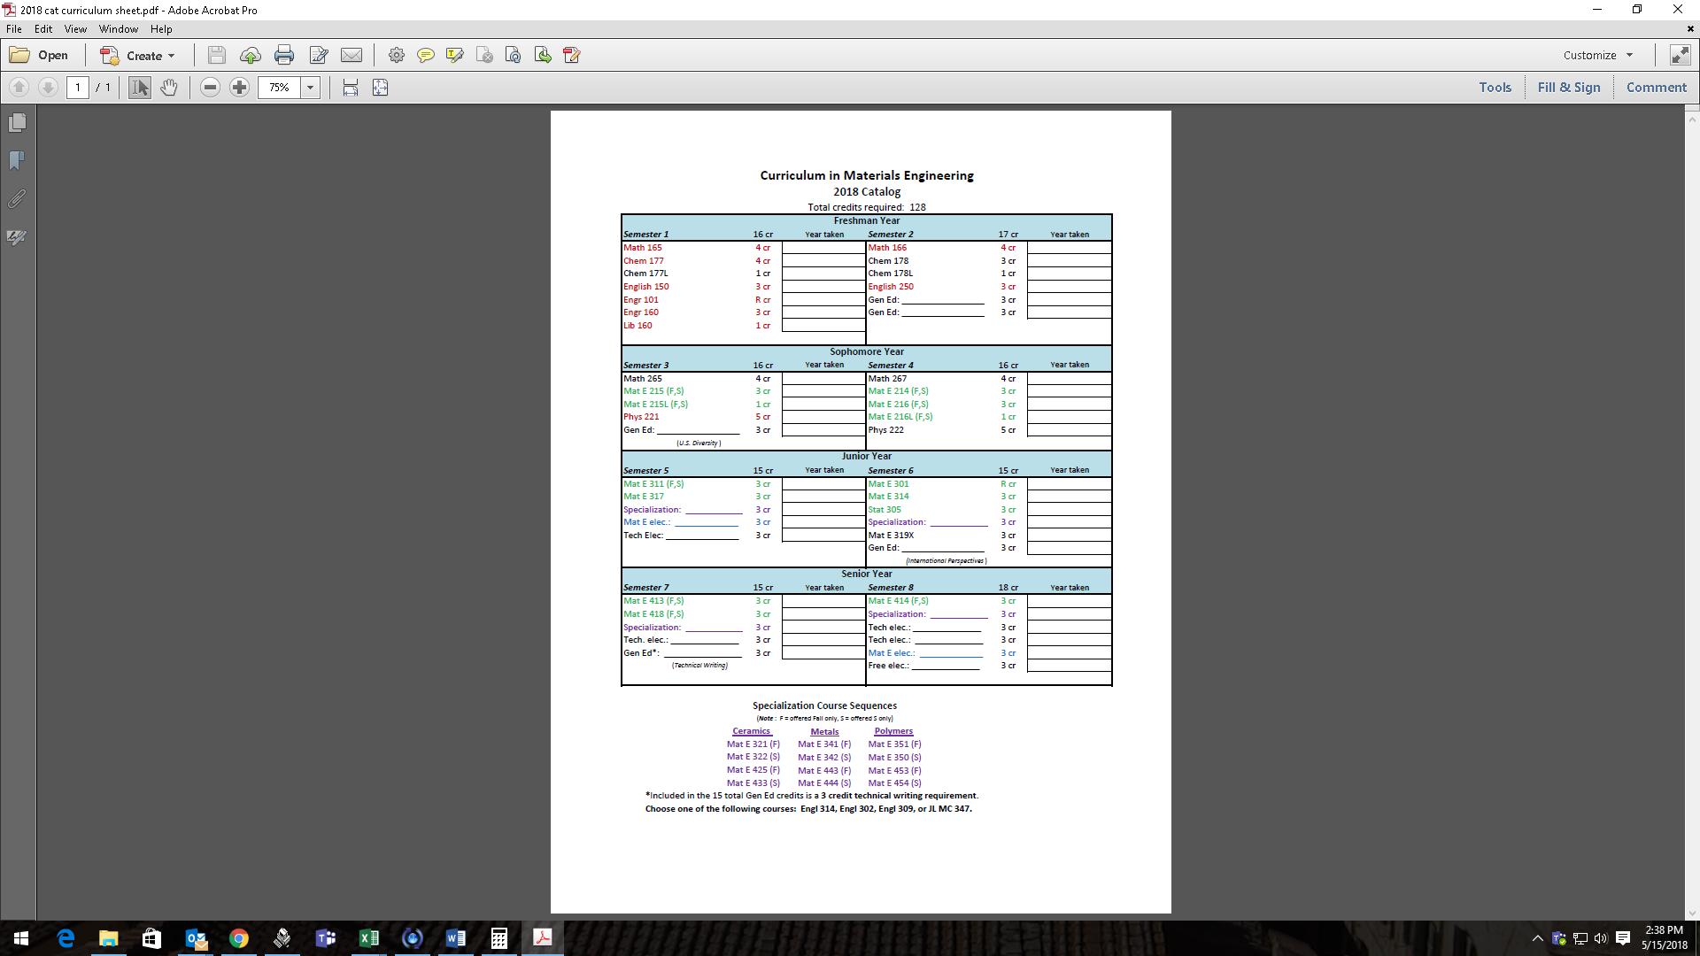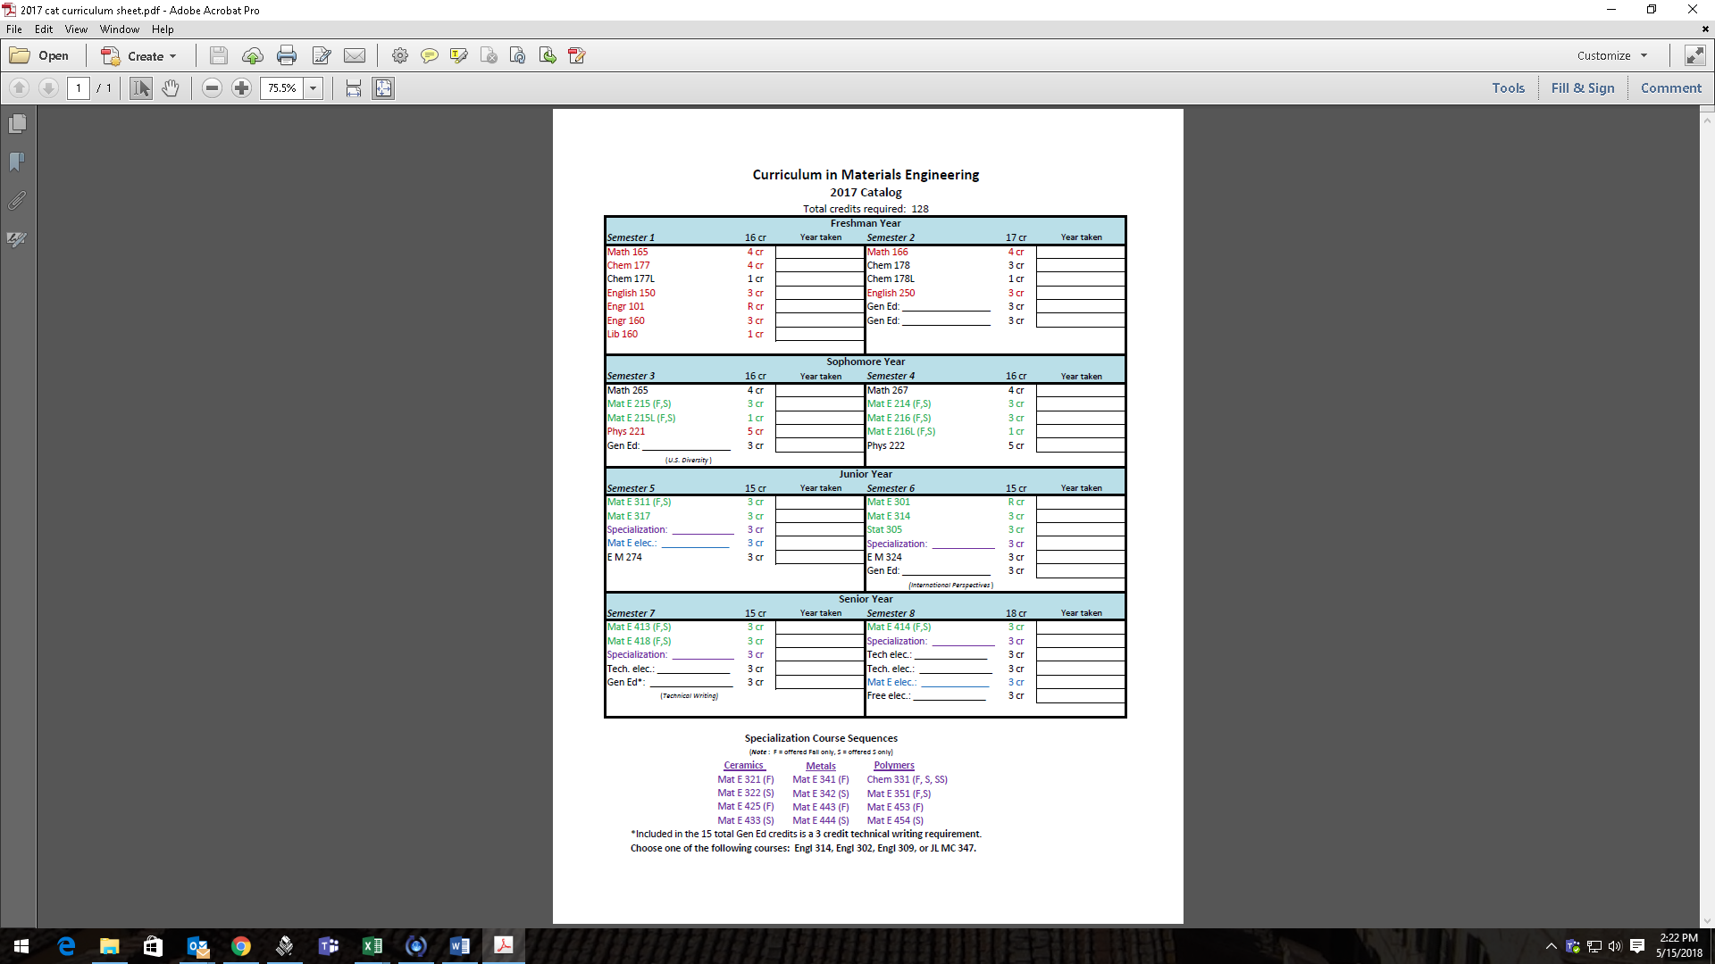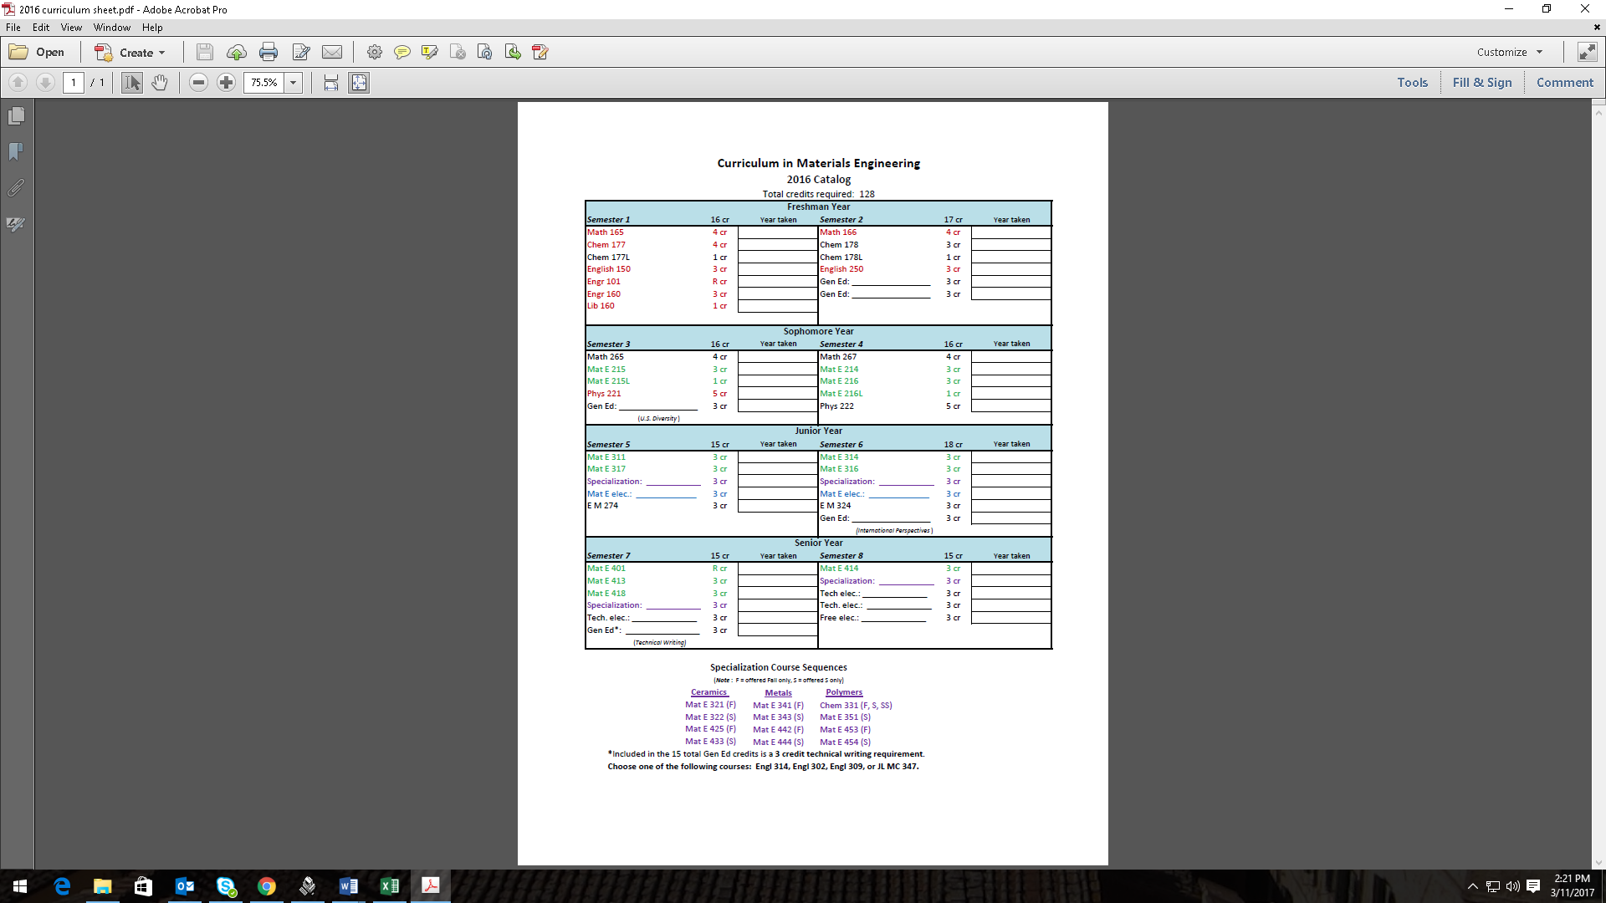





GENERAL EDUCATION (GEN ED) ELECTIVES ACCEPTABLE FOR MATERIALS ENGINEERING CURRICULUM

Materials engineering students are encouraged to select Gen Ed courses that broaden their

academic program. Courses in the social sciences (sociology, anthropology, journalism and mass

communication, economics, political science, human development and family studies,

psychology) or humanities (architecture, literature, foreign language, philosophy,

religion, history) are especially encouraged.

All materials engineering majors must take 15 credits of Gen Ed courses. The university

requirements for U.S. Diversity and International Perspectives must be met, and can be met

through the courses selected in the Gen Ed requirement. The technical writing requirement may also be used toward the required 15 credits.

Any university course may be taken to fulfill the Gen Ed requirements, as long as it meets the following rules:

1. The course may not be remedial - courses must be at the 100+ level.
2. The course may not be offered in engineering, physics, chemistry, or mathematics.
3. You may not use an orientation course from another department (e.g. BUSAD 101).
4. The course may not be one that could have counted as a technical elective (e.g. 100- and 200- level Biol courses may be used as a Gen Ed. However, a 300+ level Biol course may not be used as a Gen Ed since it can count as a tech elective)
5. You must complete at least 6 credits at the 200-level or higher toward the Gen Ed requirement.
6. You may not use more than 9 credits from a single department toward the Gen Ed requirement.
7. No “skills” courses may be used. (e.g. Kinesiology courses - golf, tennis, etc. or music courses focused on playing an instrument or participating in band, choir, etc.)

|  |  |
| --- | --- |
| ACCT – Accounting | FOR - Forestry (100 or 200 level) |
| ADVRT – Advertising | FRNCH - French |
| AF AM – African American Studies | GEOL - Geology (100 or 200 level) |
| AGRON – Agronomy (100 or 200 level) | GER - German |
| AFAS – Air Force Aerospace Studies | GERON - Gerontology |
| AM IN – American Indian Studies | GLOBE - Global Resource Systems |
| AN S – Animal Science | GREEK - Greek Language |
| ANTHR – Anthropology | H S - Health Studies |
| AESHM – Apparel, Events, and Hospitality Management | HIST - History |
| A M D – Apparel, Merchandising and Design | HORT - Horticulture |
| ARABC – Arabic | HD FS - Human Development and Family Studies |
| ARCH – Architecture | HSP M – Hospitality Management |
| ART – Art and Design | IND D - Industrial Design |
| ARTED – Art Education | JL MC - Journalism and Mass Communication |
| ARTGR - Graphic Design | L A - Landscape Architecture |
| ART H – Art History | LAS - Liberal Arts and Sciences |
| ARTIS - Integrated Studio Arts | LATIN - Latin Language |
| ARTID - Interior Design | LING - Linguistics |
| ASTRO – Astronomy and Astrophysics (100 or 200 level) | MGMT - Management |
| A TR - Athletic Training | MIS - Management Information Systems |
| BBMB - Biochemistry, Biophysics, and Molecular Biology (100 or 200 level) | MKT - Marketing |
| BCBIO - Bioinformatics and Computational Biology (100 or 200 level) | MTEOR – Meteorology (100 or 200 level) |
| BPM I - Biological/Pre-Medical Illustration | MICRO – Microbiology (100 or 200 level) |
| BIOL - Biology (100 or 200 level) + Biol 307 | M S - Military Science |
| CHIN - Chinese | MUSIC (see adviser for courses allowed) |
| CL ST - Classical Studies | NREM - Natural Resource Ecology and Management |
| CMDIS - Communication Disorders | N S - Naval Science |
| COMST - Communication Studies | PHIL - Philosophy |
| C R P - Community and Regional Planning | POL S - Political Science |
| COM S - Computer Science (200 level) | PSYCH - Psychology |
| CJ ST - Criminal Justice Studies | RELIG - Religious Studies |
| C I - Curriculum and Instruction | RUS - Russian Language |
| DES - Design | SCM - Supply Chain Management |
| DSN S - Design Studies | SOC - Sociology |
| ECON - Economics | SPAN - Spanish |
| ENGL - English | SP ED - Special Education |
| ENSCI - Environmental Science (200 level) | SP CM - Speech Communication |
| ENV S - Environmental Studies | T SC - Technology and Social Change |
| EVENT - Event Management | THTRE - Theatre |
| FCEDS - Family and Consumer Sciences Education and Studies | W S - Women's Studies |
| FIN - Finance | WLC - World Languages and Cultures |
| FS HN - Food Science and Human Nutrition |  |

**Common Gen Ed Courses Taken by Mat E Undergraduates**

*Use this as a starting point, but there are many other options for courses if these do not appeal to you – see rules on page 19 for details.*

**ACCT 284. Financial Accounting**

(3-0) Cr. 3. F.S.SS. Prereq: not open to first term freshmen  
Introduction to the basic concepts and procedures of financial accounting from a user perspective. The course examines the accounting cycle, business terminology, basic control procedures, and the preparation and evaluation of financial reports, with an emphasis on financial statement analysis.

**AF AM 201. Introduction to African American Studies**

(3-0) Cr. 3. F.S.   
An interdisciplinary introduction to the study of African American culture. Includes history, the social sciences, literature, religion, and the arts, as well as conceptual frameworks for investigation and analysis of the African American experience.   
Meets U.S. Diversity Requirement.

**AM IN 210. Introduction to American Indian Studies**

(3-0) Cr. 3. F.S.SS.   
Introduction to the multidisciplinary aspects of American Indian studies. Topics include literature, the arts, history, anthropology, sociology, education, and contemporary Indian politics. Guest lectures, media presentations, and discussion of assigned readings.   
Meets U.S. Diversity Requirement.

**ANTHR 201. Introduction to Cultural Anthropology**

(3-0) Cr. 3. F.S.SS.   
Comparative study of culture as key to understanding human behaviors in different societies. Using a global, cross-cultural perspective, patterns of family life, economic and political activities, religious beliefs, and the ways in which cultures change are examined.   
Meets International Perspectives Requirement.

**ANTHR 220. Globalization and Sustainability**

(Cross-listed with ENV S, GLOBE, M E, MAT E, SOC, T SC). (3-0) Cr. 3. F.S.   
An introduction to understanding the key global issues in sustainability. Focuses on interconnected roles of energy, materials, human resources, economics, and technology in building and maintaining sustainable systems. Applications discussed will include challenges in both the developed and developing world and will examine the role of technology in a resource-constrained world. Cannot be used for technical elective credit in any engineering department.  
Meets International Perspectives Requirement.

**ANTHR 230. Globalization and the Human Condition**

(3-0) Cr. 3. F.S.   
An introduction to understanding key global issues in the contemporary world. Focuses on social relations, cultural practices and political-economic linkages among Africa, the Americas, Asia, Europe and the Pacific.   
Meets International Perspectives Requirement.

**A M D 165. Dress and Diversity in Society**

(3-0) Cr. 3. F.S.   
Examination of diversity among consumers and forecasting future trends in consumer behavior. Introduction to social justice and responsibility issues.   
Meets U.S. Diversity Requirement.

**ASTRO 120. The Sky and the Solar System.**

(3-0) Cr. 3. F.S.SS.   
For the nonscientist. The sky: constellations; motions of the sun, moon, and planets; seasons and the calendar; eclipses. The solar system: origin and evolution; characteristics of the sun, planets, satellites, comets, meteorites, and asteroids. Extensive use of the planetarium is included. Students who take Astro 120 may count credit in only one of Astro 102 or 103 toward graduation.

**ASTRO 150. Stars, Galaxies, and Cosmology.**

(3-0) Cr. 3. F.S.   
For the nonscientist. Observational aspects of stellar astronomy: motions, distances, sizes, spectra; types of stars; variability; binary systems. Stellar evolution: the birth, life, and death of stars, including supernovae, neutron stars, and black holes. The Milky Way Galaxy: clouds of matter in space, the structure and evolution of our galaxy. Other galaxies, clusters of galaxies, quasars. Theories of the origin of the universe.

**BIOL 101. Introductory Biology.**

(3-0) Cr. 3. F.S.SS.   
Life considered at cellular, organism, and population levels. Function and diversity of the living world. Presentation of basic biological principles as well as topics and issues of current human interest. Does not satisfy biology major requirements.

**BIOL 211. Principles of Biology I.**

(3-0) Cr. 3. F.S. Prereq: High school biology  
Introduction to the nature of life, including the diversity of microbial, plant, and animal life; the nature of heredity; evolution; and principles of ecology. Intended for life science majors.

**BIOL 212. Principles of Biology II.**

(3-0) Cr. 3. F.S. Prereq: High School Biology; high school chemistry or credit or enrollment in CHEM 163 or CHEM 177  
Introduction to the chemical, molecular, and cellular basis of life; form and function of microbial, plant, and animal life. Intended for life science majors.

**BIOL 255. Fundamentals of Human Anatomy.**

(3-0) Cr. 3. F. Prereq: High School Biology and Chemistry, or BIOL 101  
An introduction to human anatomy, beginning with cells and tissues, surveying all body systems, relating form to function. Systems covered include: integumentary, bones and joints, muscles, nervous, sensory, endocrine, circulatory, lymphatic, respiratory, digestive, urinary, and reproductive. Pre-Medical students should consider Biol 351 for their anatomy background. Does not satisfy biology major requirements.

**BIOL 256. Fundamentals of Human Physiology.**

(3-0) Cr. 3. S. Prereq: High School Biology and Chemistry, or BIOL 101, or BIOL 255 (recommended)  
An introduction to human physiology, studying the function of all body systems. Systems covered include: integumentary, bones and joints, muscles, nervous, sensory, endocrine, circulatory, lymphatic and immune, respiratory, digestive, urinary, and reproductive. Pre-Medical students should consider 335 for their physiology background. Does not satisfy biology major requirements.

**CL ST 273. Greek and Roman Mythology.**

(3-0) Cr. 3. F.SS.   
Survey of the legends, myths of the classical world with emphasis on the principal gods, and heroes, and their relation to ancient social, psychological, and religious practices; some attention may be given to important modern theories.   
Meets International Perspectives Requirement.

**COMST 102. Introduction to Interpersonal Communication.**

(3-0) Cr. 3.   
Application of communication principles, theory, and research to the process of interpersonal communication; includes verbal and nonverbal communication, listening, and conflict management. Particular emphasis given to using communication to manage interpersonal relationships.

**COMST 214. Professional Communication.**

(3-0) Cr. 3.   
Communication theory and skill development in organizational settings. Emphasis on interpersonal skill development, team and meeting facilitation, informational interviewing, individual and team presentations, and self-assessment.

**COM S 207. Fundamentals of Computer Programming.**

(Cross-listed with MIS). (3-1) Cr. 3. F.S. Prereq: MATH 150 or placement into MATH 140/MATH 141/MATH 142 or higher  
An introduction to computer programming using an object-oriented programming language. Emphasis on the basics of good programming techniques and style. Extensive practice in designing, implementing, and debugging small programs. Use of abstract data types. Interactive and file I/O. Exceptions/error-handling. This course is not designed for computer science, software engineering, and computer engineering majors. Credit may not be applied toward graduation for both Com S 207/MIS 207 and Com S 227.

**COM S 208. Intermediate Computer Programming.**

(3-1) Cr. 3. S. Prereq: MIS/COM S 207, credit or enrollment in MATH 151, MATH 160, or MATH 165  
Intermediate-level programming techniques. Emphasis on designing, writing, testing, debugging, and documenting medium-sized programs. Data structures and their uses. Dynamic memory usage. Inheritance and polymorphism. Algorithm design and efficiency: recursion, searching, and sorting. Event-driven and GUI programming. The software development process. This course is not designed for computer science, software engineering and computer engineering majors. Credit may not be applied toward the major in computer science, software engineering, or computer engineering.

**COM S 227. Introduction to Object-oriented Programming.**

(3-2) Cr. 4. F.S.   
An introduction to object-oriented design and programming techniques. Symbolic and numerical computation. Recursion and iteration. Modularity procedural and data abstraction, specifications and subtyping. Object-oriented techniques. Imperative programming. Emphasis on principles of programming and object-oriented design through extensive practice in design, writing, running, debugging, and reasoning about programs. This course is designed for majors. Credit may not be applied toward graduation for both Com S 207 and 227.

**ECON 101. Principles of Microeconomics.**

(3-0) Cr. 3.   
Resource allocation, opportunity cost, comparative and absolute advantage. Supply and demand. Marginal analysis. Theories of production and consumption, pricing, and the market system. Perfect and imperfect competition and strategic behavior. Factor markets. Present discounted value.

**ECON 102. Principles of Macroeconomics.**

(3-0) Cr. 3. Prereq: ECON 101 recommended  
Measurement of macro variables and general macro identities. Classical models of full employment. Production and growth. Savings and investment. Employment and unemployment. Money, inflation, and price levels. Operation of the U.S. banking system. Fiscal and monetary policy. Elements of international finance.

**GEOL 100. The Earth.**

(3-0) Cr. 3. F.S.SS.   
How does the earth work, what is it made of, and how does it change through time? Plate tectonics, Earth materials, landforms, structures, climate, and natural resources. Emphasis on the observations and hypotheses used to interpret earth system processes. Students may also enroll in Geol 100L.

**GEOL 101. Environmental Geology: Earth in Crisis.**

(Cross-listed with ENV S). (3-0) Cr. 3. F.S.   
An introduction to geologic processes and the consequences of human activity from local to global scales. Discussion of human population growth, resource depletion, pollution and waste disposal, global warming and ozone depletion, desertification, and geologic hazards such as earthquakes, landslides, flooding, and volcanism.

**HD FS 240. Literature for Children.**

(3-0) Cr. 3. F.S.   
Evaluation of literature for children, including an emphasis on cultural, racial, ethnic, and social diversity. Roles of literature in the overall development of children. Literature selection and use.   
Meets U.S. Diversity Requirement.

**HD FS 276. Human Sexuality.**

(3-0) Cr. 3. F.S.SS.   
Behavioral, biological, and psychological aspects of human sexuality within the social context of family, culture, and society. Role of sexuality in human development. Critical analysis of media and research. Communication and decision-making skills relating to sexuality issues and relationships.   
Meets U.S. Diversity Requirement.

**HIST 201. Introduction to Western Civilization I.**

(3-0) Cr. 3. F.   
Western civilization from ancient Mediterranean world to 1500. Social and cultural developments; economic and political ideas and institutions; problems of historical change and continuity.   
Meets International Perspectives Requirement.

**HIST 202. Introduction to Western Civilization II.**

(3-0) Cr. 3. S.   
Western civilization from 1500 to present. Social and cultural developments; economic and political ideas and institutions; problems of historical change and continuity.   
Meets International Perspectives Requirement.

**HIST 221. Survey of United States History I.**

(3-0) Cr. 3-5. F.   
Colonial foundations: revolution, confederation, and constitution; nationalism and democracy; sectional disunity, Civil War, and reunion.

**HIST 222. Survey of United States History II.**

(3-0) Cr. 3. S.   
Industrialization; emergence as a great power; boom and depression; war, internationalism and Cold War; modern industrial society.

**HIST 280. Introduction to History of Science I.**

(3-0) Cr. 3. F.   
Ideas of nature from ancient Greece to the seventeenth-century scientific revolution.   
Meets International Perspectives Requirement.

**HIST 281. Introduction to History of Science II.**

(3-0) Cr. 3. S.   
Science from seventeenth-century scientific revolution to Darwin and Einstein.   
Meets International Perspectives Requirement.

**INTST 235. Introduction to International Studies.**

(3-0) Cr. 3. F.SS.   
Overview of international studies, emphasizing cultural, geographic, economic, and political characteristics of major world areas and nations.   
Meets International Perspectives Requirement.

**LAS 170. Leadership ISU.**

(0-2) Cr. 1. F. Prereq: Freshman or sophomore classification  
An introductory leadership course for first-year and second-year students. Students will gain a basic understanding of leadership skill development and resources available to student leaders at Iowa State University. Course content will be delivered through a variety of methods such as guest speakers, team building exercises, and small group discussions. Students will be expected to complete several out of class assignments to apply the leadership skills they have learned. Offered on a satisfactory-fail basis only.

[**LD ST 322: Leadership Styles and Strategies in a Diverse Society**](http://catalog.iastate.edu/azcourses/ld_st/)

***(3-0) Cr. 3. F.S.SS.*** *Prereq: Sophomore classification*  
Developing and practicing leadership skills through understanding personal leadership styles, leadership theory and communication theory, including how they relate to gender issues and cultural diversity; exploring personality types, communication styles, and leadership styles, networking and developing mentoring relationships; setting goals and participating in leadership opportunities and service.   
Meets U.S. Diversity Requirement

**LING 286. Communicating with the Deaf.**

(Cross-listed with CMDIS). (3-0) Cr. 3.   
Learn to communicate with the deaf using Signed English and Signed Pidgin English. Other topics covered include types, causes, and consequences of hearing loss, hearing technology (hearing aids, assistive listening devices, and cochlear implants), education of hearing-impaired children, Deaf culture, and the history of manual communication.   
Meets U.S. Diversity Requirement.

**MUSIC 102. Introduction to Music Listening.**

(3-0) Cr. 3. F.S.SS.   
Expansion of the music listening experiences for the general student through greater awareness of differences in techniques of listening, performance media, and materials of the art. The course focuses on the elements of music: rhythm, melody, harmony, form, and style, and how these elements are used in musics of different cultures and time periods. Ability to read or perform music not required.   
Meets International Perspectives Requirement.

**MUSIC 304. History of Rock 'n' Roll.**

(3-0) Cr. 3. S. Prereq: MUSIC 101, MUSIC 102, MUSIC 221, or MUSIC 222  
Rock 'n' Roll from the mid 1950s through the 1990s, focusing on the development of rock styles from its roots in blues, folk, country, and pop. Expansion of listening experience through study of song forms, musical instruments of rock, and the socio-political significance of song lyrics. Examinations, research paper or in class presentation required. Ability to read or perform music not required.   
Meets U.S. Diversity Requirement.

**PHIL 201. Introduction to Philosophy.**

(3-0) Cr. 3. F.S.SS.   
It has been rumored that the unexamined life is not worth living. Philosophy is an attempt to begin examining life by considering such questions as: What makes us human? What is the world ultimately like? How should we relate to other people? Is there a god? How can we know anything about these questions? Understanding questions of this kind and proposed answers to them is what this course is all about.

**PHIL 230. Moral Theory and Practice.**

(3-0) Cr. 3. F.S.SS.   
Investigation of moral issues in the context of major ethical theories of value and obligation; e.g., punishment, abortion, economic justice, job discrimination, world hunger, and sexual morality. Emphasis on critical reasoning and argument analysis.

**PHIL 235. Ethical Issues in A Diverse Society.**

(3-0) Cr. 3. S.   
This course will examine a range of arguments on diversity issues. Topics will include: the social status of women, the moral status of sexuality and homosexuality, the nature and role of racism in contemporary society, the relationship between biology, gender roles and social status, and various proposals for change from a variety of political perspectives.   
Meets U.S. Diversity Requirement.

**POL S 215. Introduction to American Government.**

(3-0) Cr. 3. F.S.SS.   
Fundamentals of American democracy; constitutionalism; federalism; rights and duties of citizens; executive, legislative, and judicial branches of government; elections, public opinion, interest groups, and political parties.

**POL S 241. Introduction to Comparative Government and Politics.**

(3-0) Cr. 3. F.S.   
Basic concepts and major theories; application to selected political systems, including non-western political systems.   
Meets International Perspectives Requirement.

**POL S 251. Introduction to International Politics.**

(3-0) Cr. 3. F.S.   
Dynamics of interstate relations pertaining to nationalism, the nation state; peace and war; foreign policy making; the national interest; military capability and strategy; case studies of transnational issues, such as population, food, energy, and terrorism.   
Meets International Perspectives Requirement.

**PSYCH 101. Introduction to Psychology.**

(3-0) Cr. 3. F.S.SS.   
Fundamental psychological concepts derived from the application of the scientific method to the study of behavior and mental processes. Applications of psychology.

**PSYCH 230. Developmental Psychology.**

(3-0) Cr. 3. F.S.SS.   
Life-span development of physical traits, cognition, intelligence, language, social and emotional behavior, personality, and adjustment.

**PSYCH 280. Social Psychology.**

(3-0) Cr. 3. F.S.SS.   
Individual human behavior in social contexts. Emphasis on social judgments and decisions, attitudes, perceptions of others, social influence, aggression, stereotypes, and helping.

**RELIG 205. Introduction to World Religions.**

(3-0) Cr. 3. F.S.SS.   
An introduction to the academic study of religions, including myths, beliefs, rituals, values, social forms. Examples chosen from oral cultures and major religions of the world.  
Meets International Perspectives Requirement.

**RELIG 210. Religion in America.**

(3-0) Cr. 3. F.S.SS.   
Introductory study of the major beliefs, practices, and institutions of American Judaism, Catholicism, Protestantism, and Islam with emphasis on the diversity of religion in America, and attention to issues of gender, race, and class.   
Meets U.S. Diversity Requirement

**SOC 134. Introduction to Sociology.**

(3-0) Cr. 3. F.S.SS.   
Social interaction and group behavior with emphasis on the scientific study of contemporary U.S. society, including issues relating to socialization, inequality, and changing rural and urban communities. Analysis of relationships among the institutions of family, religion, political participation, work, and leisure.

**SOC 219. Sociology of Intimate Relationships.**

(3-0) Cr. 3. F.S.SS. Prereq: SOC 134  
Analysis of intimate relationships among couples using a sociological perspective. Attention is given to singlehood; dating and courtship; sexuality; mate selection, cohabitation, and marriage. Relationship quality, communication, conflict and dissolution of these types of relationship will also be explored.

**SOC 220. Globalization and Sustainability.**

(Cross-listed with ANTHR, ENV S, GLOBE, M E, MAT E, T SC). (3-0) Cr. 3. F.S.   
An introduction to understanding the key global issues in sustainability. Focuses on interconnected roles of energy, materials, human resources, economics, and technology in building and maintaining sustainable systems. Applications discussed will include challenges in both the developed and developing world and will examine the role of technology in a resource-constrained world. Cannot be used for technical elective credit in any engineering department.  
Meets International Perspectives Requirement.

**SOC 235. Social Problems and American Values.**

(3-0) Cr. 3. F.S. Prereq: SOC 134  
Sociological concepts, theories and methods to analyze the causes and consequences of social problems. Social problems discussed may include crime, substance abuse, income inequalities, discrimination, poverty, race relations, health care, family issues, and the environment. How American culture and values shape societal conditions, public discourse and policy.   
Meets U.S. Diversity Requirement.

**SP CM 212. Fundamentals of Public Speaking.**

(3-0) Cr. 3. F.S.SS.   
Theory and practice of basic speech communication principles applied to public speaking. Practice in the preparation and delivery of extemporaneous speeches.

**SP CM 216. Great Speakers and Speeches.**

Cr. 3.   
Survey of great speeches examined within their political and cultural contexts. Analysis of the rhetorical strategies of diverse speakers with an emphasis on texts from social movements in the United States.   
Meets U.S. Diversity Requirement.

**SP CM 312. Business and Professional Speaking.**

(3-0) Cr. 3. F.S. Prereq: SP CM 212  
Theory, principles, and competency development in the creation of coherent, articulate business and professional oral presentations.

**THTRE 110. Theatre and Society.**

(3-0) Cr. 3. F.S.   
An introduction to Theatre focusing on its relationship with society throughout history.

**THTRE 251. Acting I.**

(3-0) Cr. 3. F.S.   
Theory and practice in fundamentals of acting.

TECHNICAL ELECTIVES

Any 300+ level course in the departments listed below.

However, you **cannot** use the following courses to meet this requirement:

|  |  |  |  |
| --- | --- | --- | --- |
| * 490/590 course in any department | * M E 484/584 (cross-listed with WLC) |  | |
| * Biol 307 (cross-listed with W S) | * Stat 305 |  |
| * Mat E 370, 391 |  |  |

**AER E** – Aerospace Engineering  
**A B E** – Agricultural and Biosystems Engineering  
**ASTRO** – Astronomy and Astrophysics  
**BBMB** – Biochemistry, Biophysics, and Molecular Biology  
**B M E** – Biomedical Engineering  
**BIOL** – Biology   
**C E** – Civil Engineering  
**CH E** – Chemical Engineering  
**CHEM** – Chemistry  
**COM S** – Computer Science  
**CON E** – Construction Engineering  
**CPR E** – Computer Engineering  
**E E** – Electrical Engineering  
**E M** – Engineering Mechanics  
**ENSCI** – Environmental Science   
 *(not to be confused with ENV S – Environmental Studies – which cannot be used as a tech elective)***GEN** – Genetics  
**GEOL** – Geology  
**I E** – Industrial Engineering  
**MATH** – Mathematics   
**MAT E** – Materials Engineering  
**M E** – Mechanical Engineering  
**MICRO** – Microbiology **MSE** – Materials Science & Engineering (graduate-level courses)  
**NUC E** – Nuclear Engineering  
**PHYS** – Physics  
**S E** – Software Engineering  
**STAT** – Statistics

Additionally, the following 200-level courses may be used toward this requirement:

* Math 207
* BME 220
* BME 208X

**Recommendations for Technical Electives**

**If you are interested in metals…**

* Mat E 334 (S) – Electronic & Magnetic Properties of Metallic Materials
* I E/Mat E 348 (S) – Solidification Processes
* Mat E 457 (alternate S) – Chemical and Physical Metallurgy of Rare Earth Metals

**If you are interested in polymers…**

* Ch E 447 (S) – Polymers and Polymer Engineering
* Aer E 423 (S) – Composite Flight Structures
* Mat E 456 (F) - Biomaterials

**If you are interested in electronic properties of materials…**

* Mat E 334 (S) – Electronic & Magnetic Properties of Metallic Materials
* Mat E 433 (S) – Advanced Electronic Materials
* Mat E 332 (F, S) – Semiconductor Materials and Devices
* Mat E 432 (S) – Microelectronics Fabrication Techniques

**If you are interested in biomaterials…**

* Mat E 456 (F) – Biomaterials
* Ch E 440 (alt. F – offered 2013) – Biomedical Applications of Chemical Engineering
* IE 547X Biomedical Design and Manufacturing
* Consider the Biomedical engineering minor

**If you are interested in business applications in engineering…**

* I E 305 (F, S, SS) – Engineering Economic Analysis
* I E 450 (F) – Technical Sales for Engineers I
* I E 451 (S) – Technical Sales for Engineers II

**To prepare for graduate school in Materials Science & Engineering…**

* Math 385 (F, S) – Introduction to Partial Differential Equations
* Phys 321 (F) – Introduction to Modern Physics I
* Phys 322 (S) – Introduction to Modern Physics II
* Mat E 481 (F) – Computational Modeling of Materials

FREE ELECTIVES ACCEPTABLE FOR MATERIALS ENGINEERING CURRICULUM

Materials Engineering students are required to take 3 credits of “free” electives. A free elective can be any non-remedial course. “Remedial” is defined by the MSE Department as a course that is at a lower level than the first required course in that area (for example, Mat E students take Math 165 as the first required math course. Any lower-level math course is considered remedial and therefore cannot be applied toward the free elective requirement).

The following is a partial list of courses that would be considered remedial and would not apply toward the free elective requirement:

* Any course at a level lower than 100
* Chem 155
* Chem 160
* Chem 163
* Chem 164
* Com S 103
* Com S 107
* Engl 1XX
* Math 104
* Math 105
* Math 140
* Math 142
* Math 143X
* Phys 101
* Phys 106
* Phys 111
* Phys 112
* Stat 1XX

MSE Faculty Directory

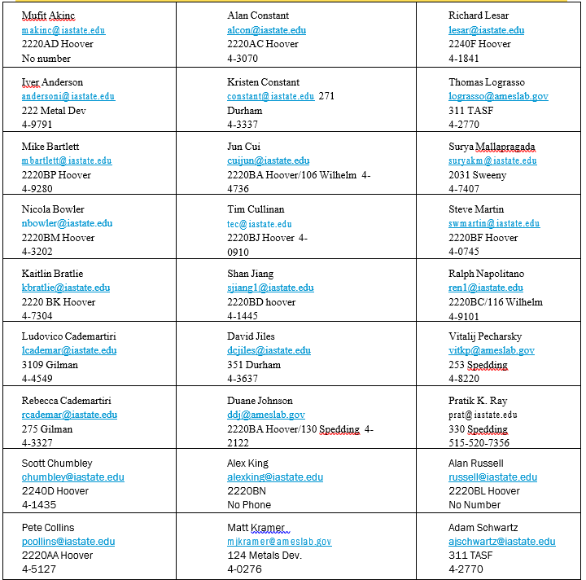

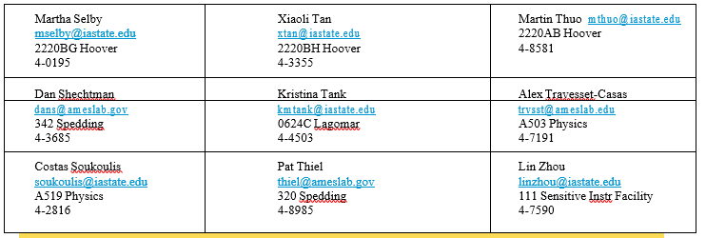

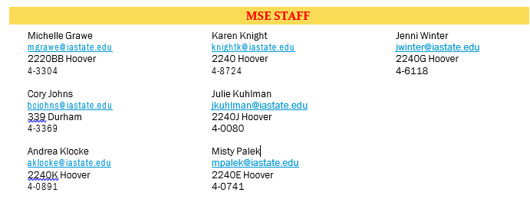

UNDERGRADUATE STUDENT ORGANIZATIONS

**MATERIAL ADVANTAGE (ACerS, ASM, and TMS combined)**

**http://ma.engineering.iastate.edu/**

PRESIDENT David Puhl  
VICE PRESIDENT Eric McDonald  
TREASURER Melany Safraniec  
SECRETARY Rachel Eckert  
EVENTS CHAIR Michael Trebisovsky  
PROGRAMMING CHAIR Emery Farmer  
OUTREACH CO-CHAIRS Haley Bodensteiner & Sarah O’Malley  
FUNDRAISING CO-CHAIRS Daniel Bonifas & Dmitriy Bayko  
WEBMASTER Kathryn Neilson  
HISTORIAN Trevor White  
FACULTY ADVISER Dr. Scott Chumbley

**METALLURGICA**

Metallurgica is an organization for students interested in the science and engineering of metals. It seeks to provide practical and hands-on opportunities for students, including competitions sponsored by the professional societies, tours of various facilities, and other experiences provided through university connections.  It is a new organization, and in its inaugural year, students competed in the TMS “Blade smithing” competition, and are currently working towards competing in a metallographic competition as well. New opportunities abound!

**https://www.facebook.com/ISUMetallurgica/**

Faculty Advisor: Dr. Pete Collins