Materials Science & Engineering is now using iLab to schedule lab equipment

Log into iLab
To do this, begin by navigating to iastate.okta.com in your web browser. Works on mobile devices too!

Once signed into Okta, click the iLab icon.

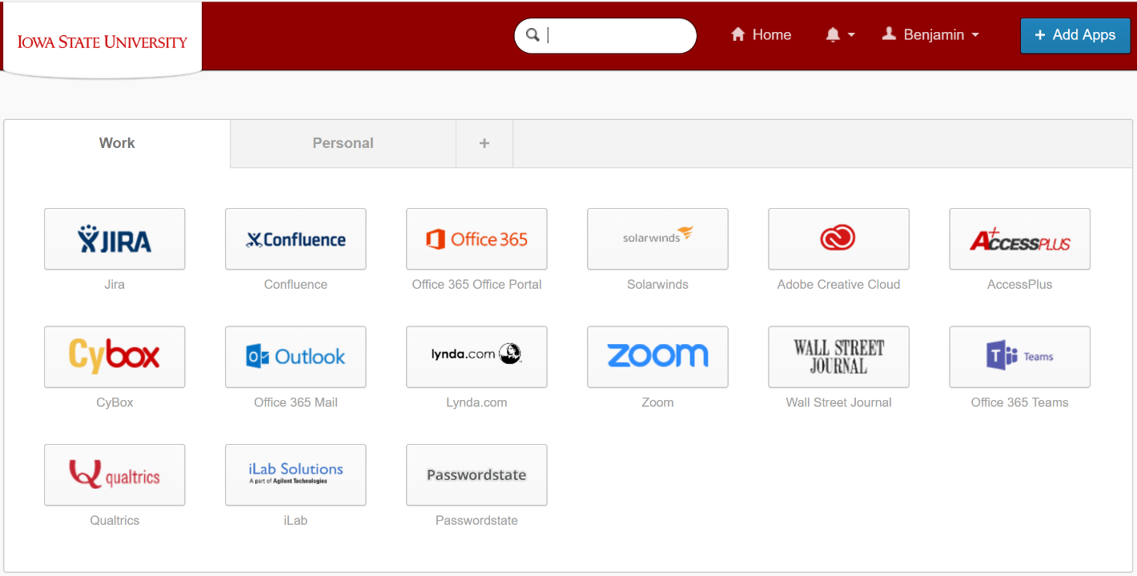

If the iLab icon does not appear as an app in Okta, you can add it by clicking on Add Apps and adding iLab Solutions.

Find Calendar
Once signed into iLab, find the MSE equipment calendars by clicking the MSE Resources tab.
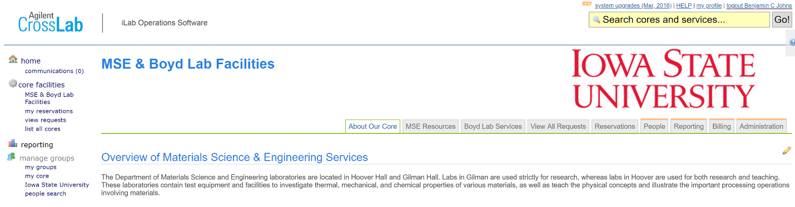

Find the calendar by selecting one of the categories and identifying the equipment you are wishing to book time on. Once the calendar has been found, click View Schedule. **You will only have access to calendars for equipment for which you are trained and approved to use.
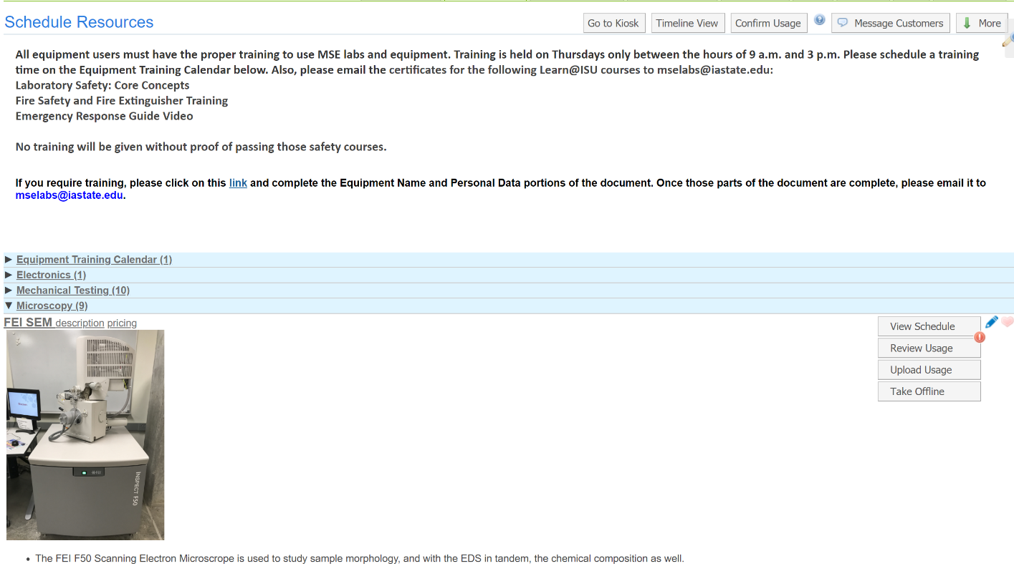

Schedule Time
The calendar for the equipment selected is then displayed. Schedule time by clicking and dragging directly on the time slot desired.
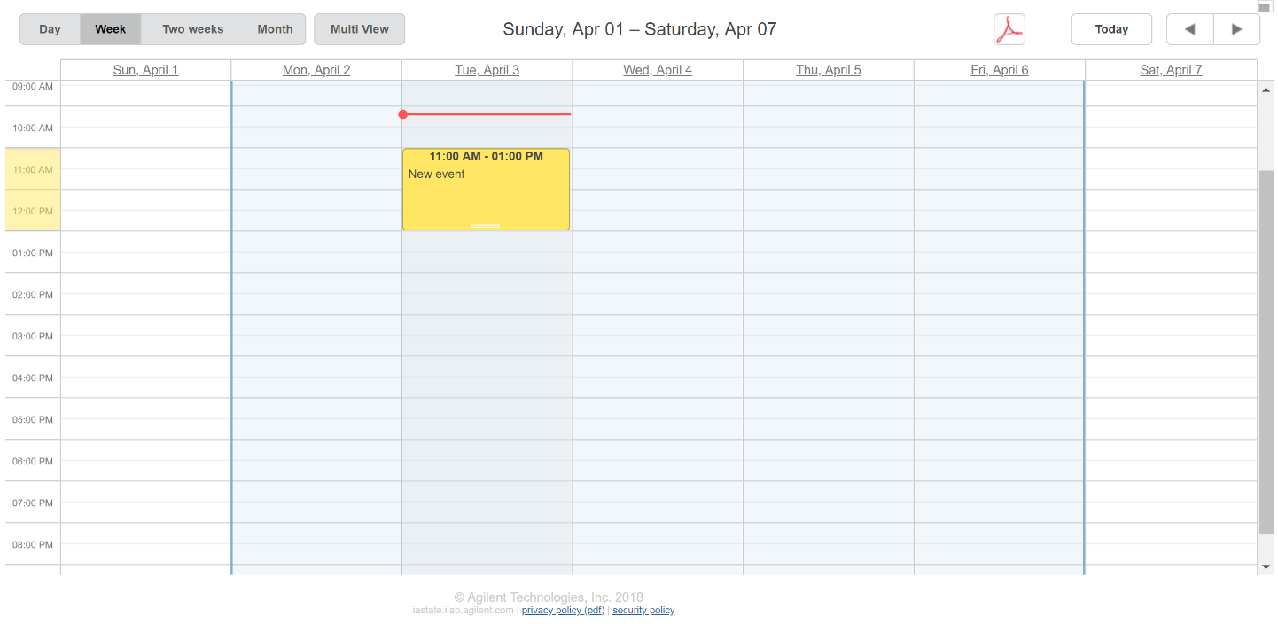

A window pops up to finalize the time selected and funding accounts to be used. Verify the information and then click Save Reservation.

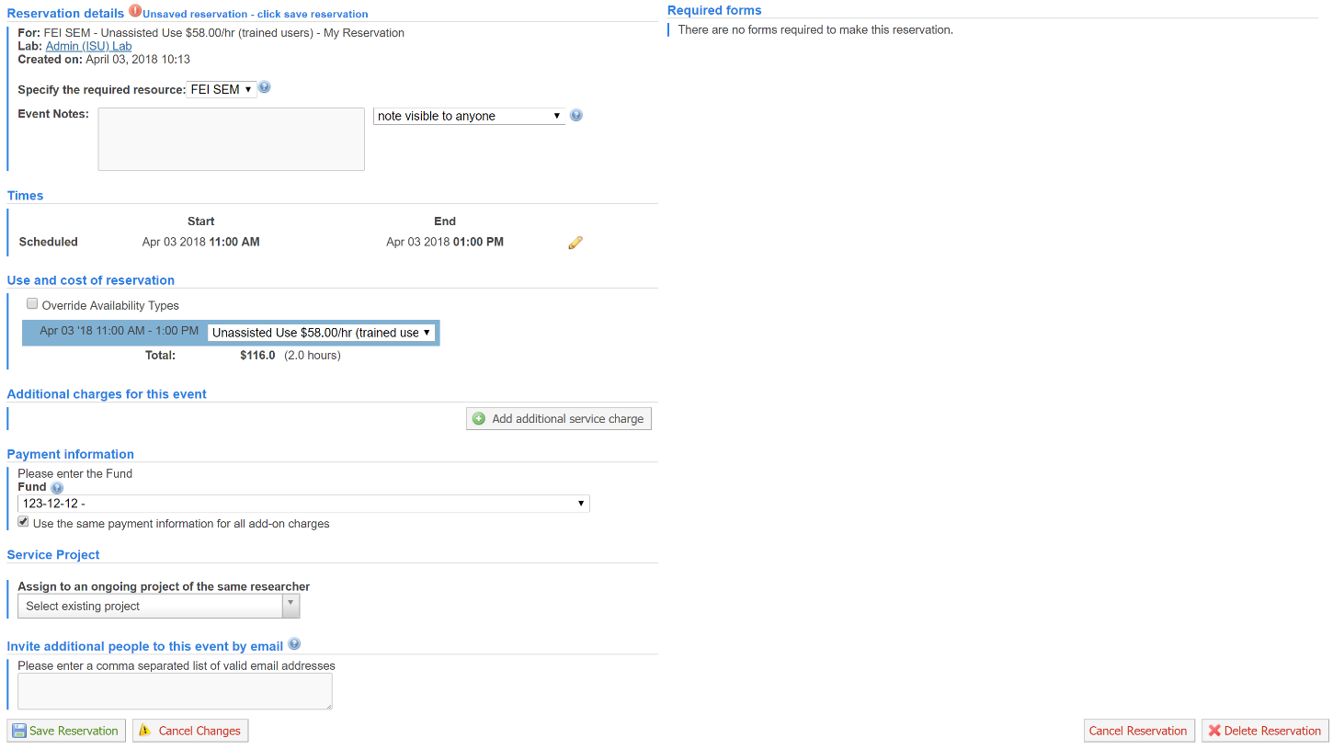
At this point, the reservation is booked and you may log out.

Begin usage
When you are ready to begin using the machine, log into iLab (shown in Step 1) and select Kiosk.
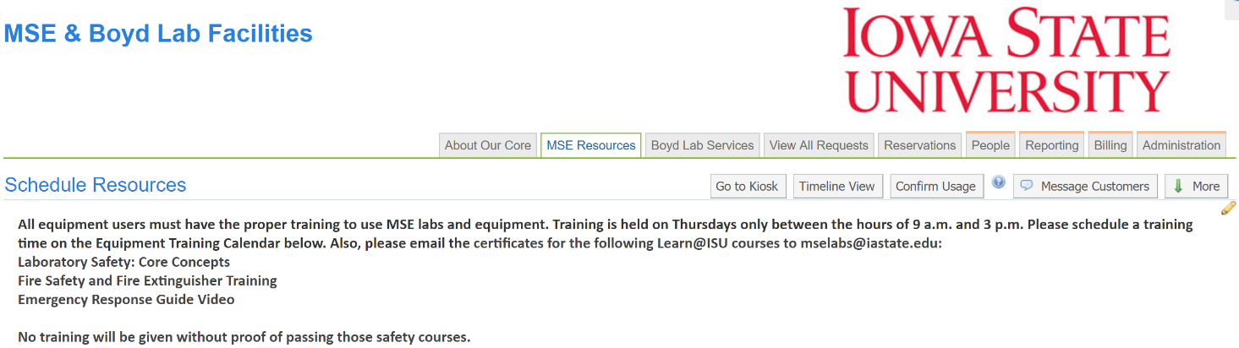

Kiosk Mode opens. Find your reservation and click Start.
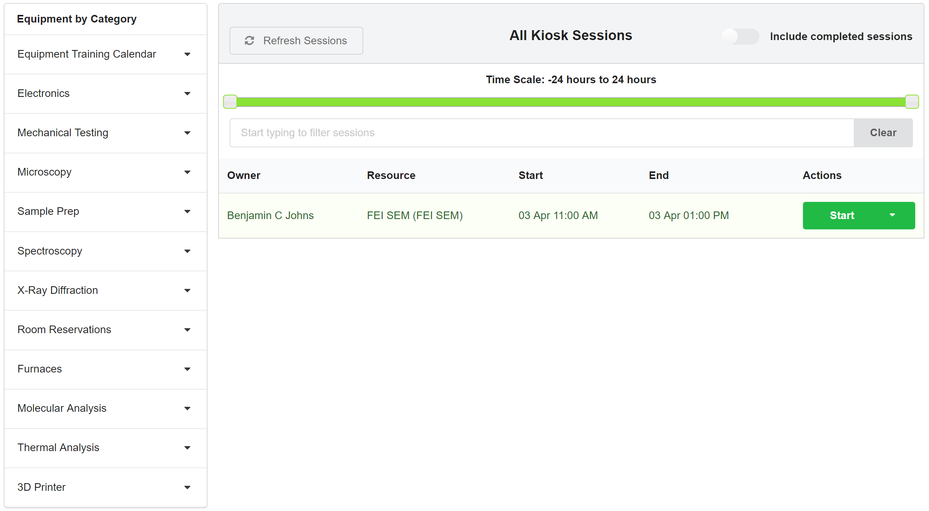

The timer starts. You may leave this window open, or Log out & use equipment if someone else needs to use the computer you are logged into iLab with.

Stop Usage
When you are finished using the equipment, log back into Kiosk Mode (Step 4). Select Finish. 