How to Add Charges for a Sample on iLab – MSE Resources
September 20, 2018
- Create a reservation
- Within the reservation, look for the large red lettering “HOW TO RECORD USE” and follow the instructions in red letters
- The first step will be the click on the “Add additional service charge” button:
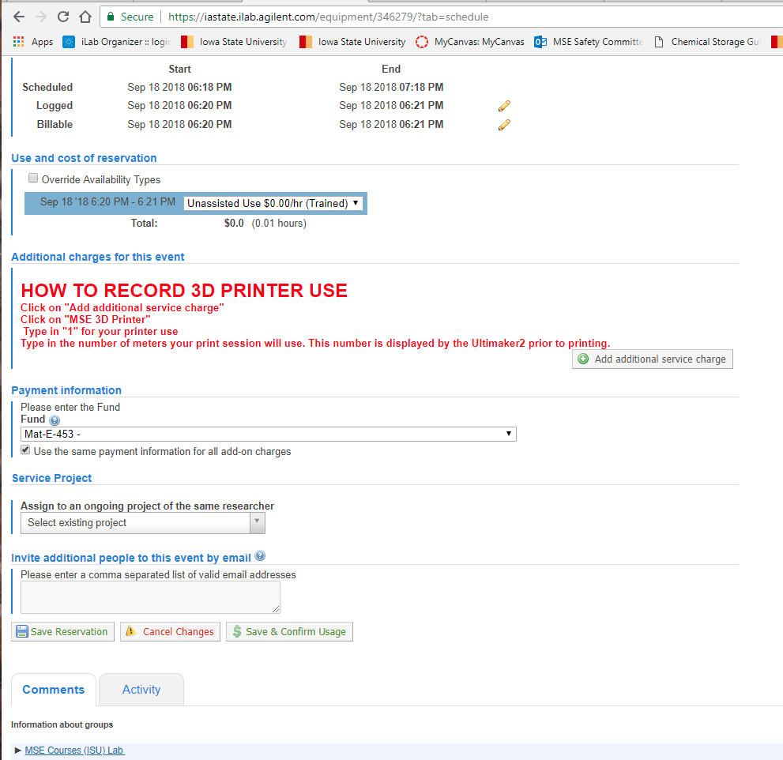

- Next Click on the link with the equipment name beside the arrow
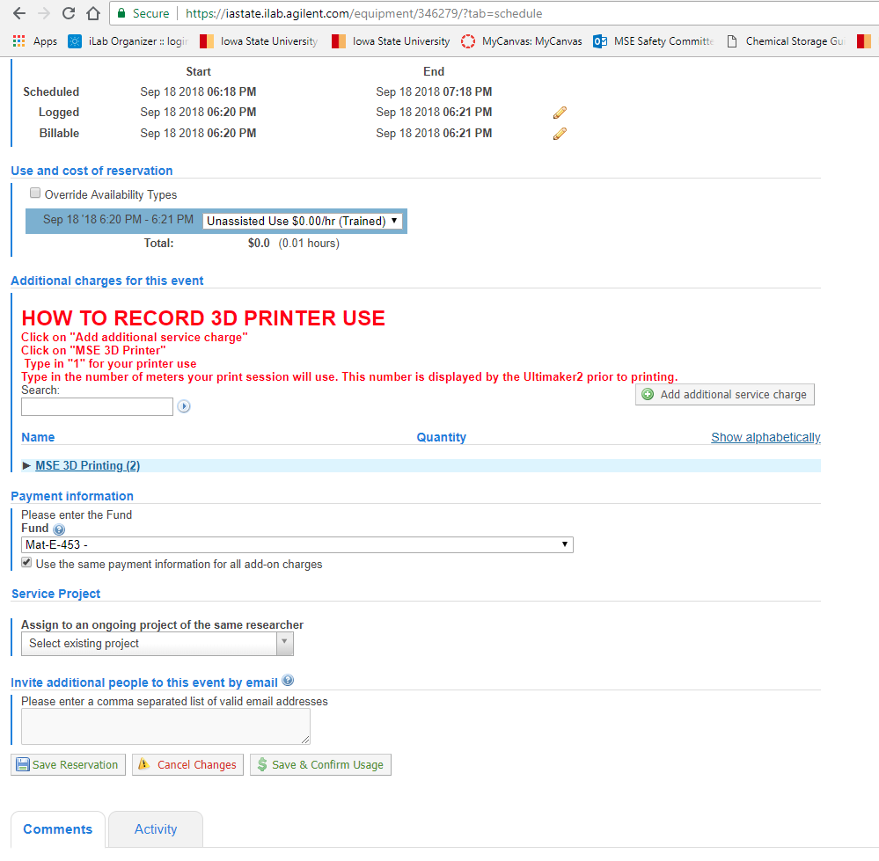

- Input the number of samples into the “Quantity” field.

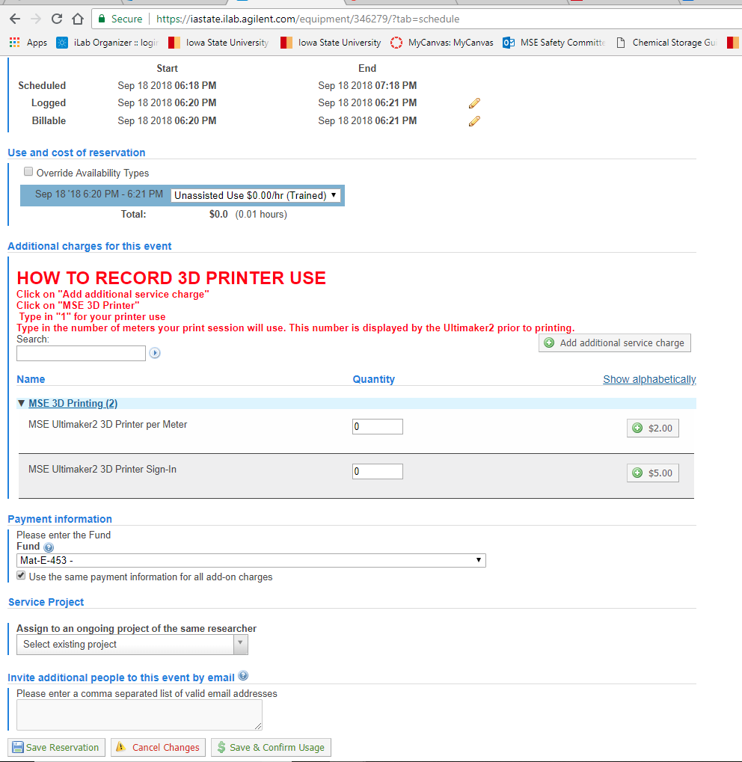

For mounting, polishing an etching, each sample is one sample.
For sputter coating, each time you run the machine it is a charge.
For the saws, each cut is a charge.
For the 3D Printer, you have to record 1 sign-in charge and also input the # of meters of material used.

- After you enter the number, click on the “+ $” button.

